10 JUNE 2020

# USER MANUAL

HARSHVARDHAN

CEO|DIRECTOR

VKARMA EDUTECH PRIVATE LIMITED

**ADMIN:**

**Side Panel and Nav Bar**

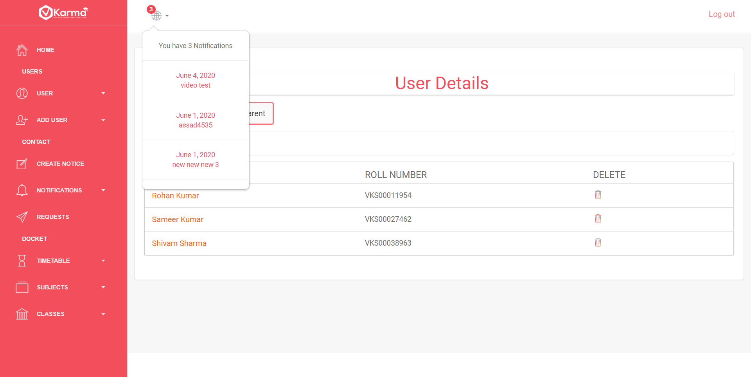

Navbar contains notification icon which displays notification count and recent 5 notifications in a dropdown and a logout button

Side panel contains link to all other pages

1. **Home Page**

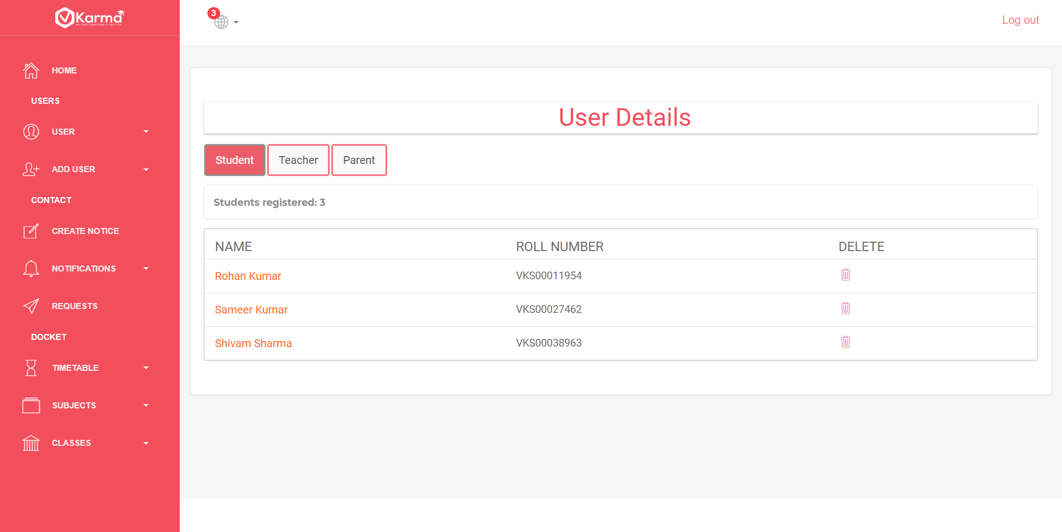

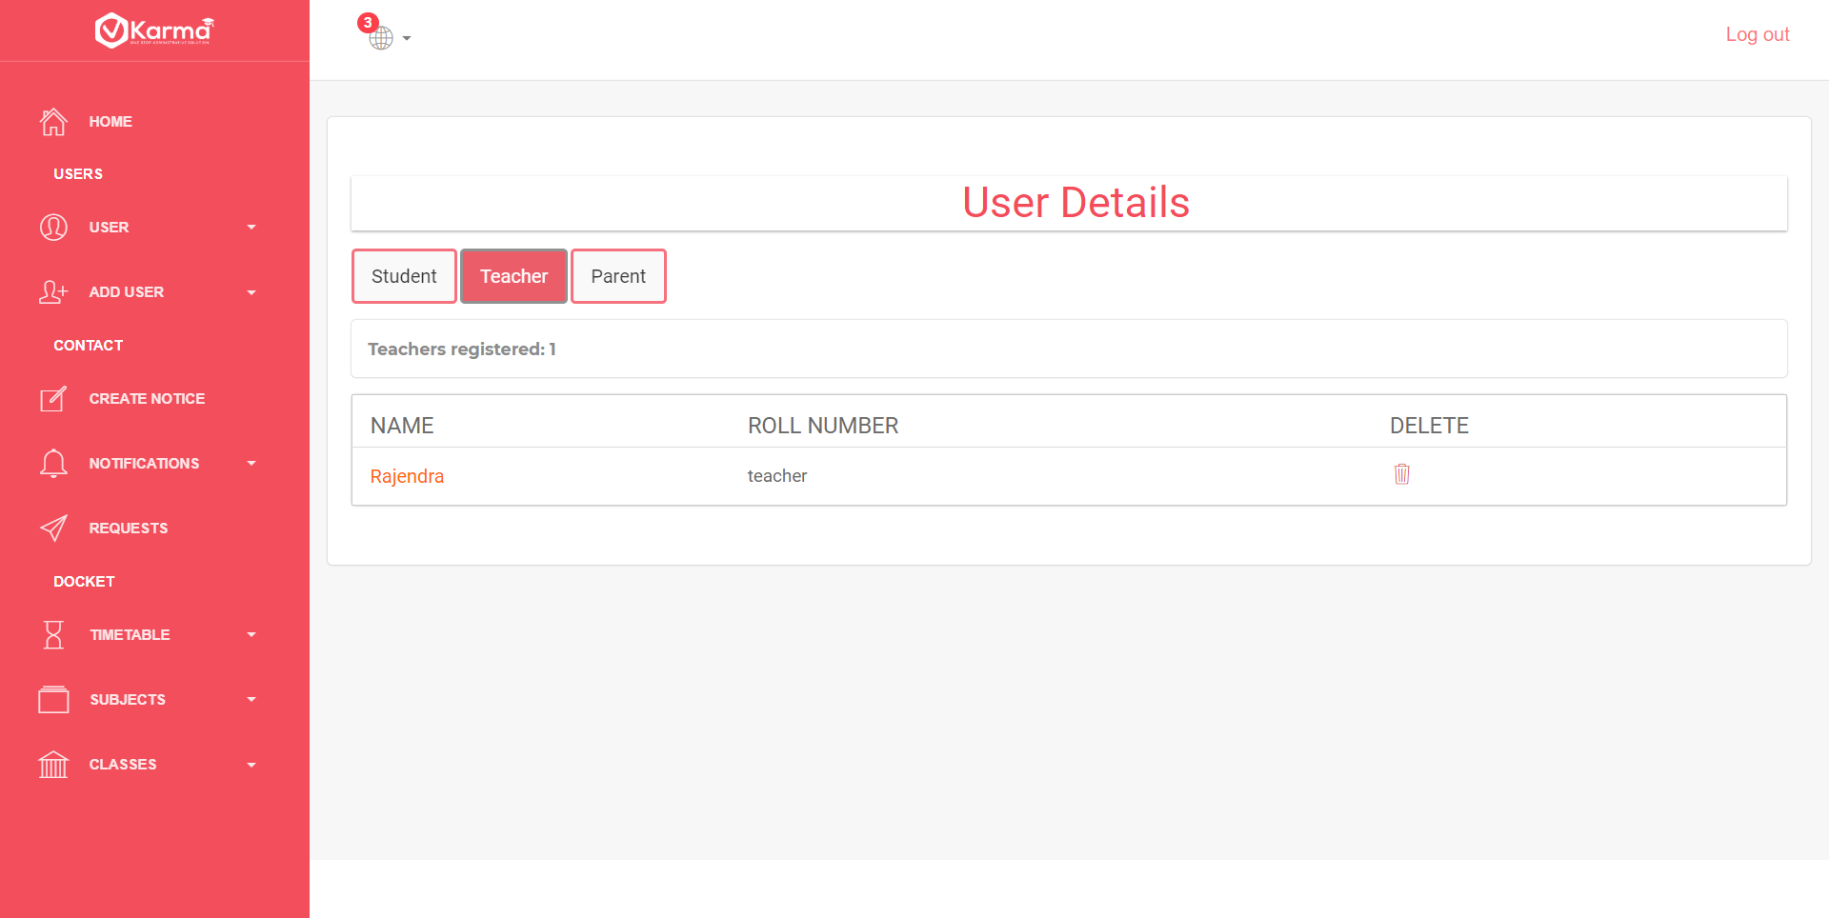

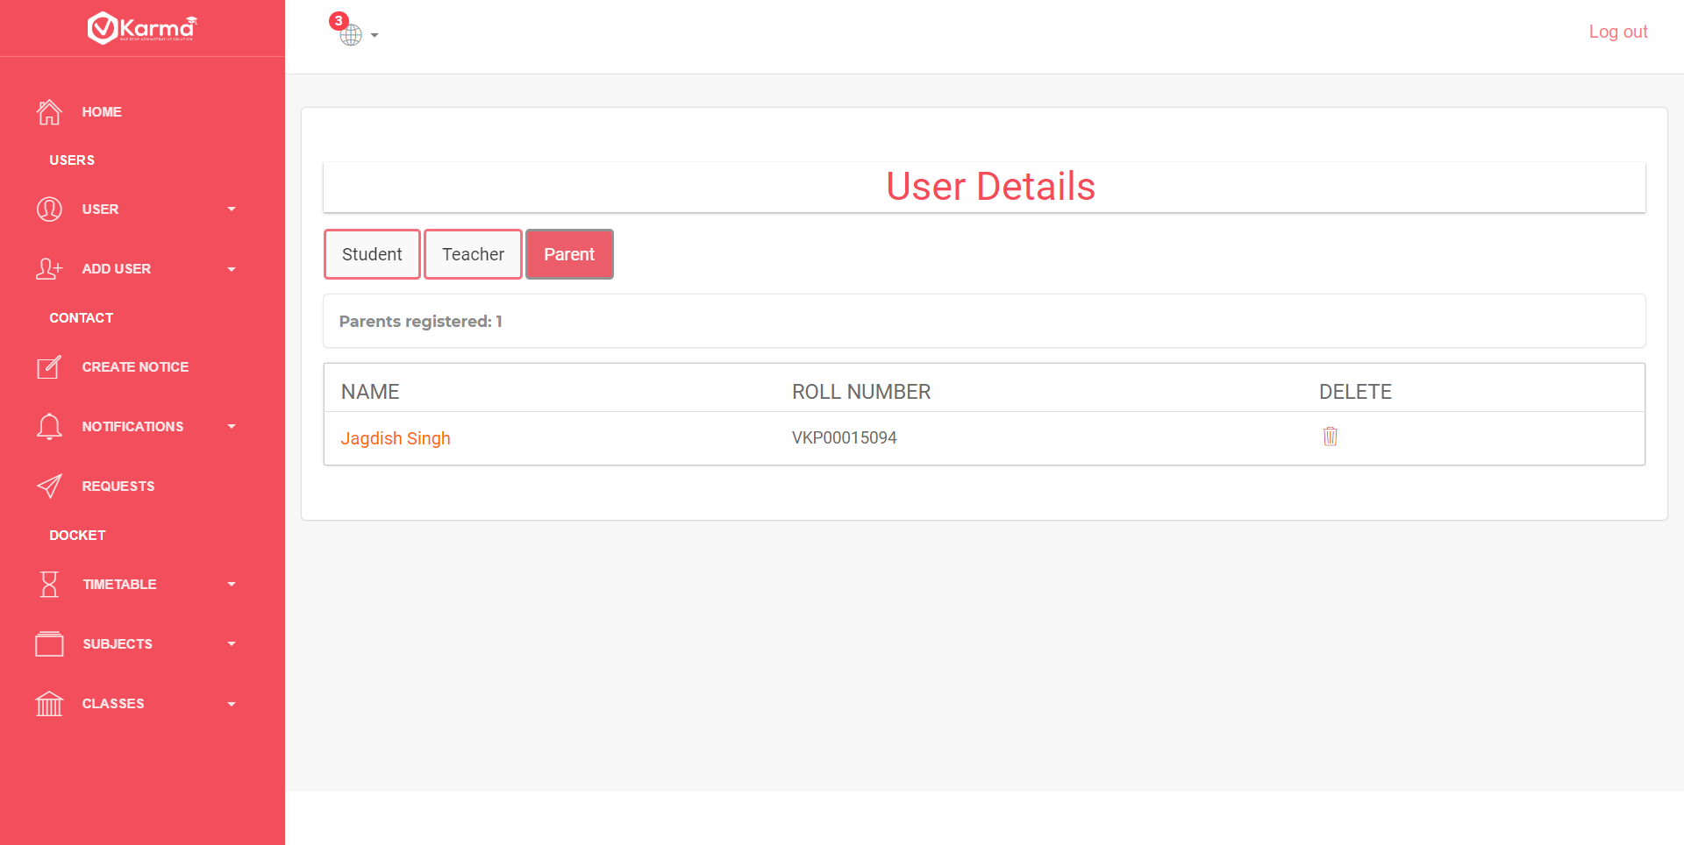

Home page can be accessed through Home link in side panel.

It displays all the students, teachers and parents currently registered.

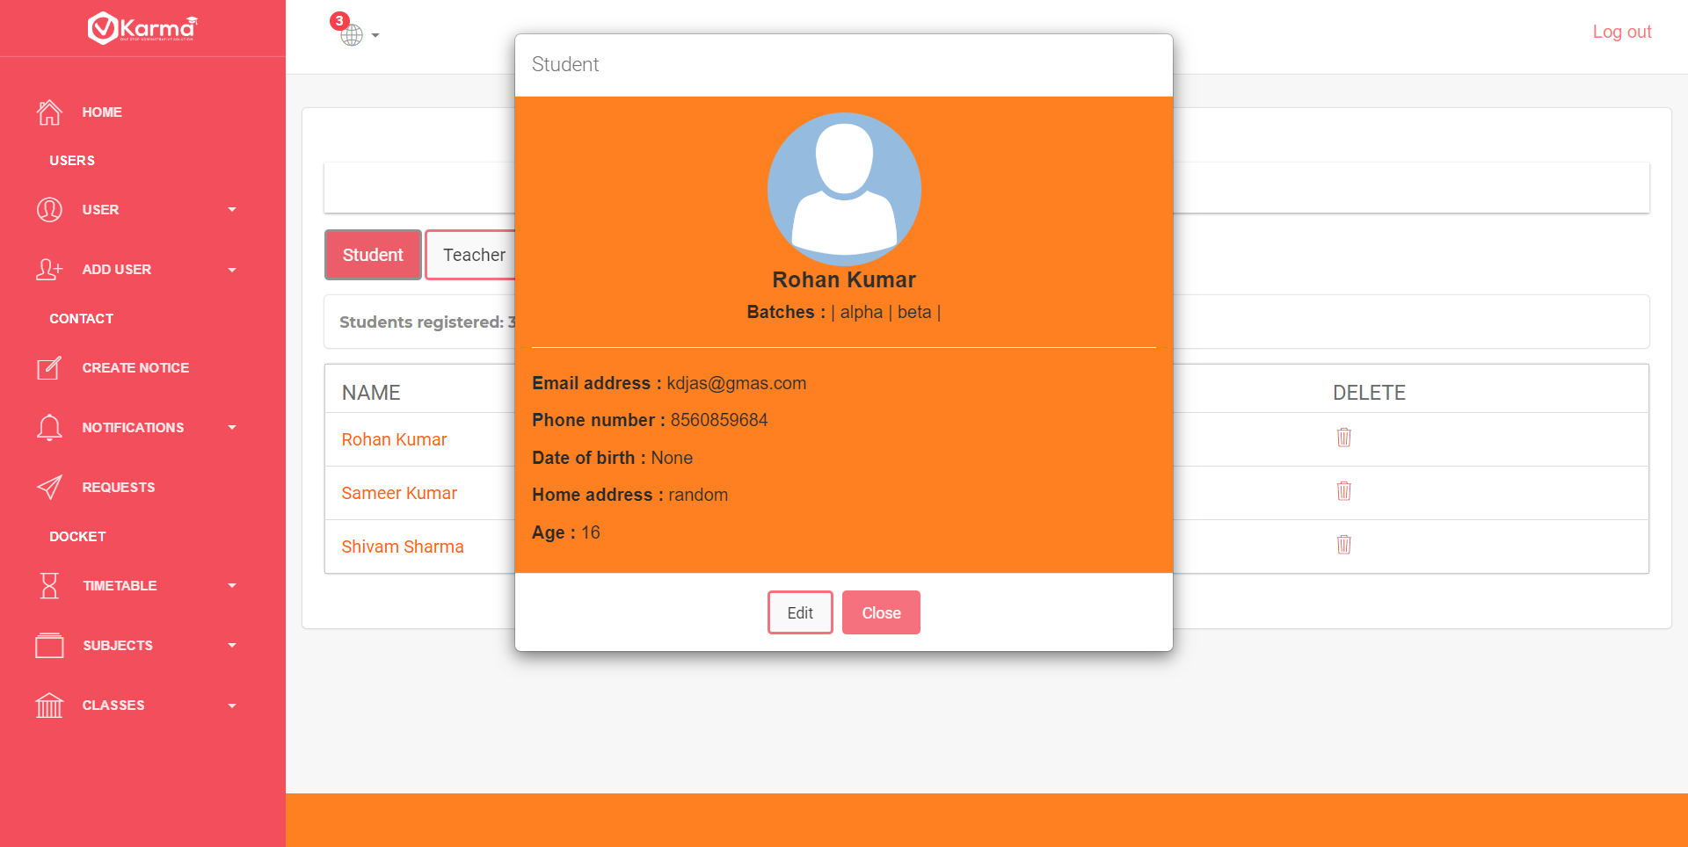

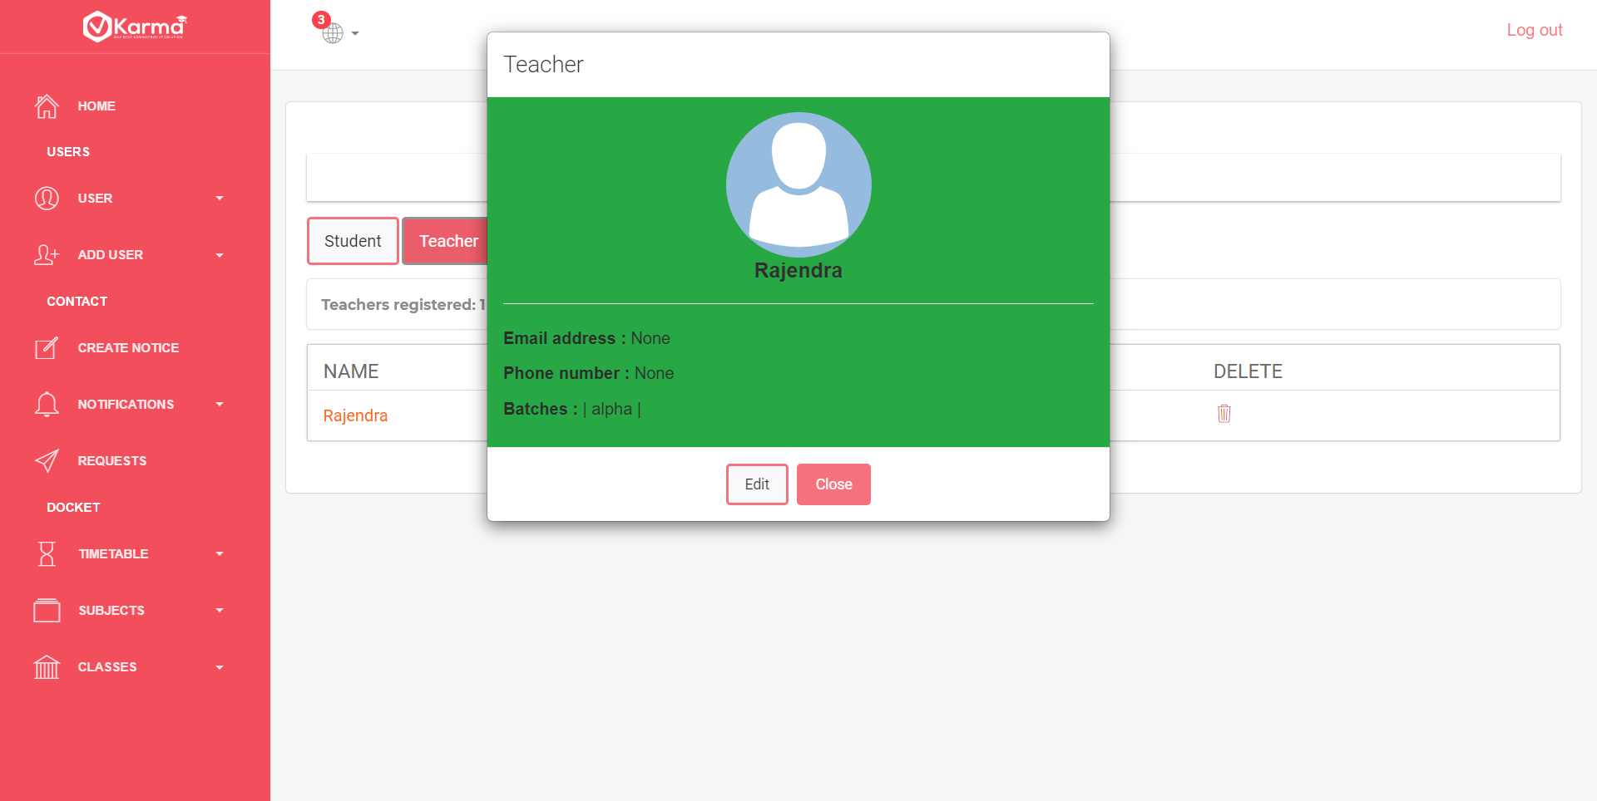

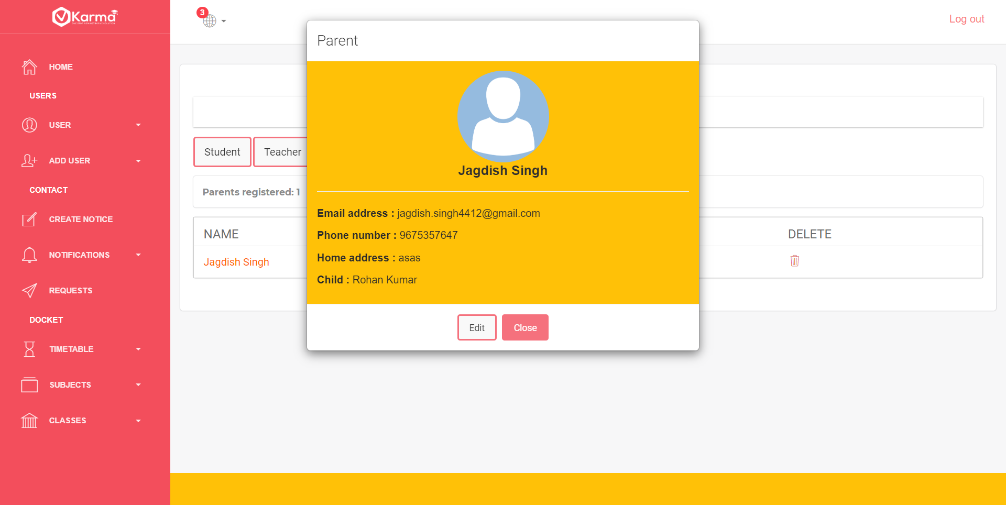

And their more information can be viewed by clicking on their names in a popup

Clicking on Edit we redirect to edit page to edit their information and click on close to close the popup

1. **Edit Detail Page**

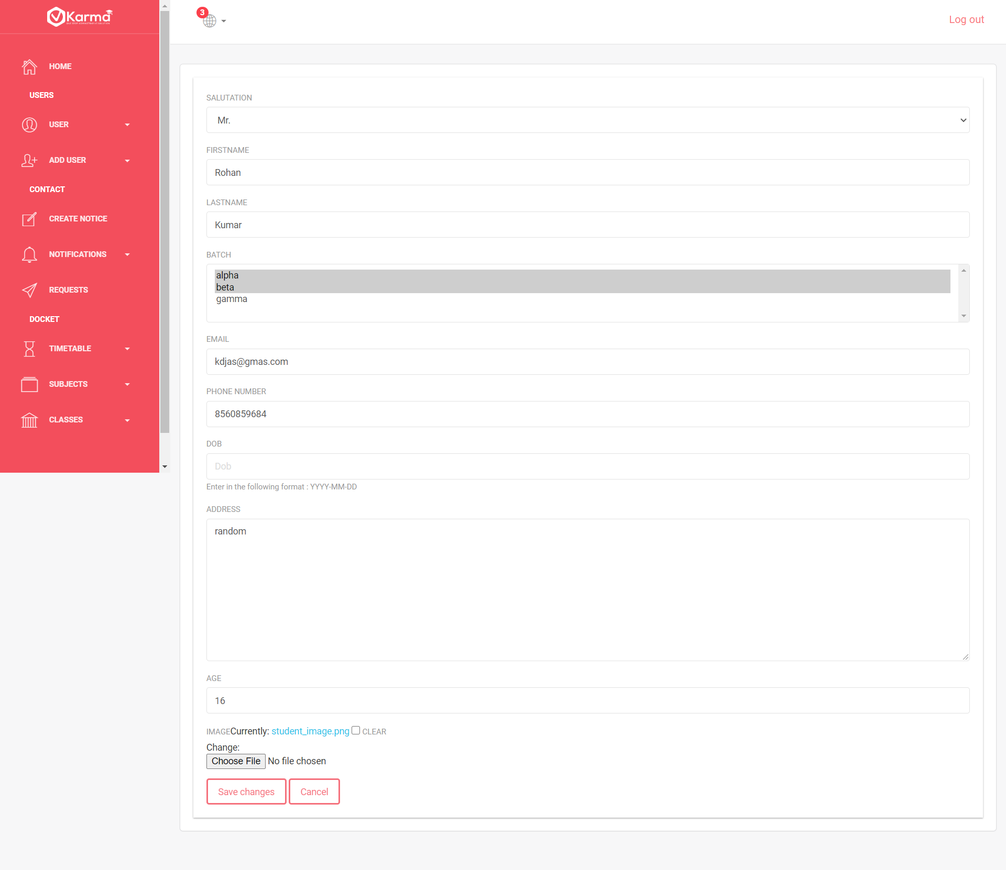

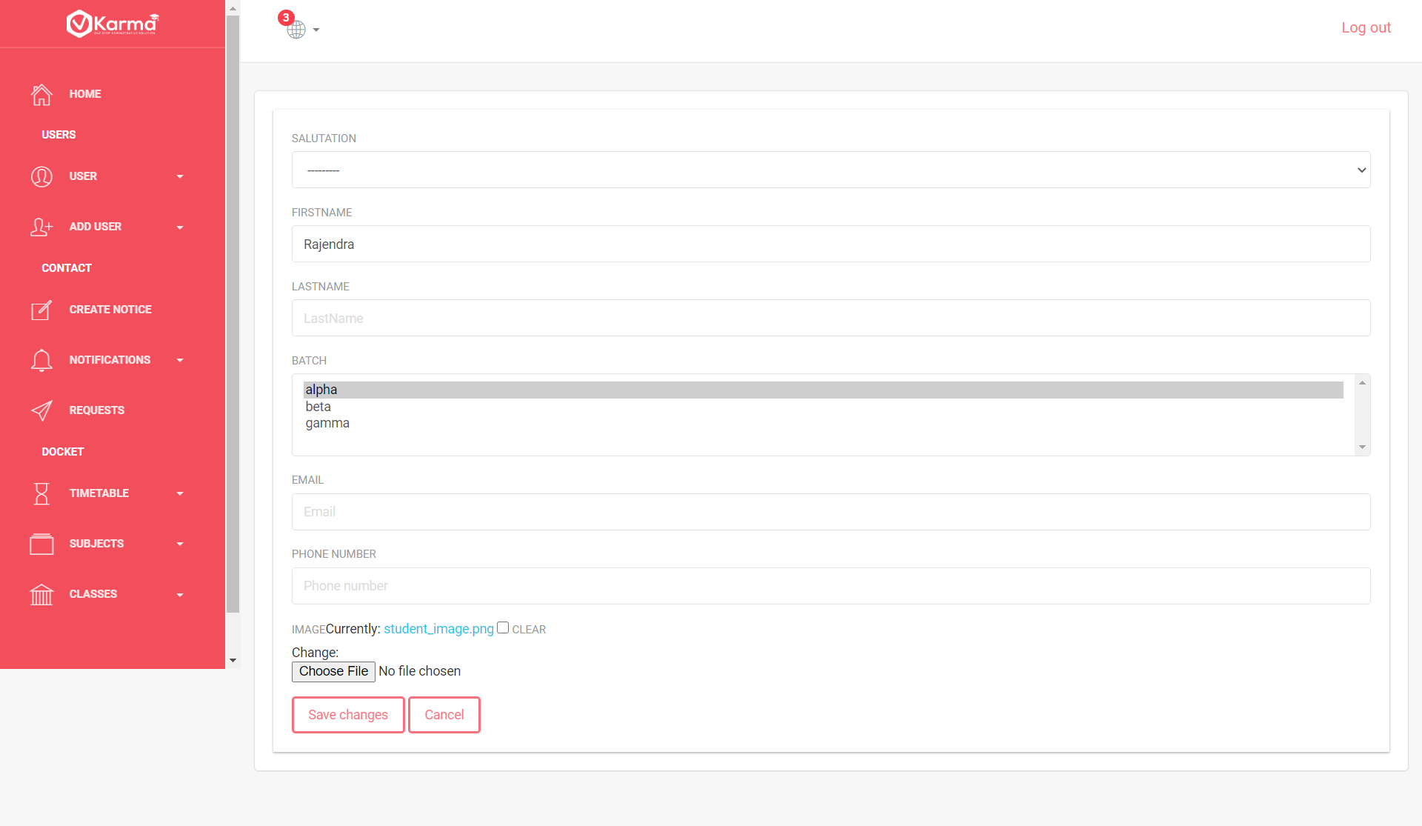

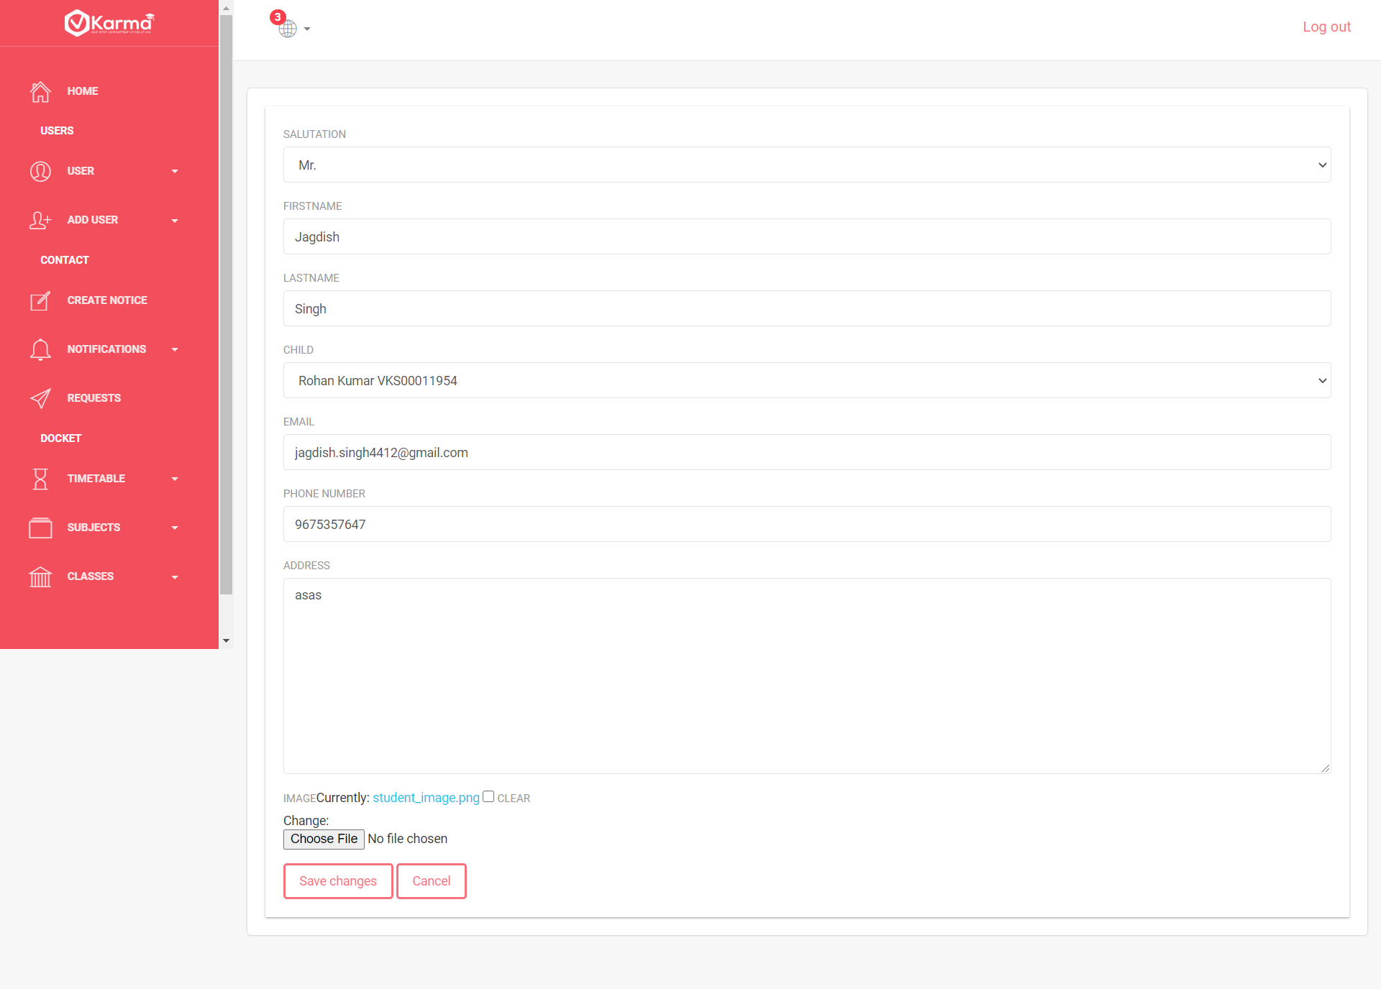

This page contains corresponding inputs for all details filled with previous information for teacher, student and parent user

On submitting we redirect back to the homepage

1. **Users Button**

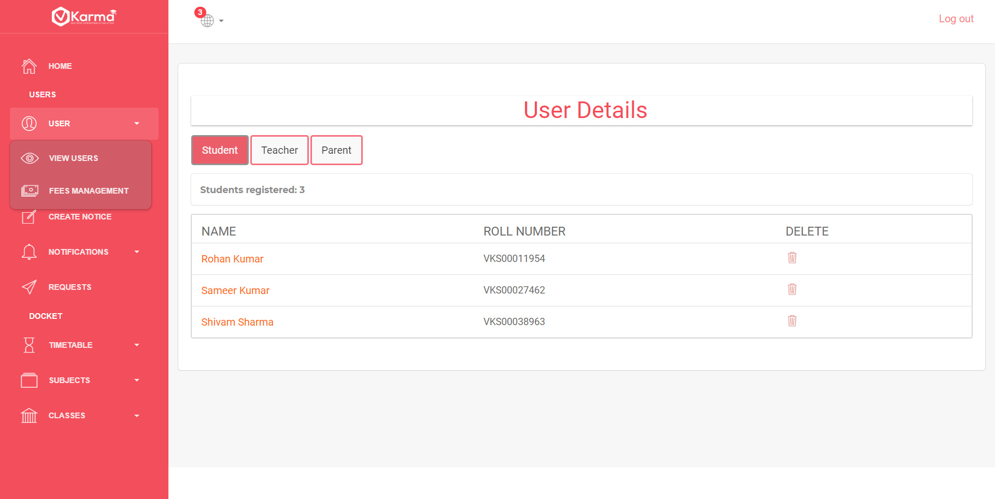

This button from side panel contains dropdown list with two links view users and fee management

View Users Button redirects back to homepage with displays all users

1. **Fee Management**

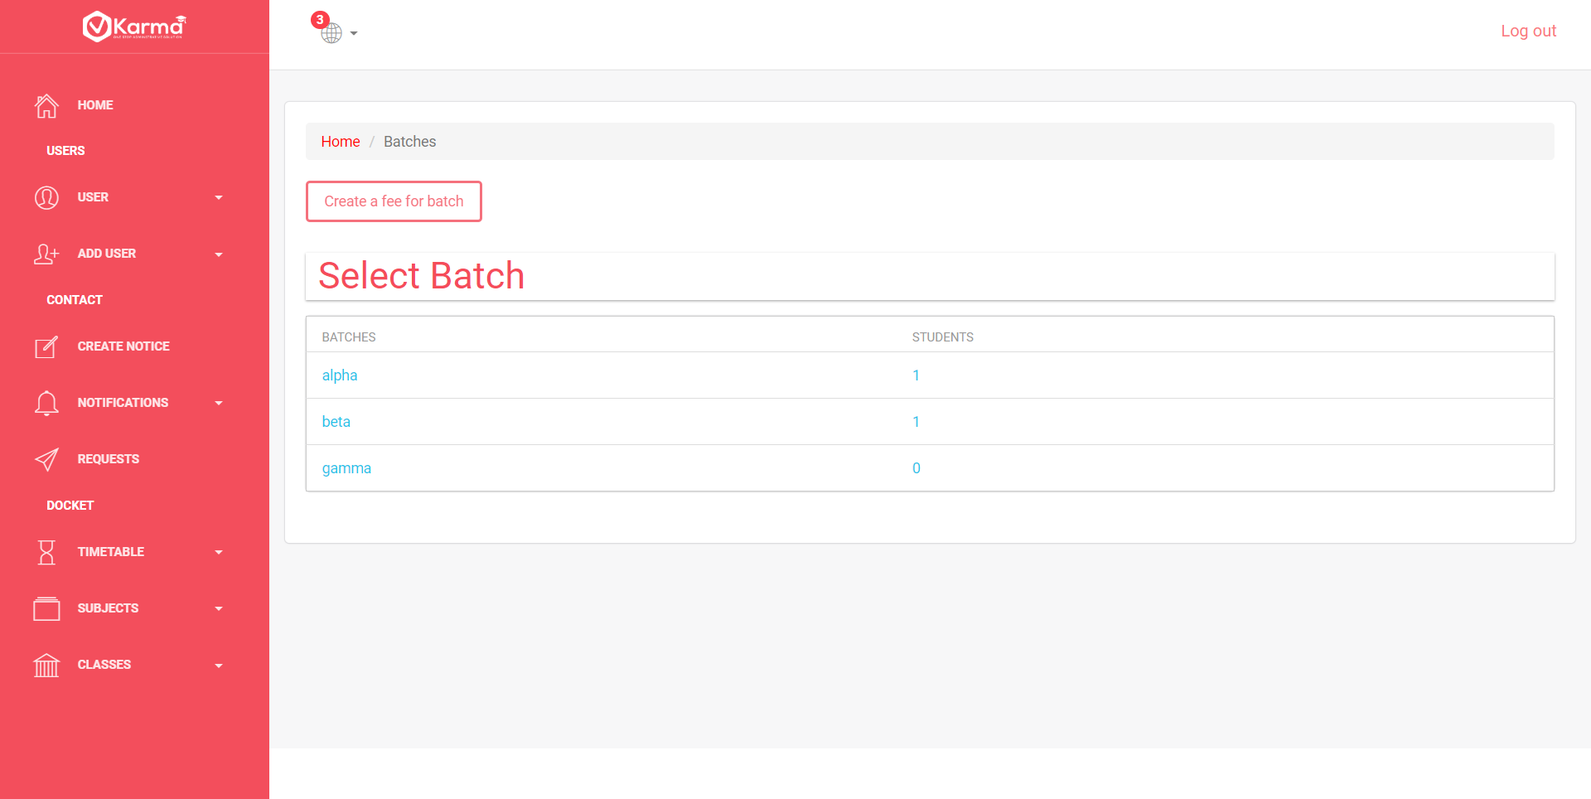

It contains a link to create a fee installment for any batch and list of all the batches

* 1. Create Fee

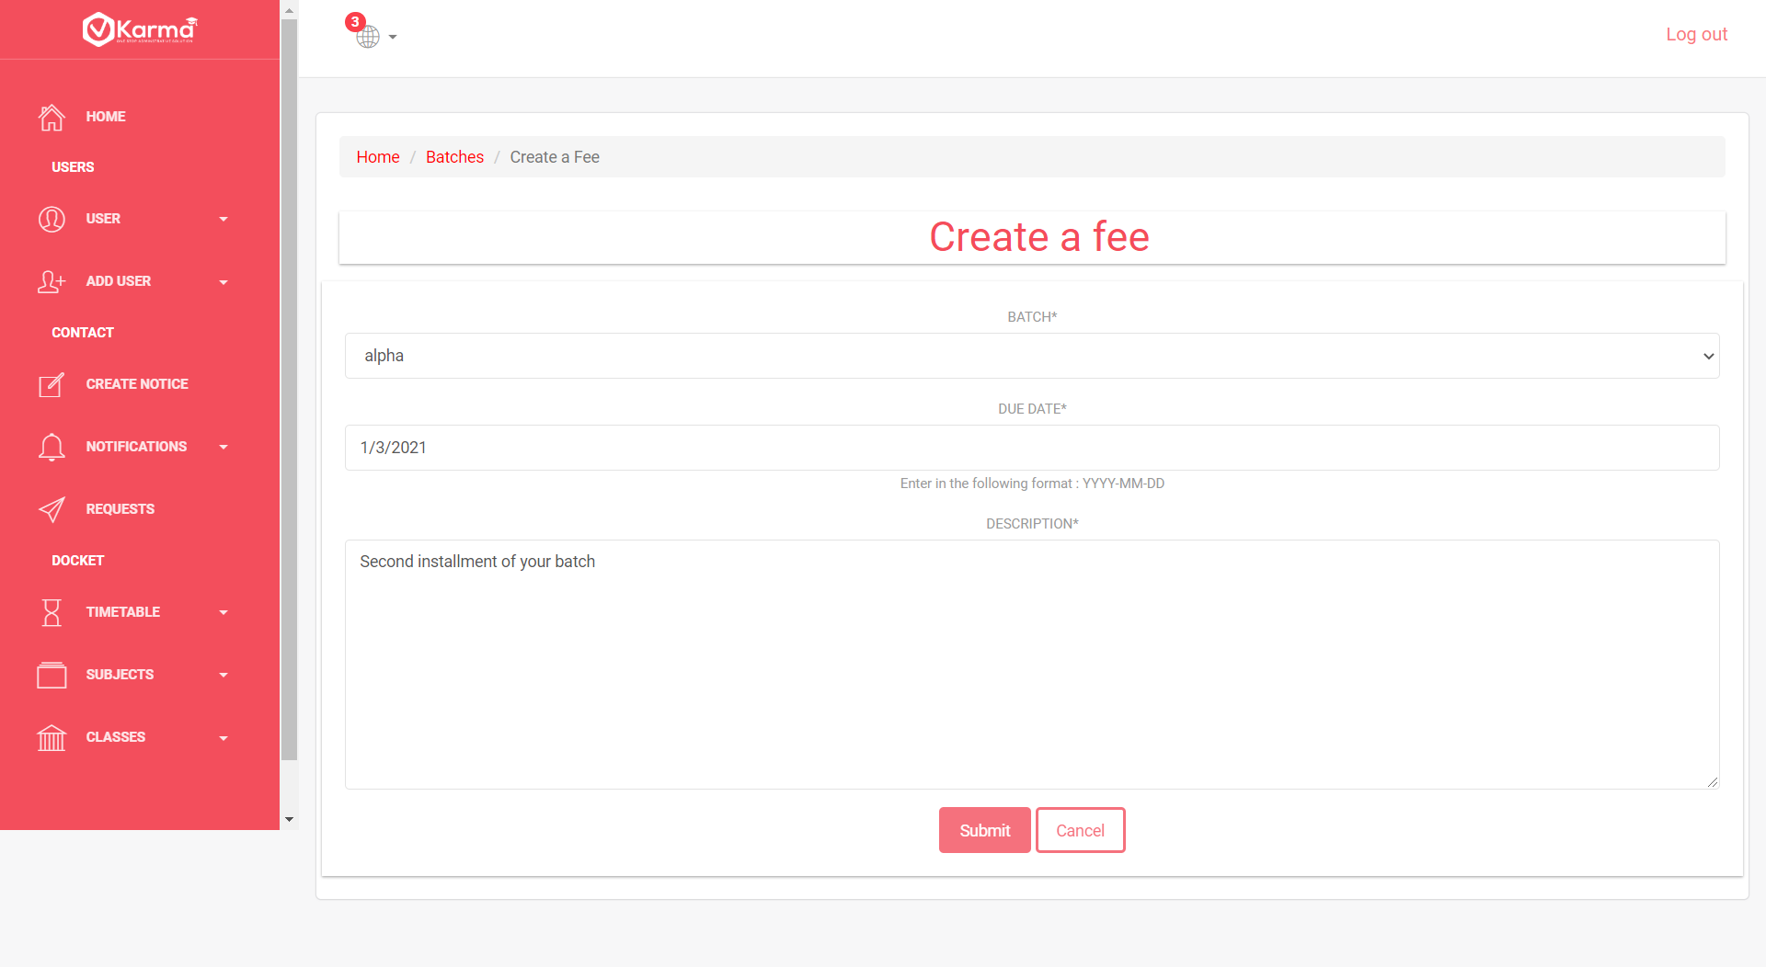

Admin can fill required entries and create a fee installment for the batch specified

* 1. Entering fee details of student by admin



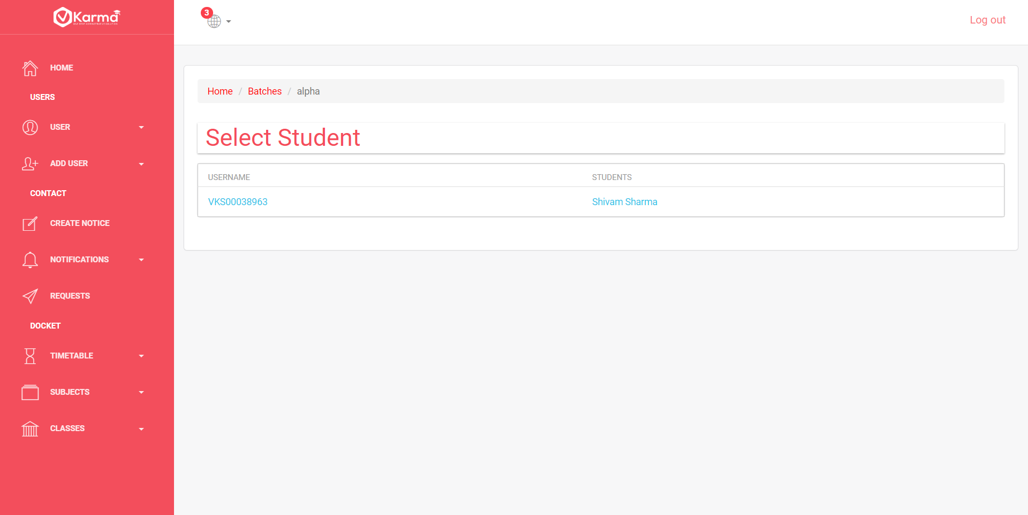

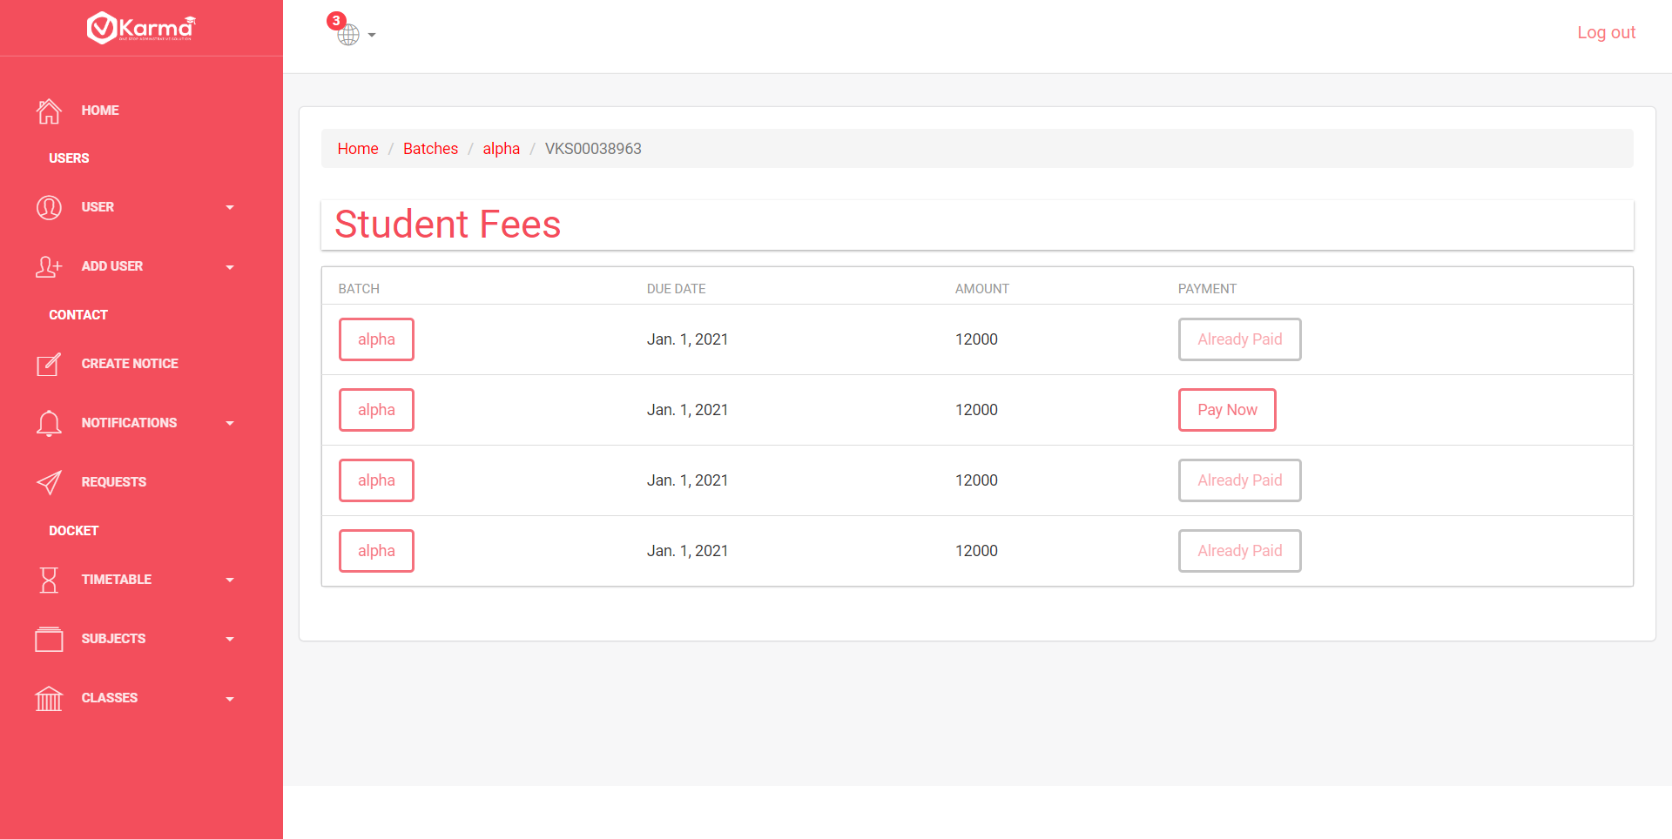

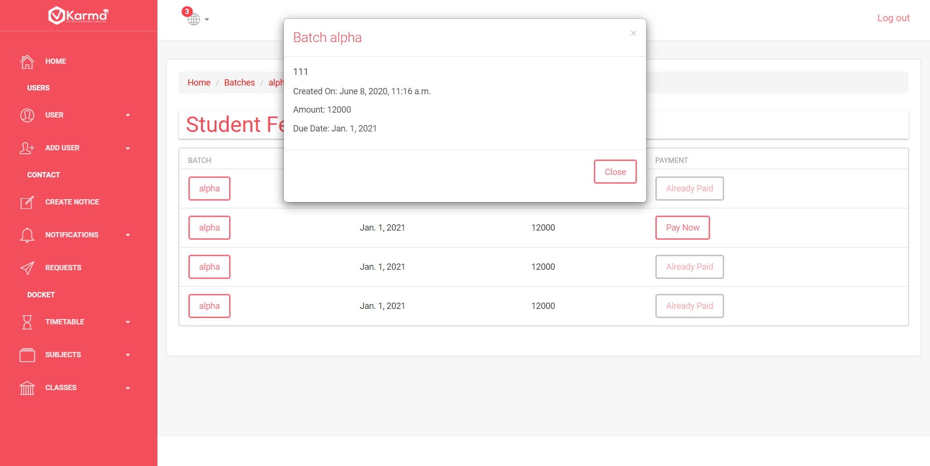

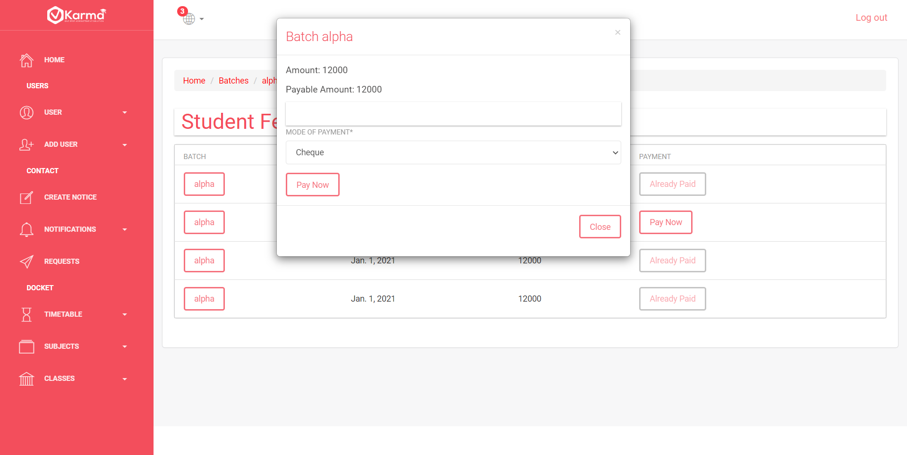

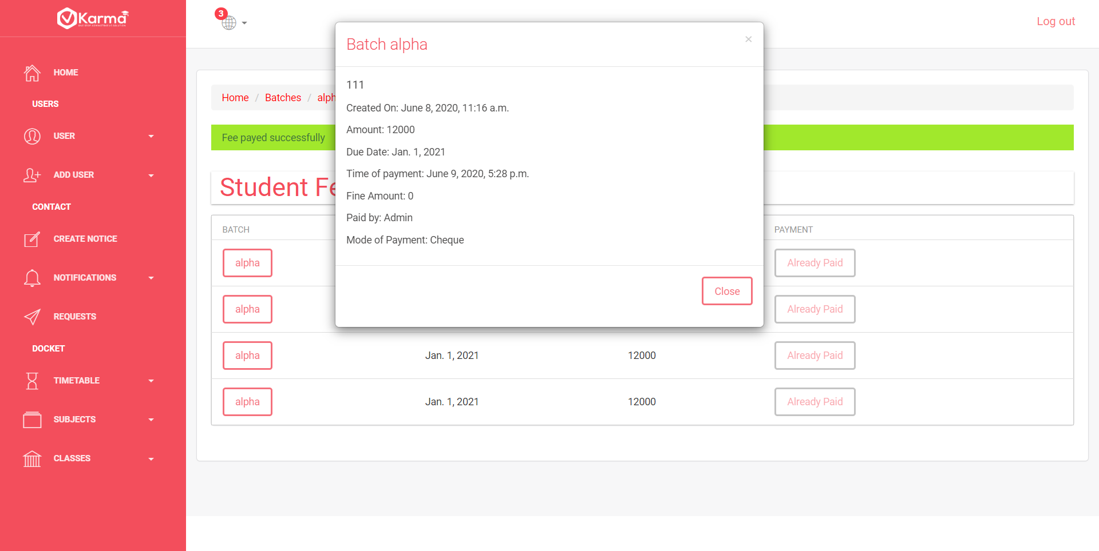

Admin can navigate to a specific student’s fee management portal through selecting batch and then the student from fee management page

At student fee management page there is list of all fee installments whether paid or not-paid whose details can be viewed by clicking batch button and can be paid using pay now button

1. **Add User**

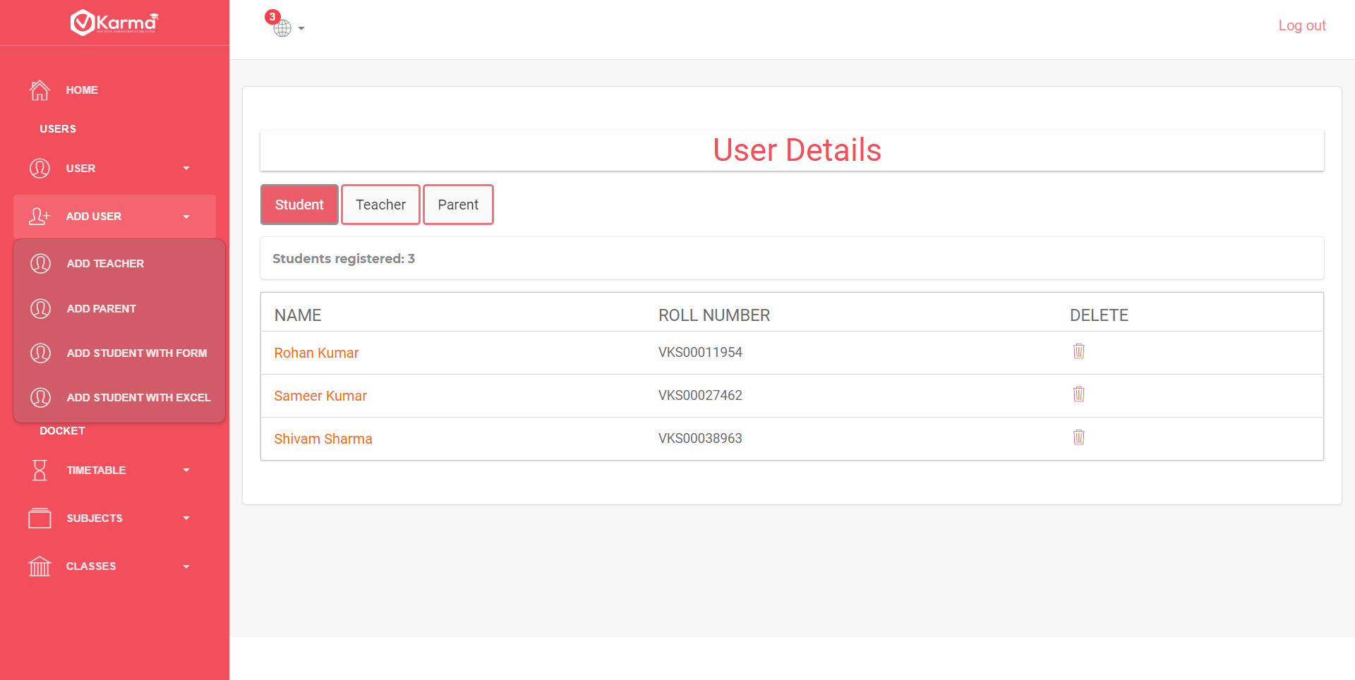

Add user button contains a dropdown with four links to Add Teacher, Add Parent, Add Student through form or excel file

* 1. Add Teacher

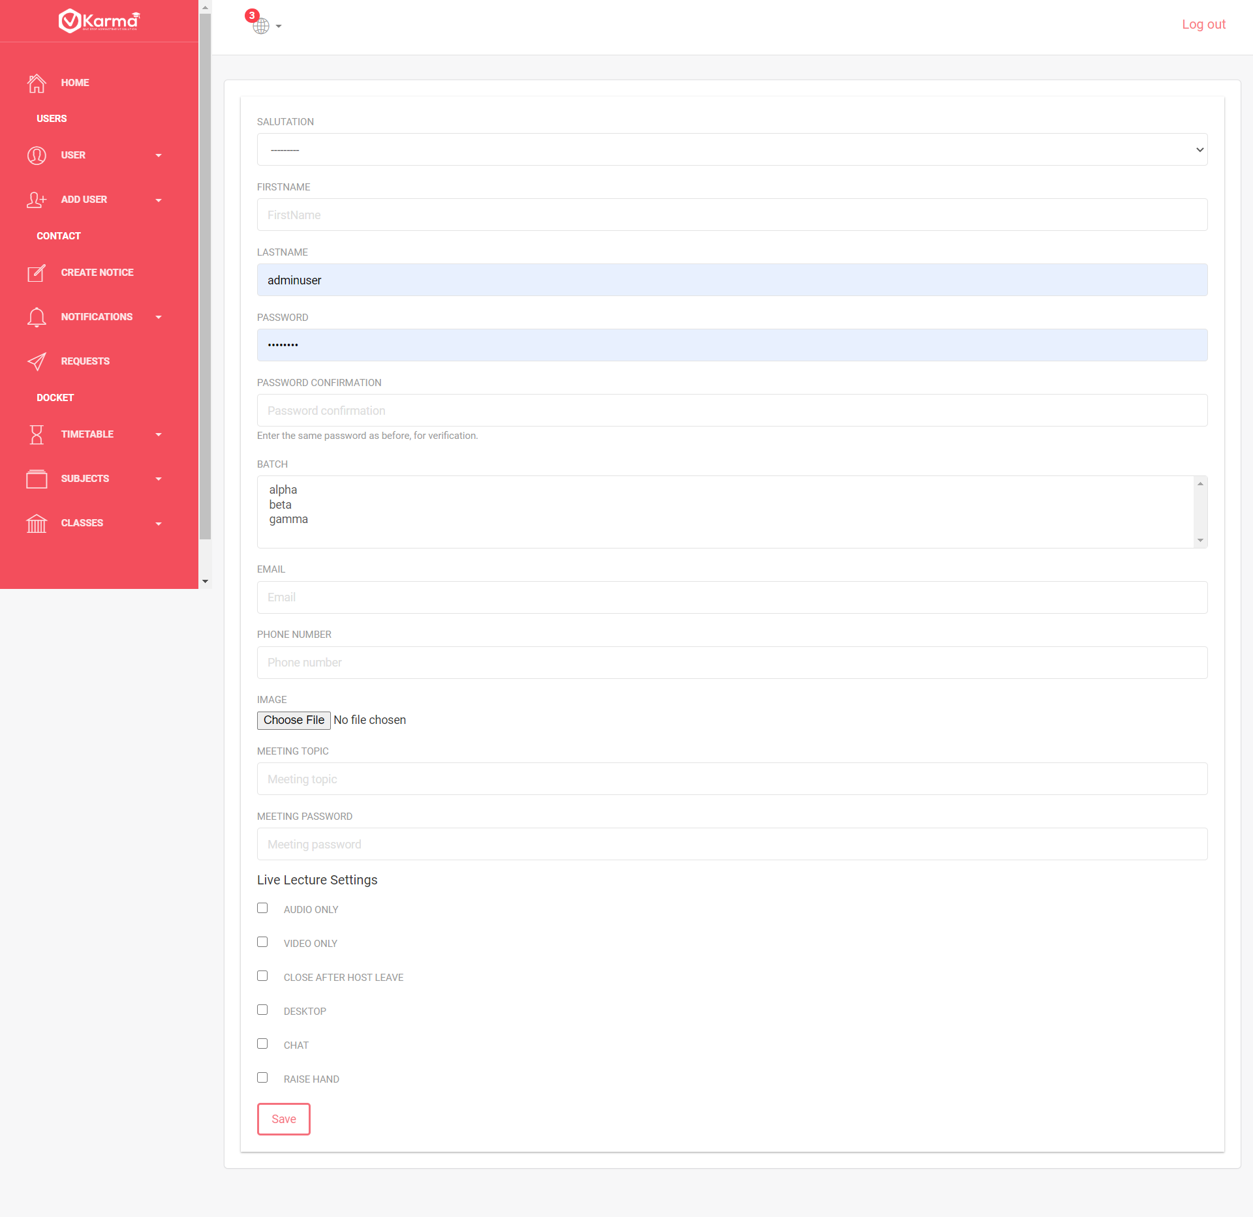

This page contains details form which contains basic information and default meeting information

* 1. Add Parent

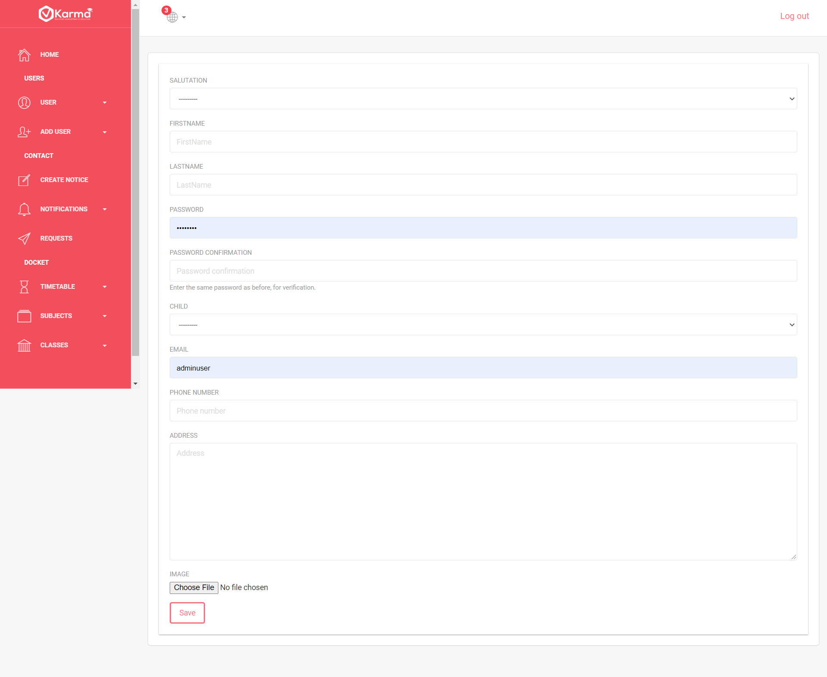

This page contains form for parent’s detail

* 1. Add Student using form

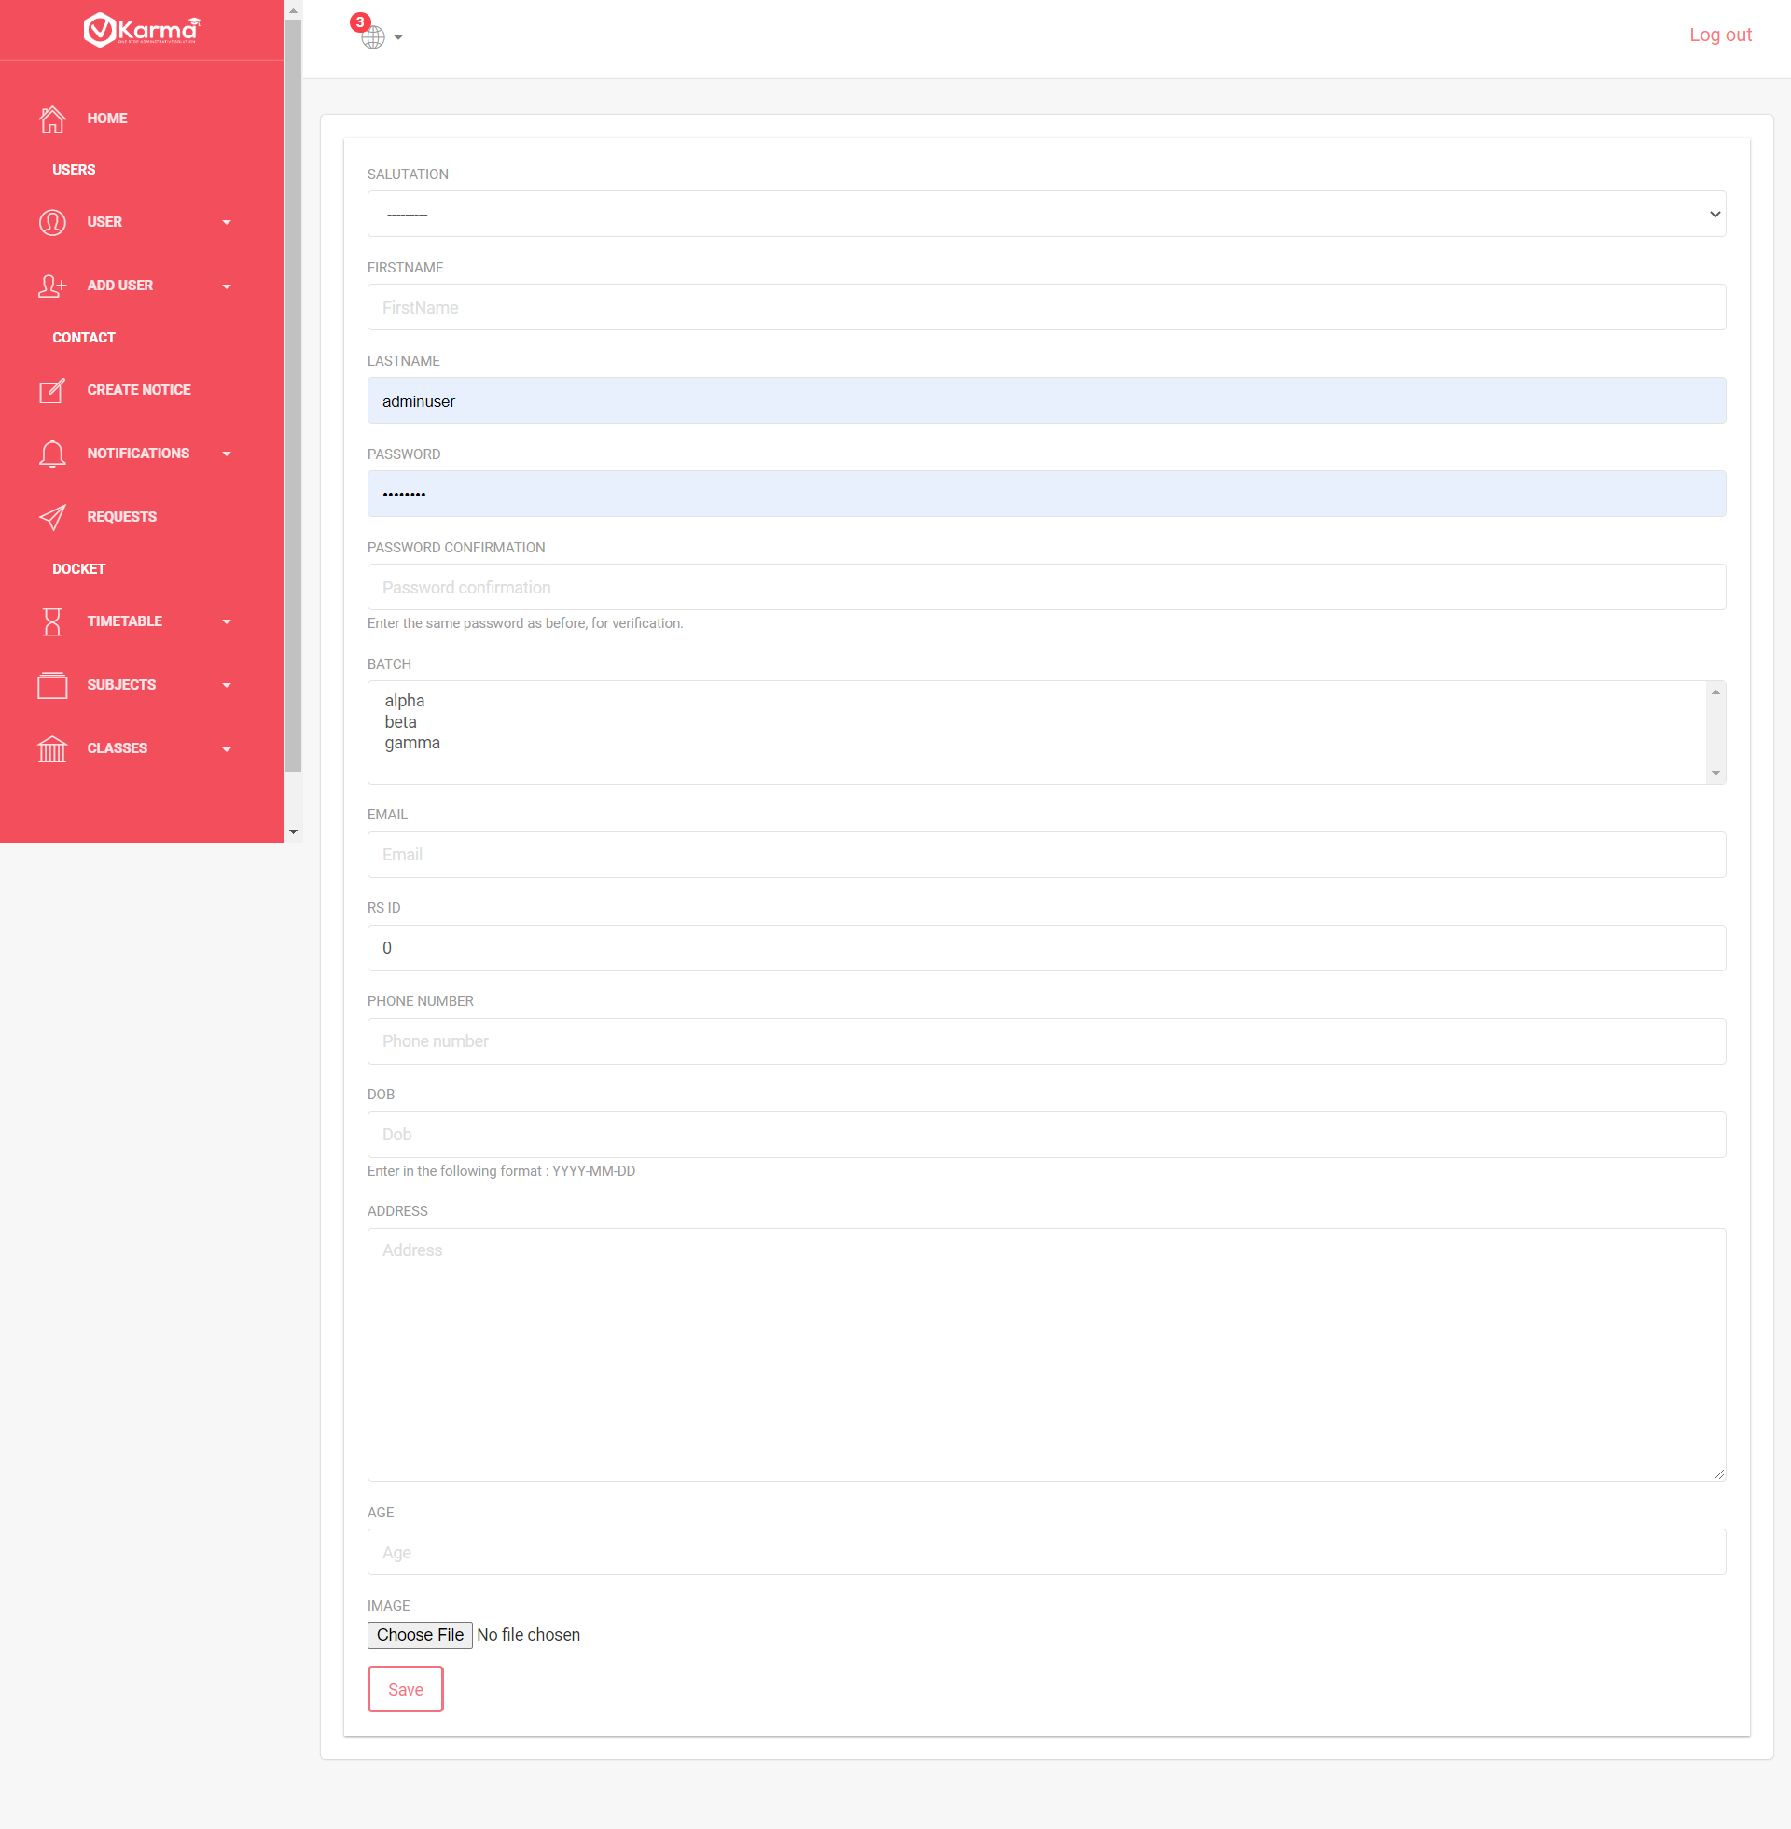

This page contains form for student details

* 1. Add Student using excel file

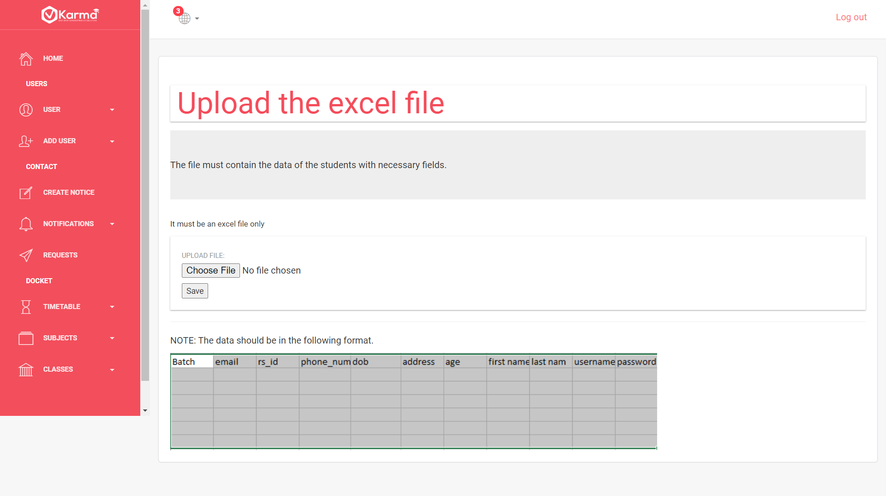

Multiple students can be registered through a excel file containing details in the specified format

1. **Create Notice**

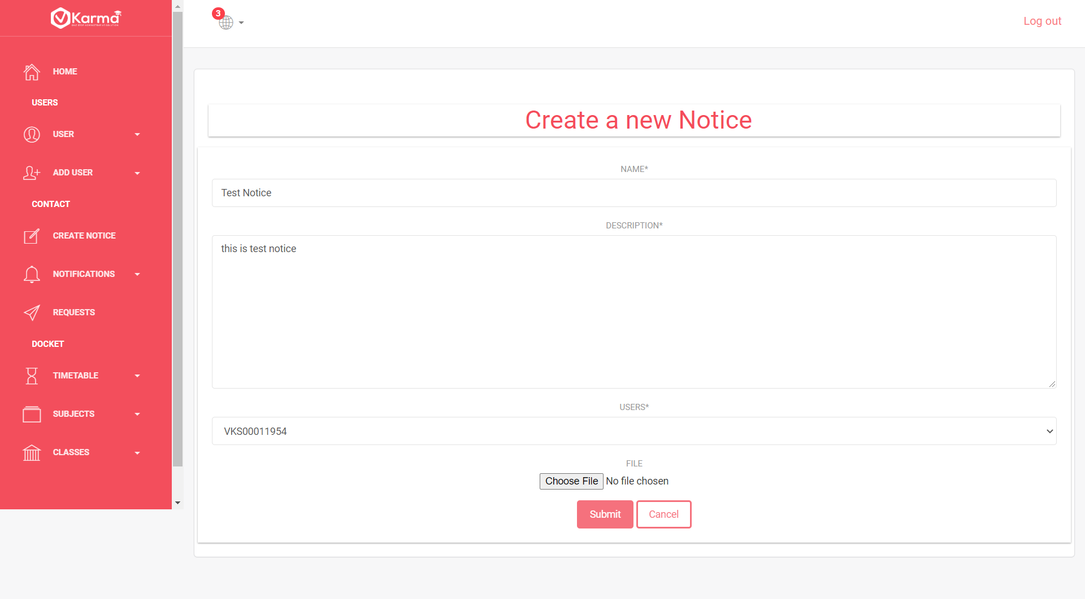

A notice can be created for any user though this page

1. **Create Notification**

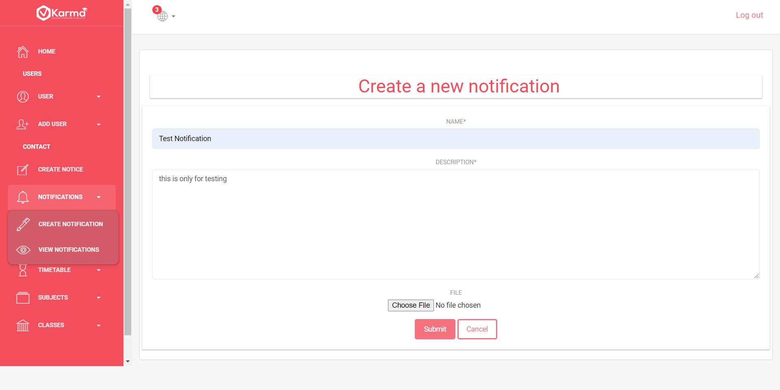

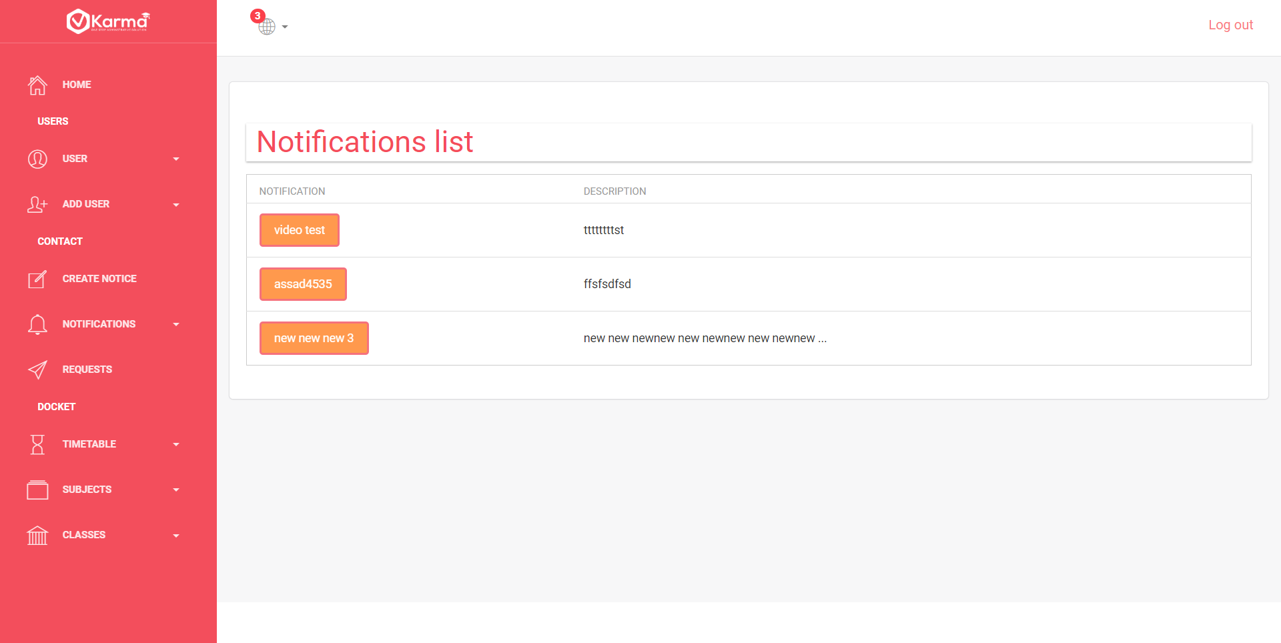

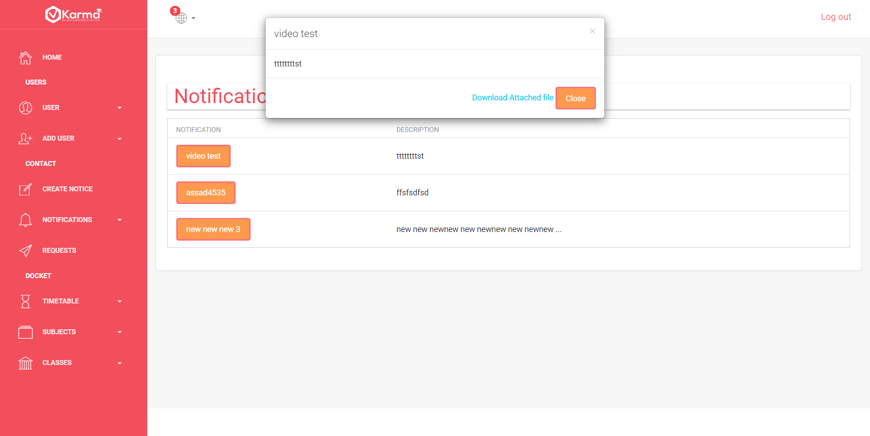

Notifications button contains two link one to create notification for every user

And View Notifications to view all the notifications and to view all details of any particular notification click on the title of the respective notification

1. **Request List**

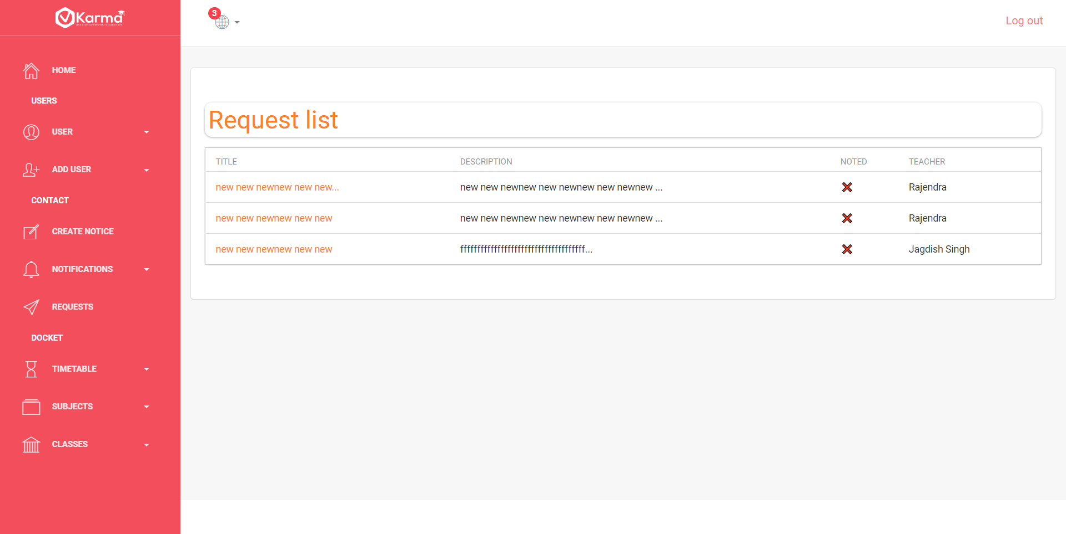

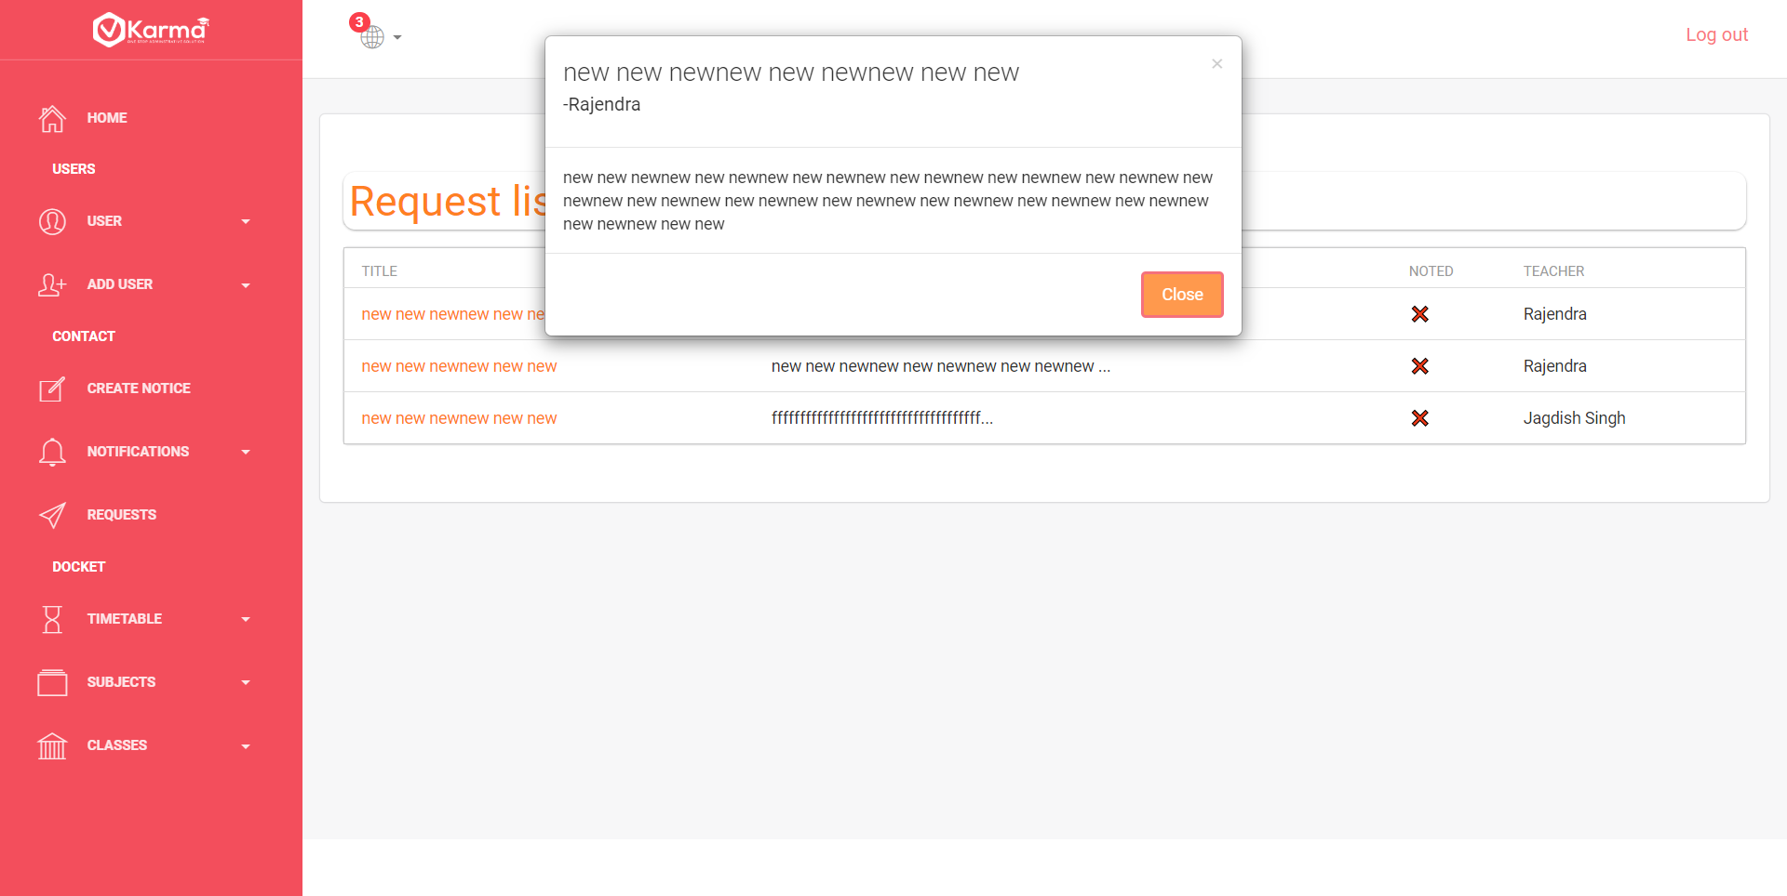

This page contains list of all requests created by other users to admin

And details can be viewed by clicking on title

1. **Timetable**

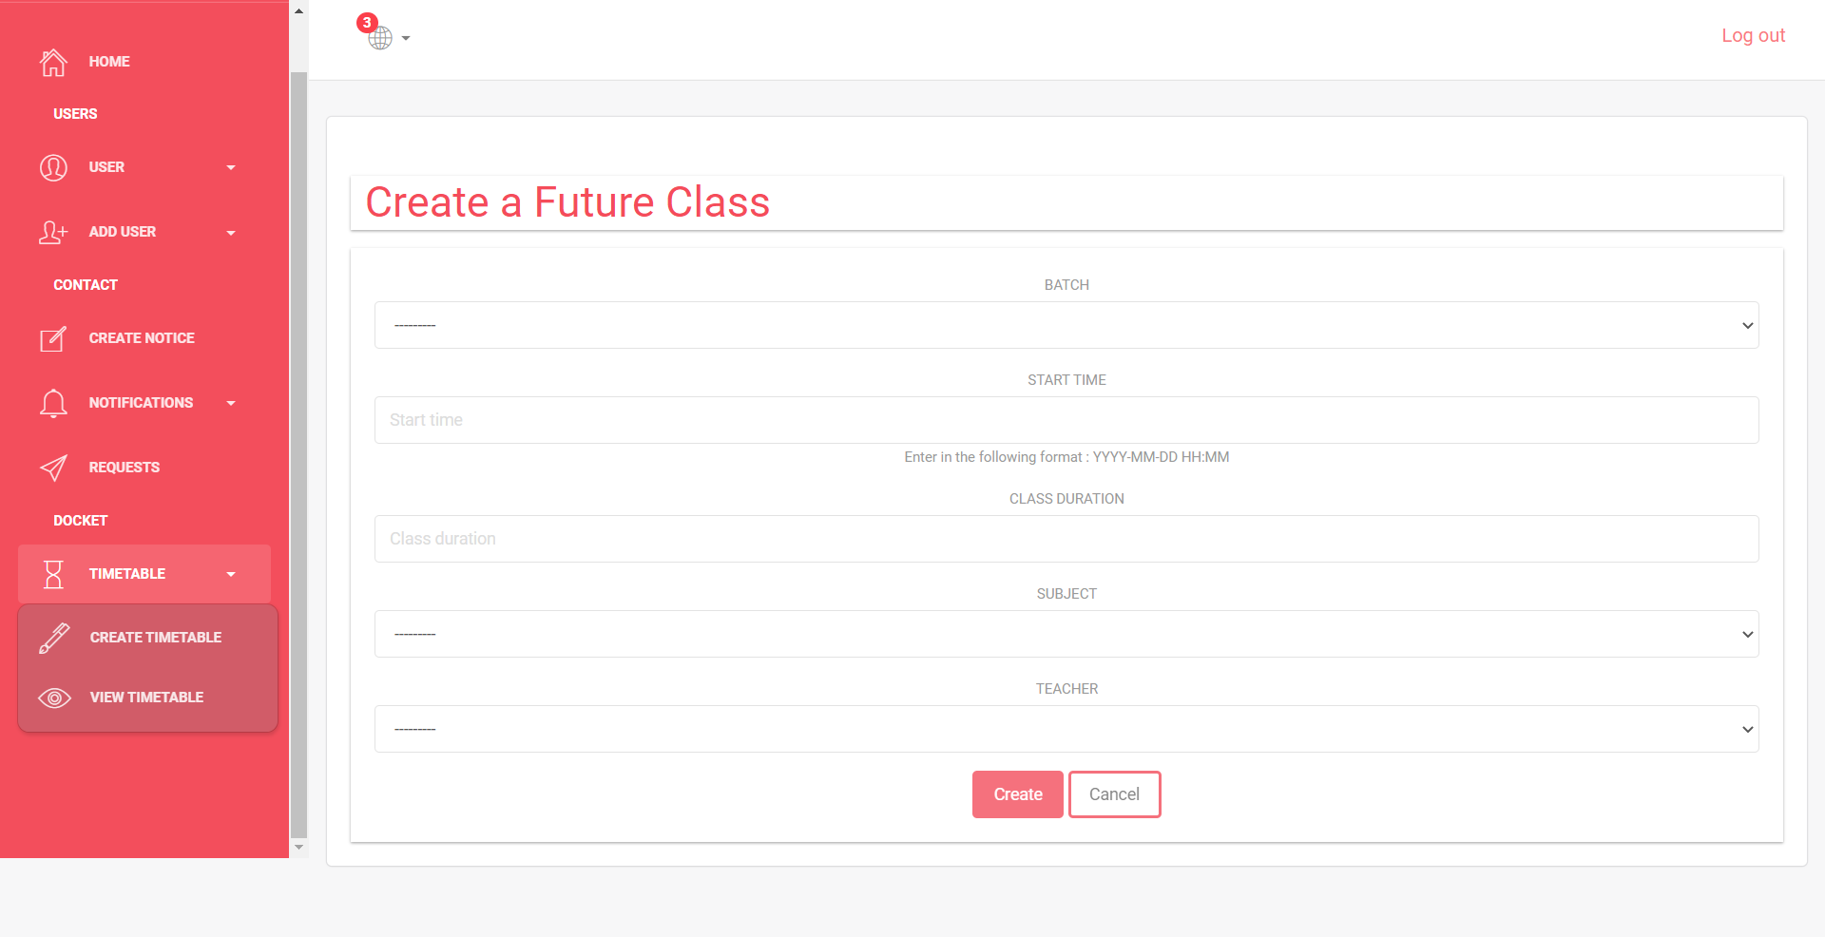

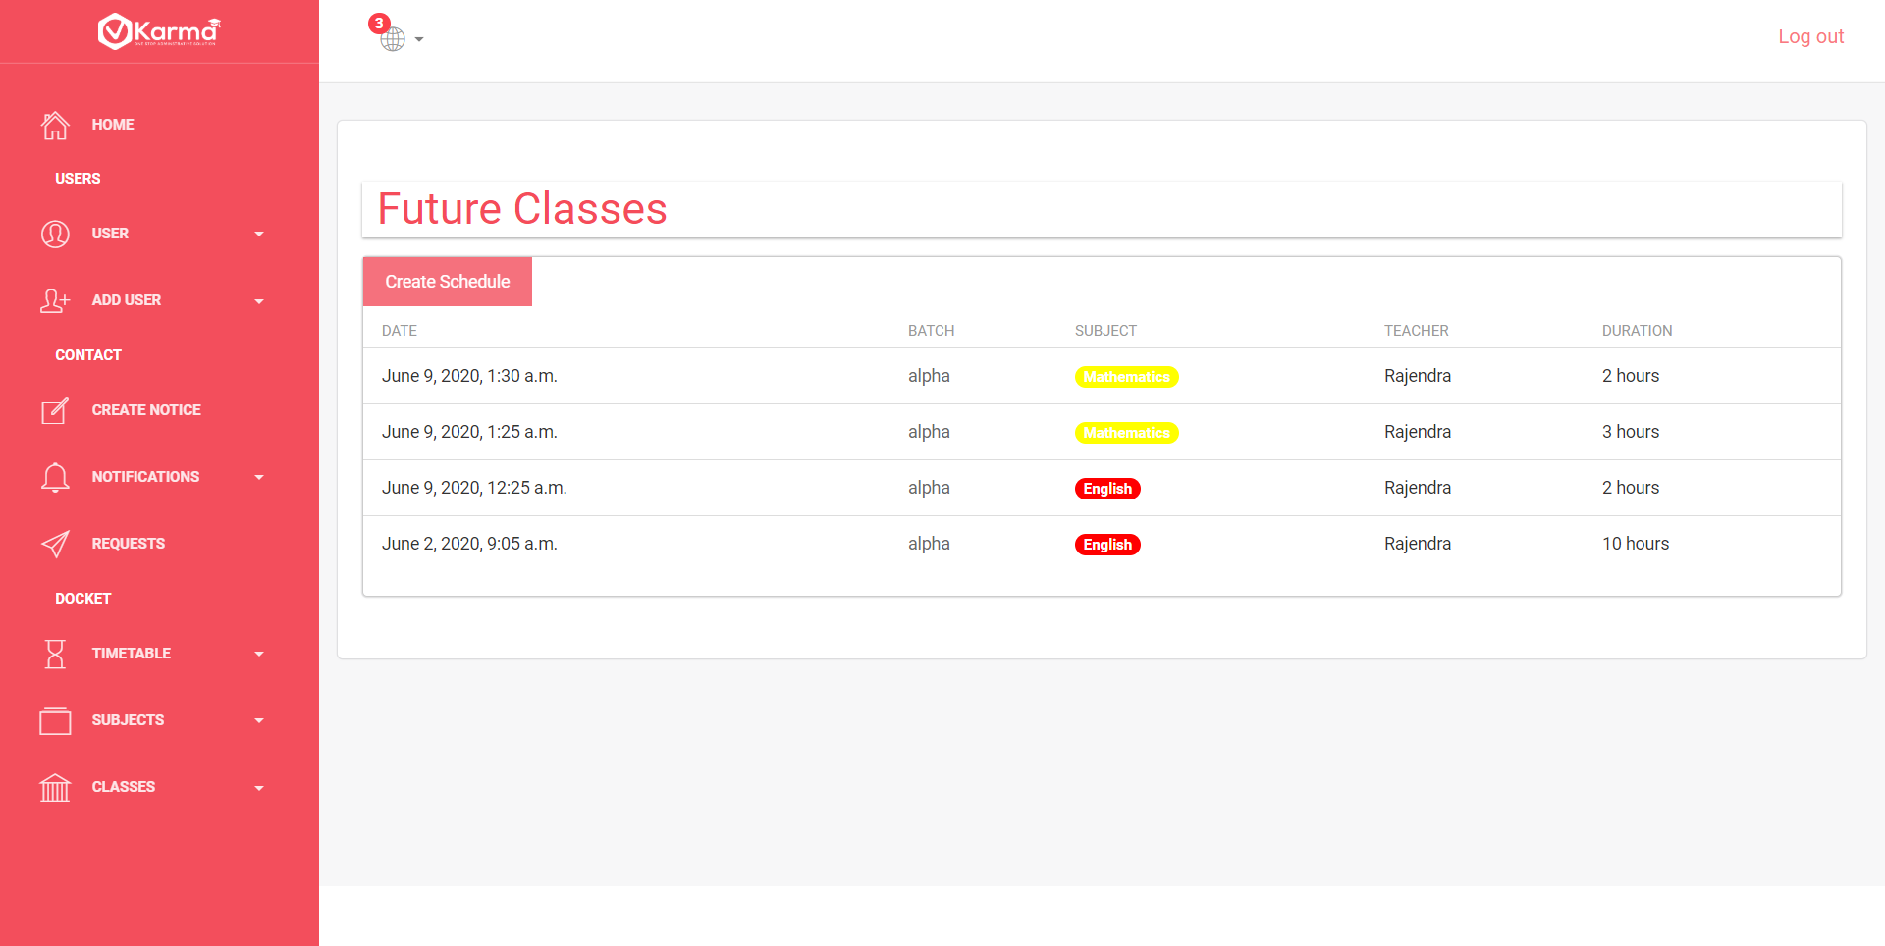

Timetable button contains two links Create Timetable to create a new schedule for any batch

View Timetable which contains a button to create schedule and lists all the schedules for all batches

1. **Subjects**

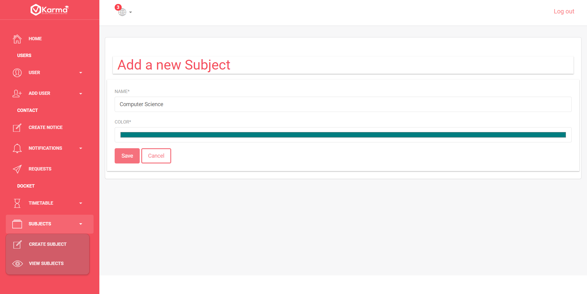

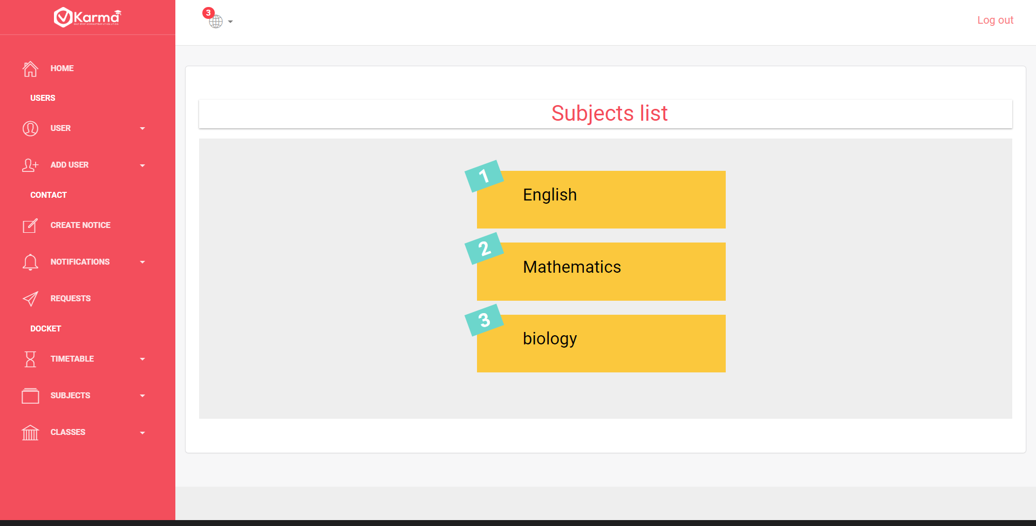

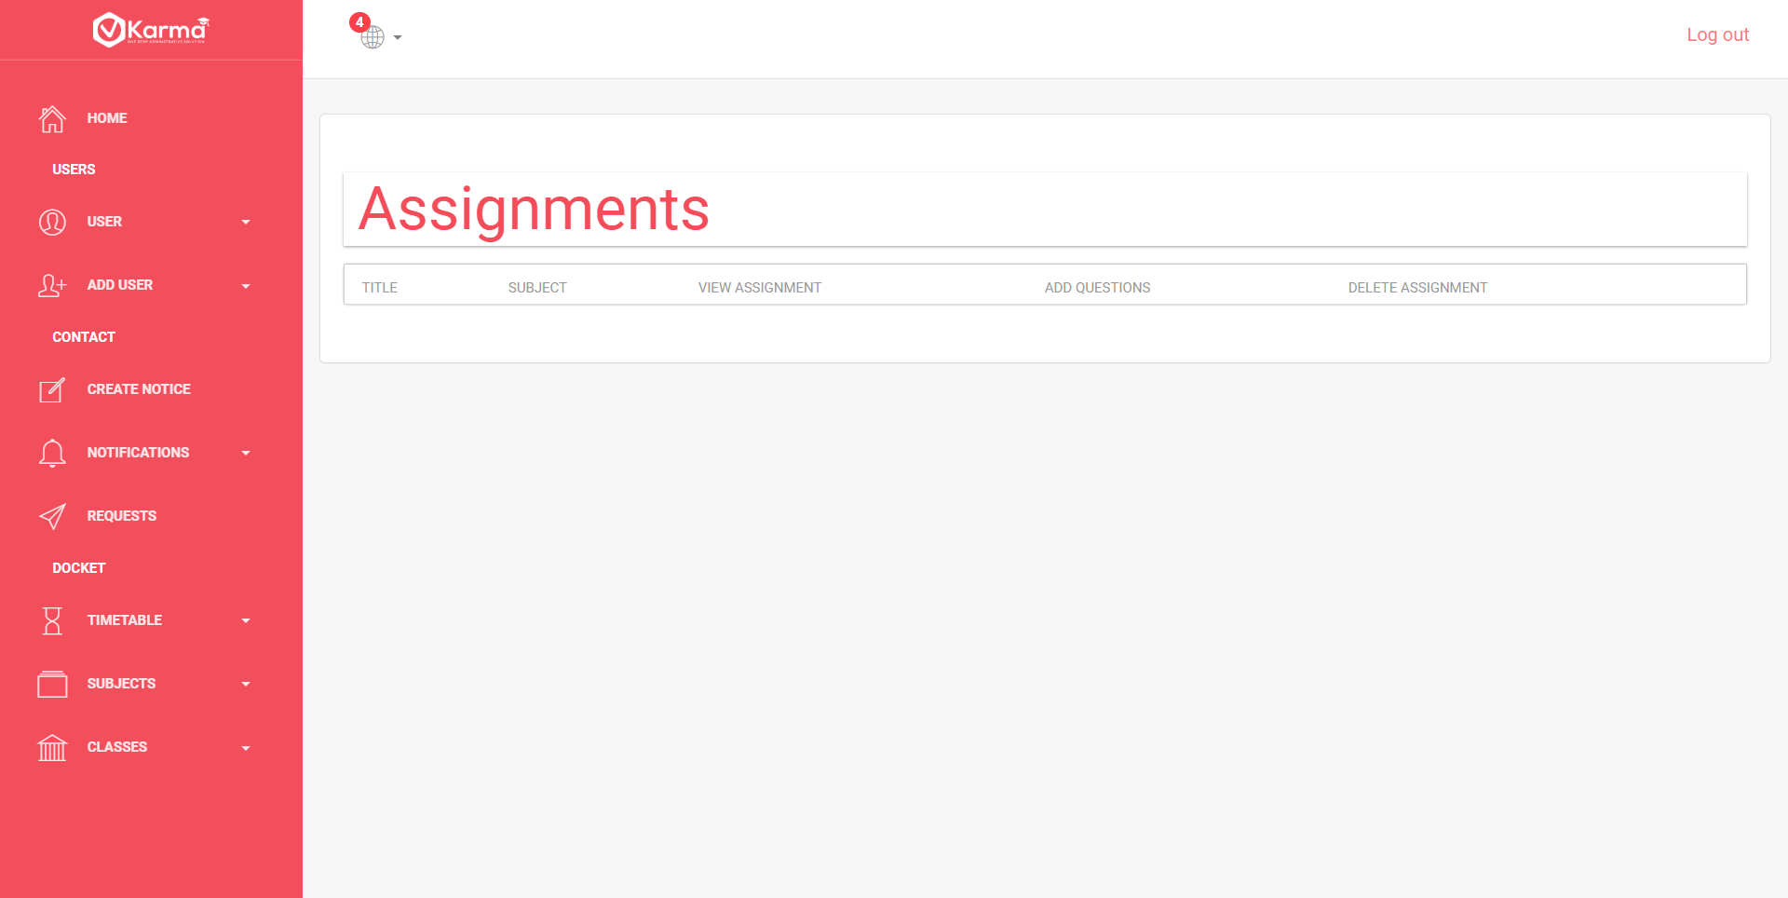

Subject button contains a dropdown with two links Create Subject and View Subject

Admin can create new subjects from create subject link and view all the subjects using view subjects link and can see all assignments for any particular subject by clicking on it

1. **Classes**

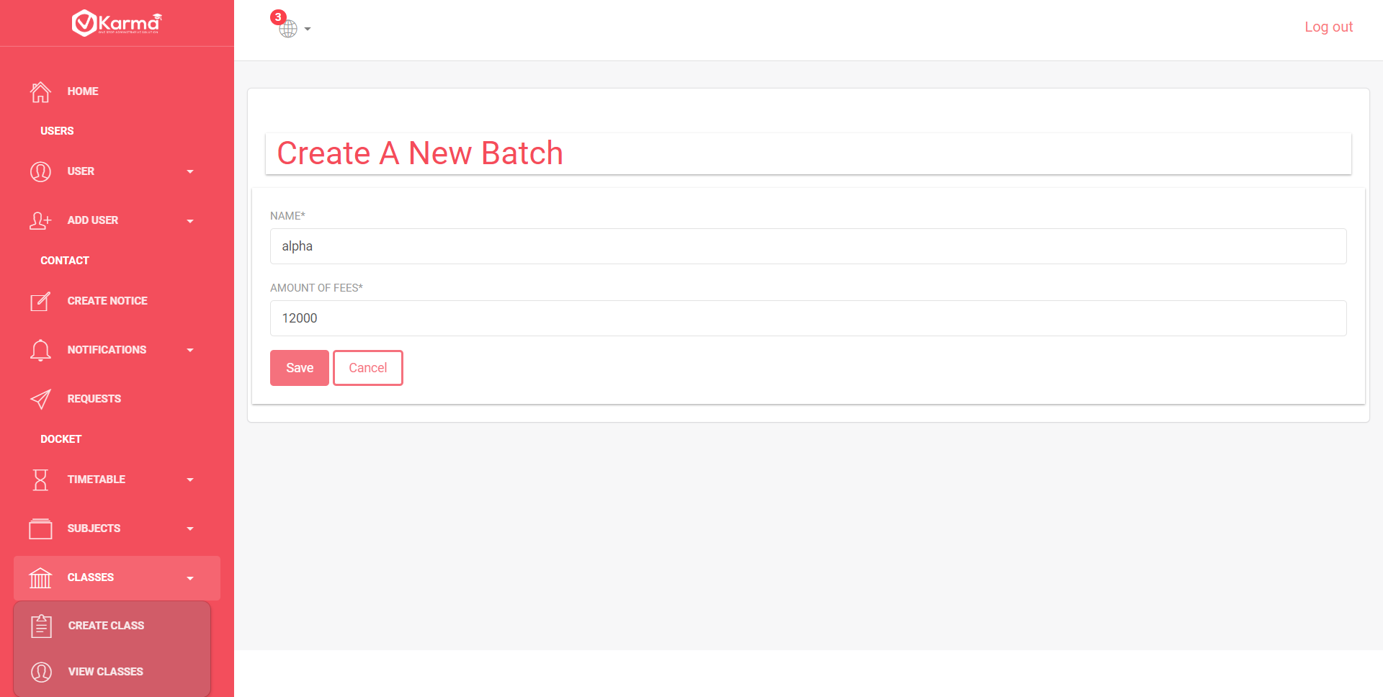

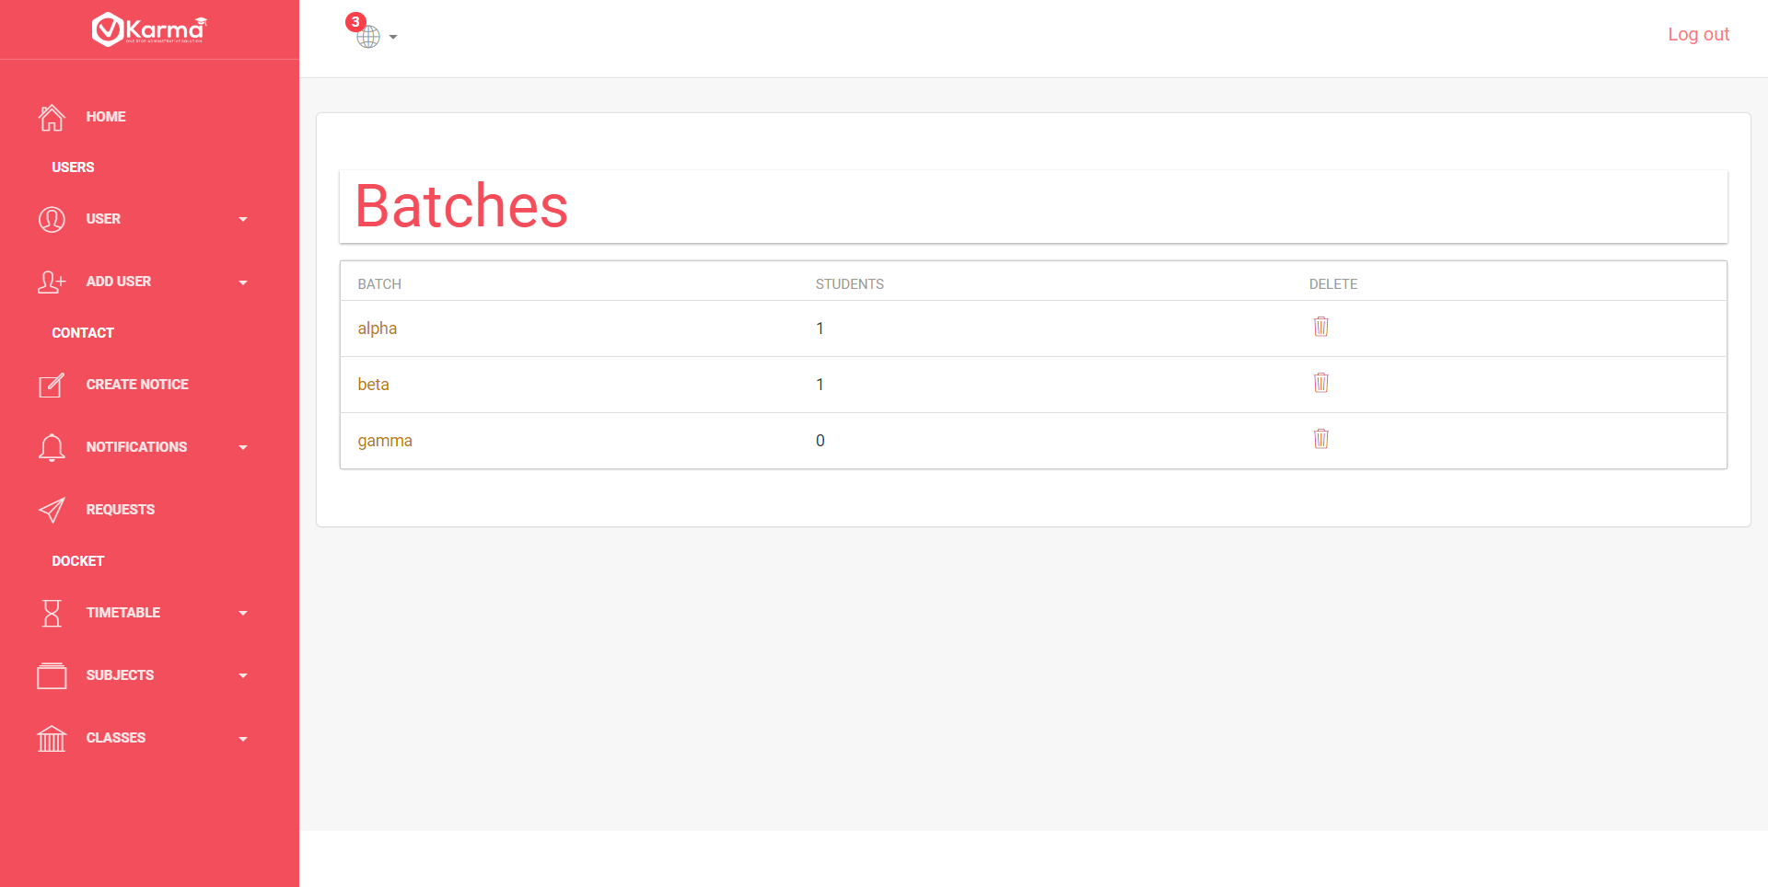

Classes button contains dropdown with two links create class to create a new batch and view class to view all the batches

**STUDENT**

**Side Panel and Nav Bar**

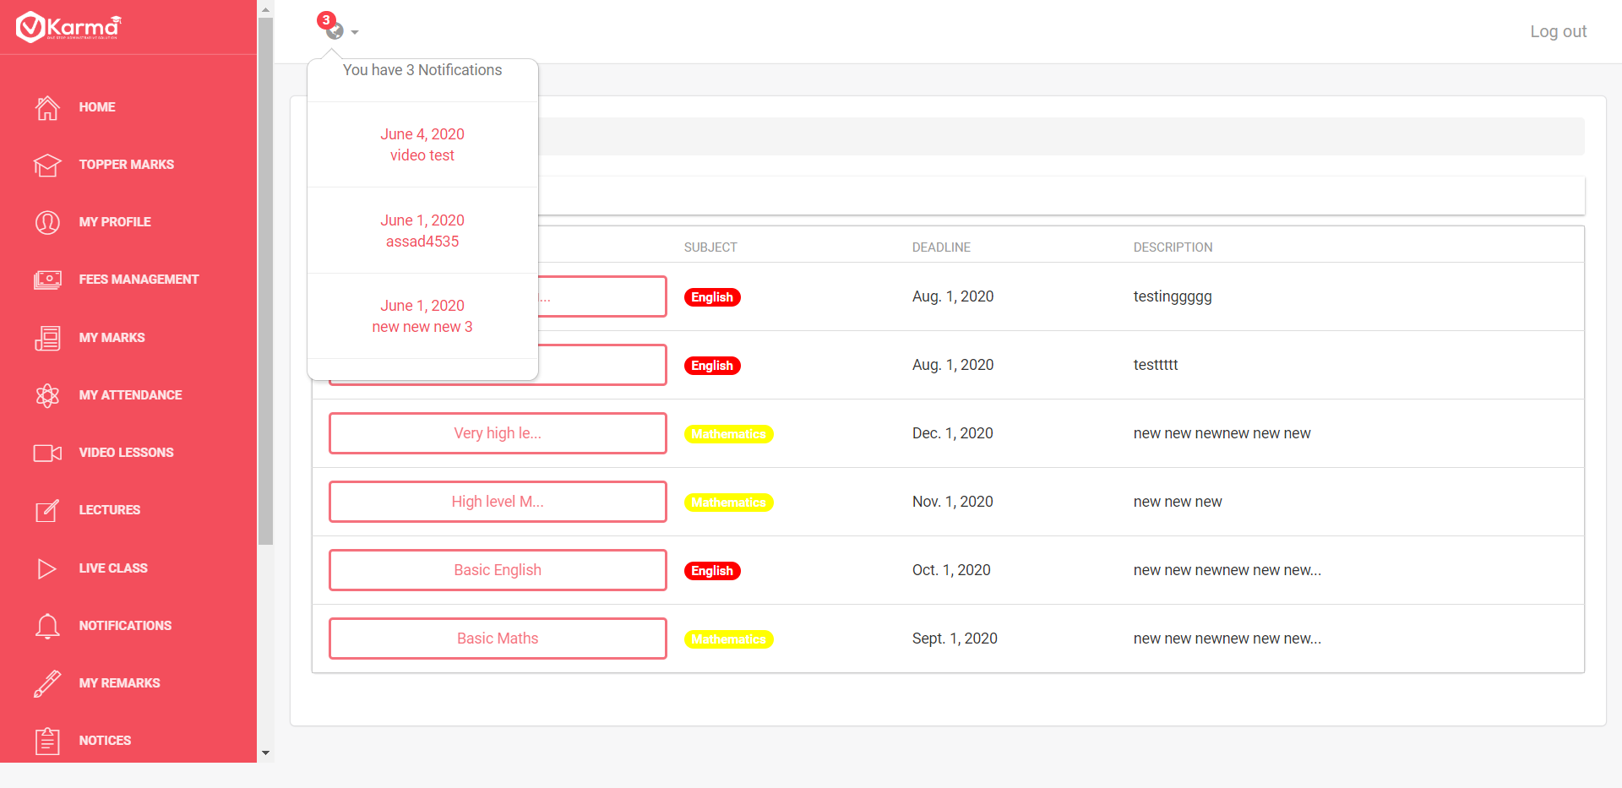

Navbar contains notification icon which displays notification count and recent 5 notifications in a dropdown and a logout button

Side panel contains link to all other pages

1. **Home**

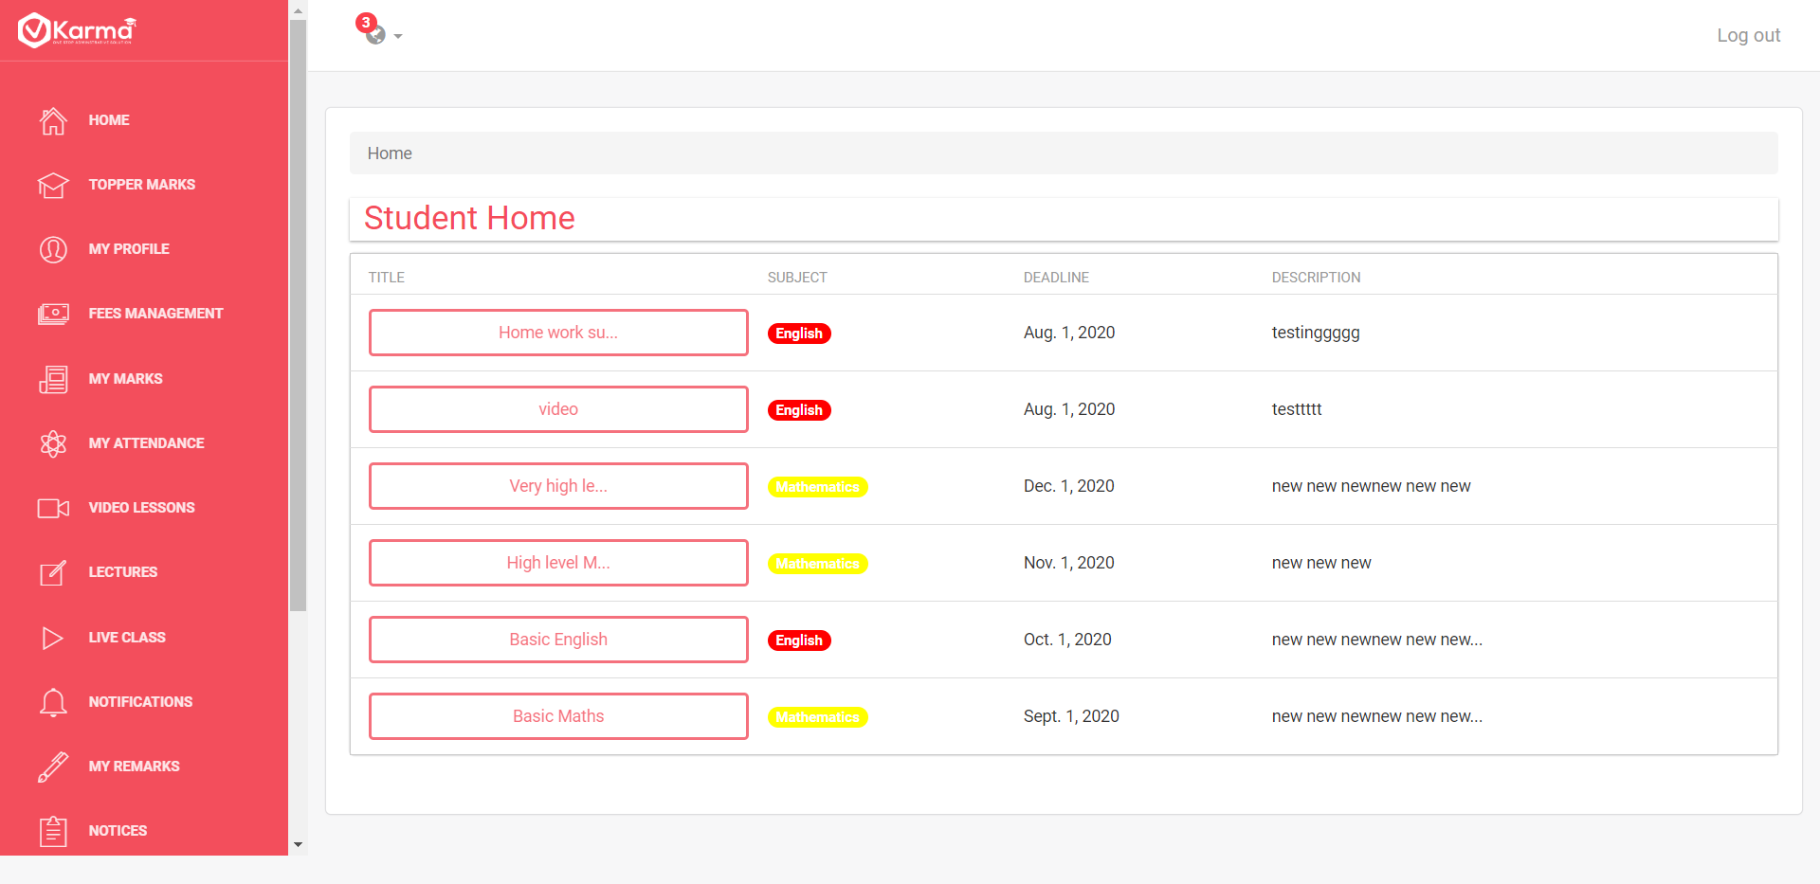

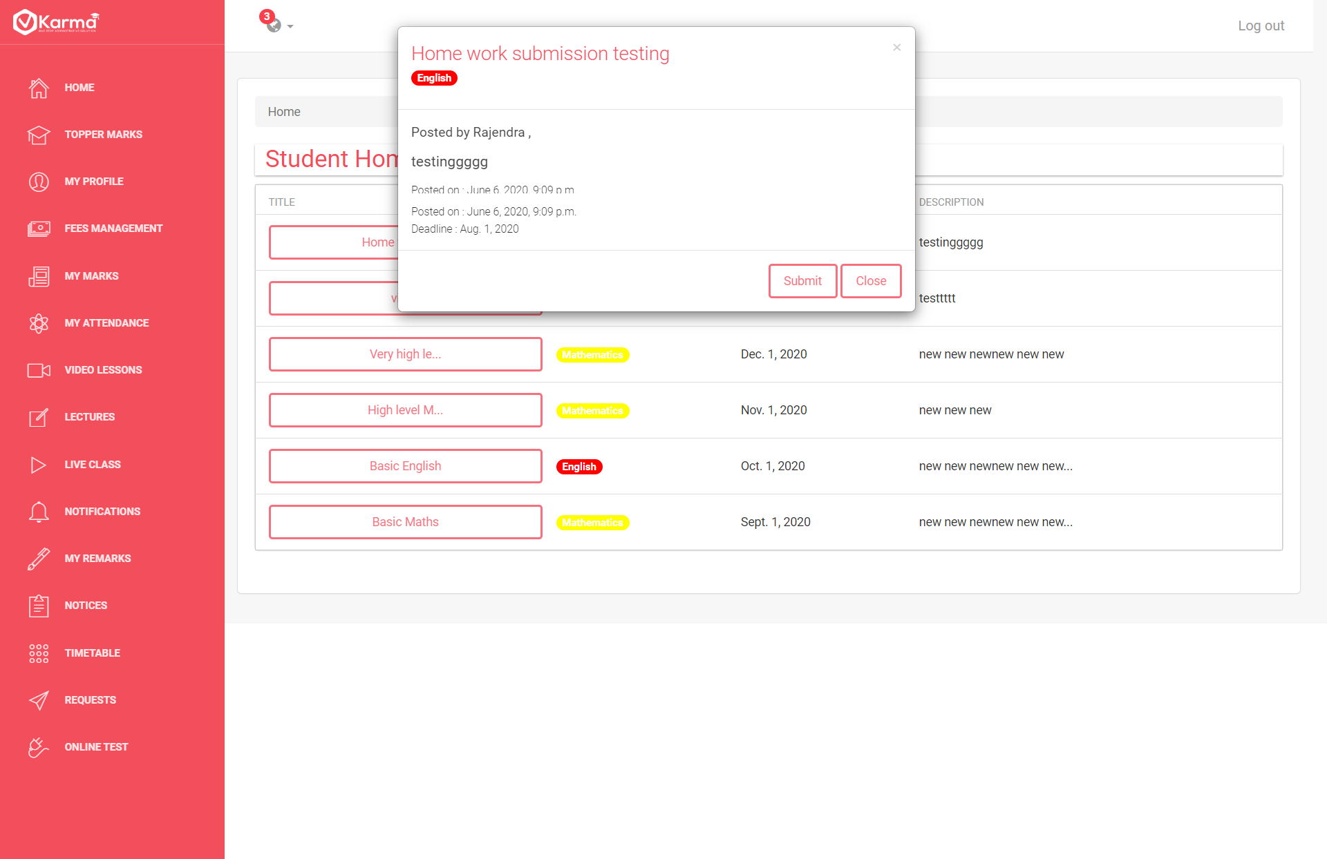

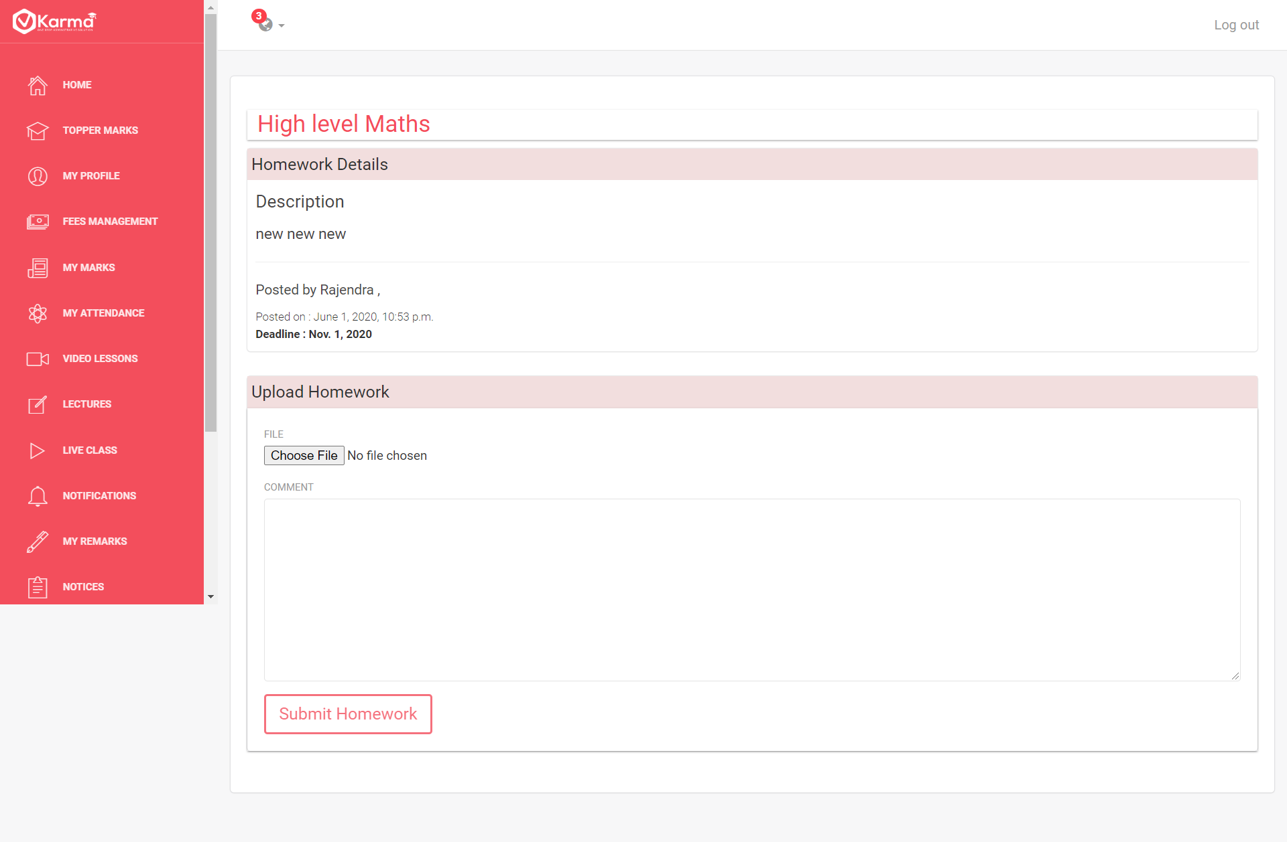 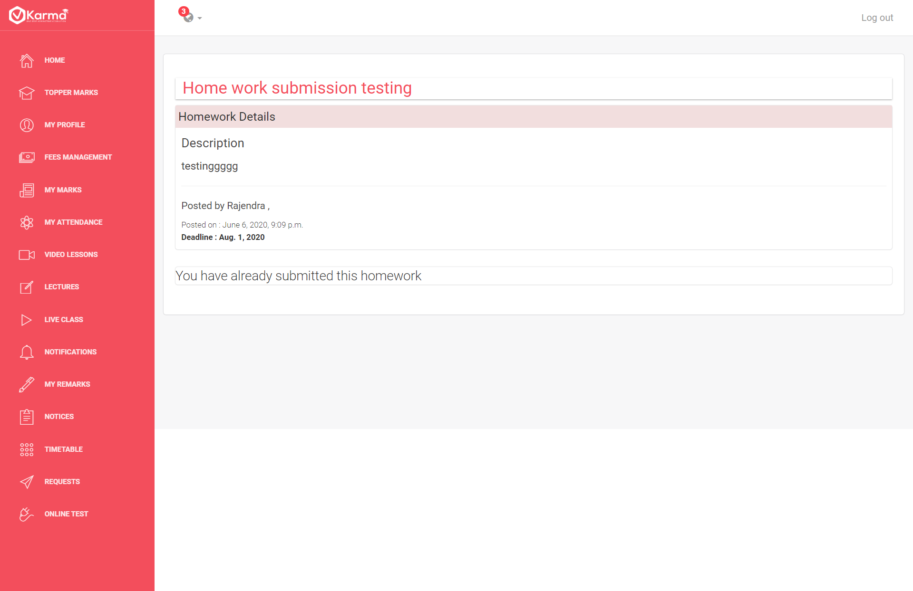

Student Home page contains a list of all assignments given by the teacher.

Further information can be viewed by clicking on title and homework can be submitted through submission page accessed by clicking on submit button

If homework is submitted then student can view his submission

1. **Topper Marks**

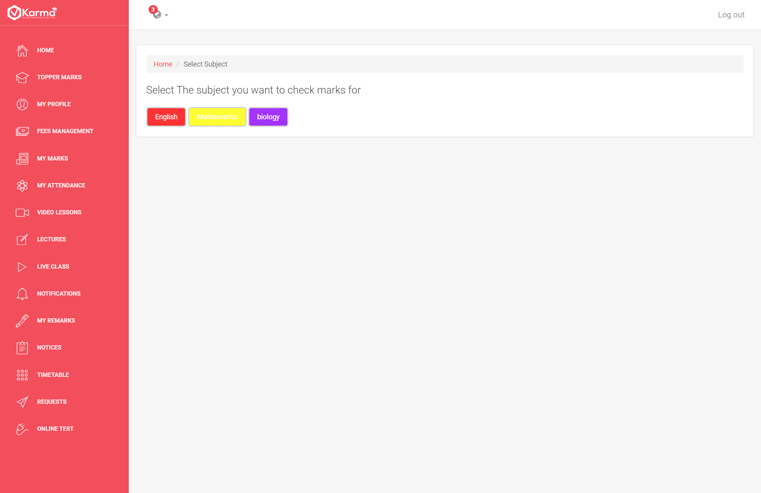

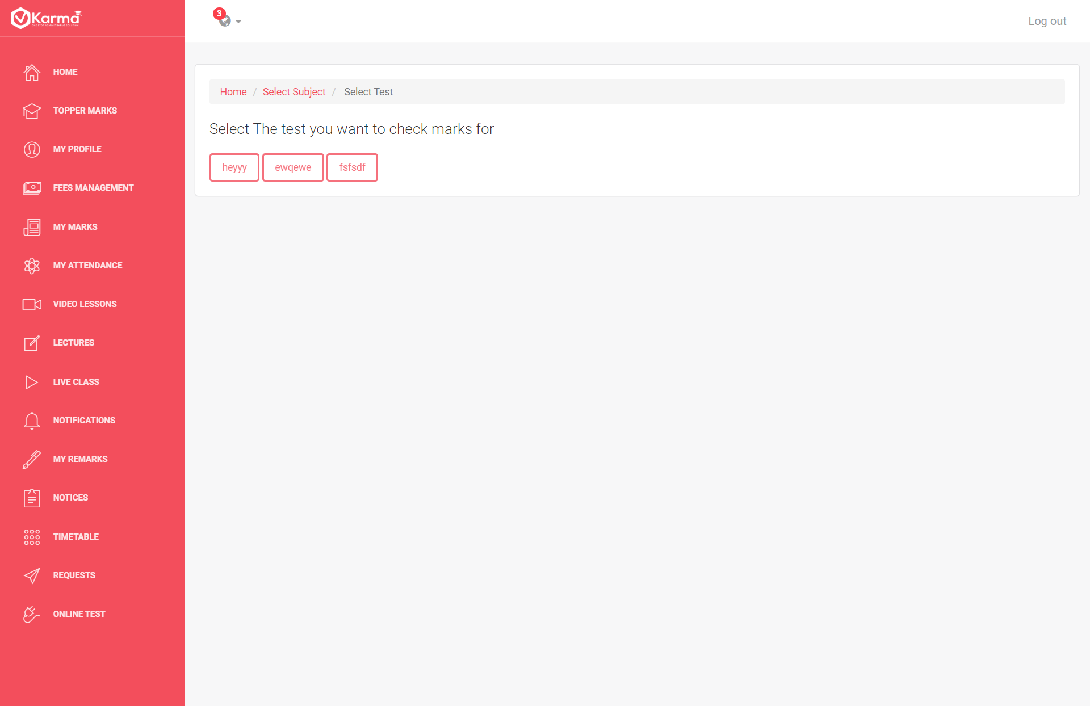

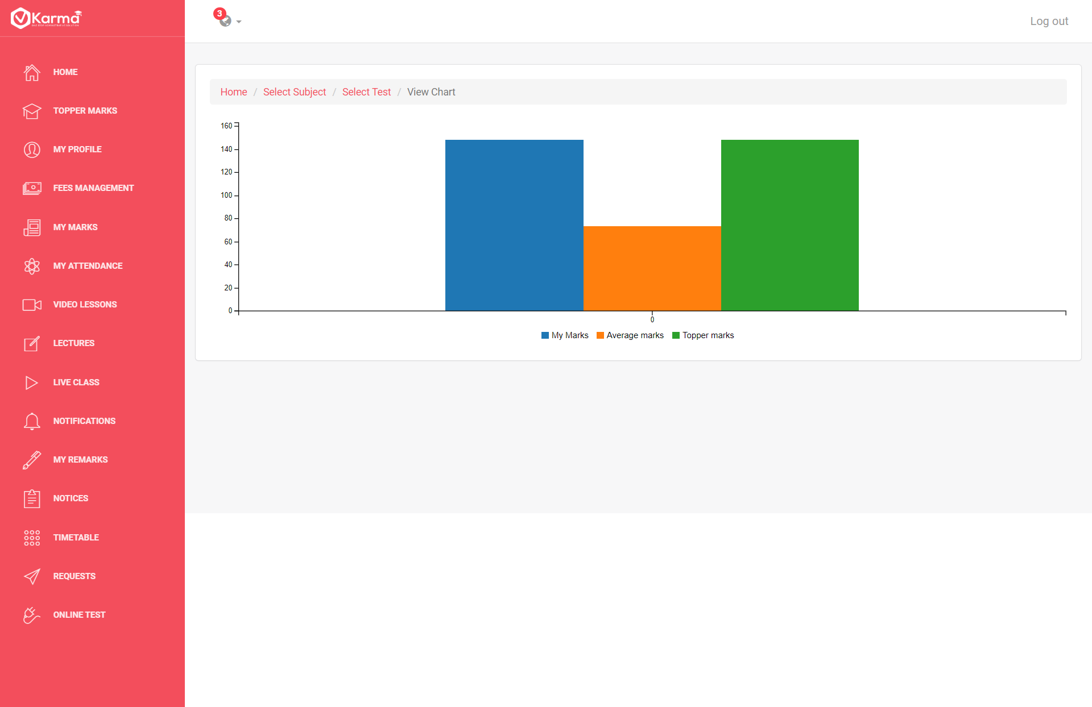

Student can navigate to compare his marks in any test on any subject with class topper and average scores all the information is shown in form of bar graphs

1. **My Profile**

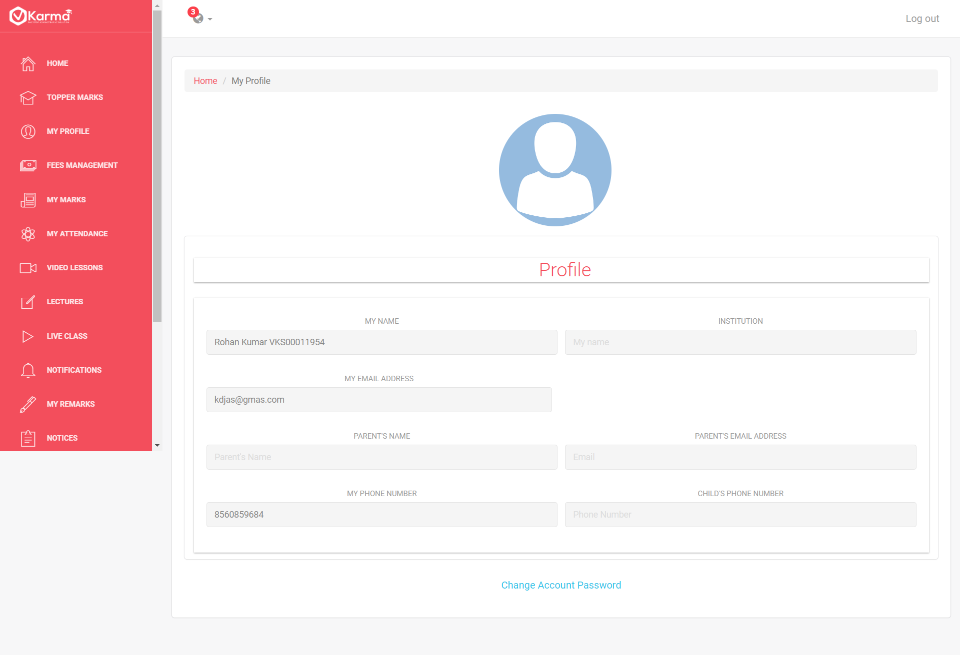

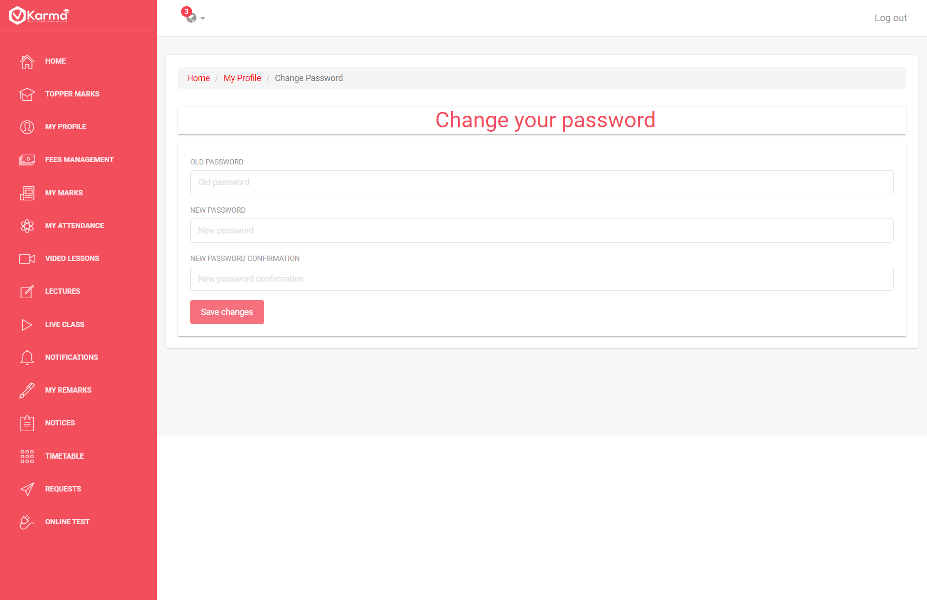

Student can view his profile details and can go to Change Password page to change his current password

1. **Fee Management**

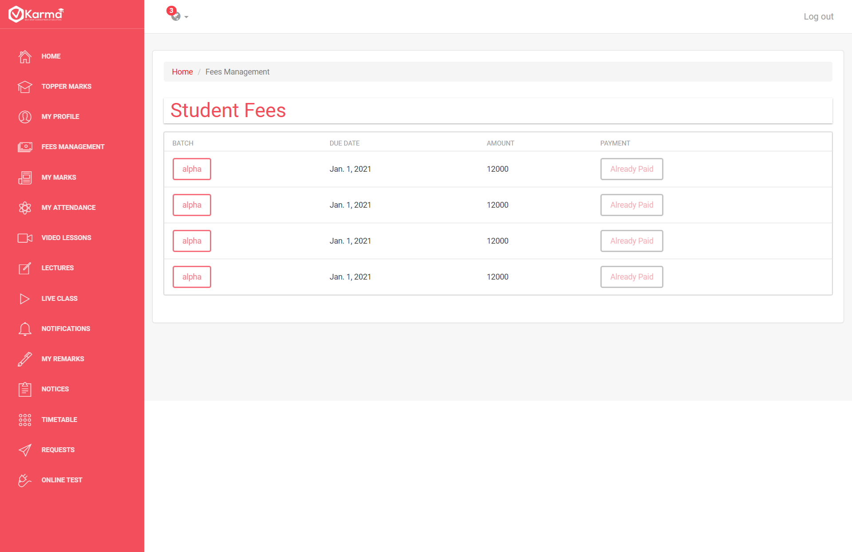

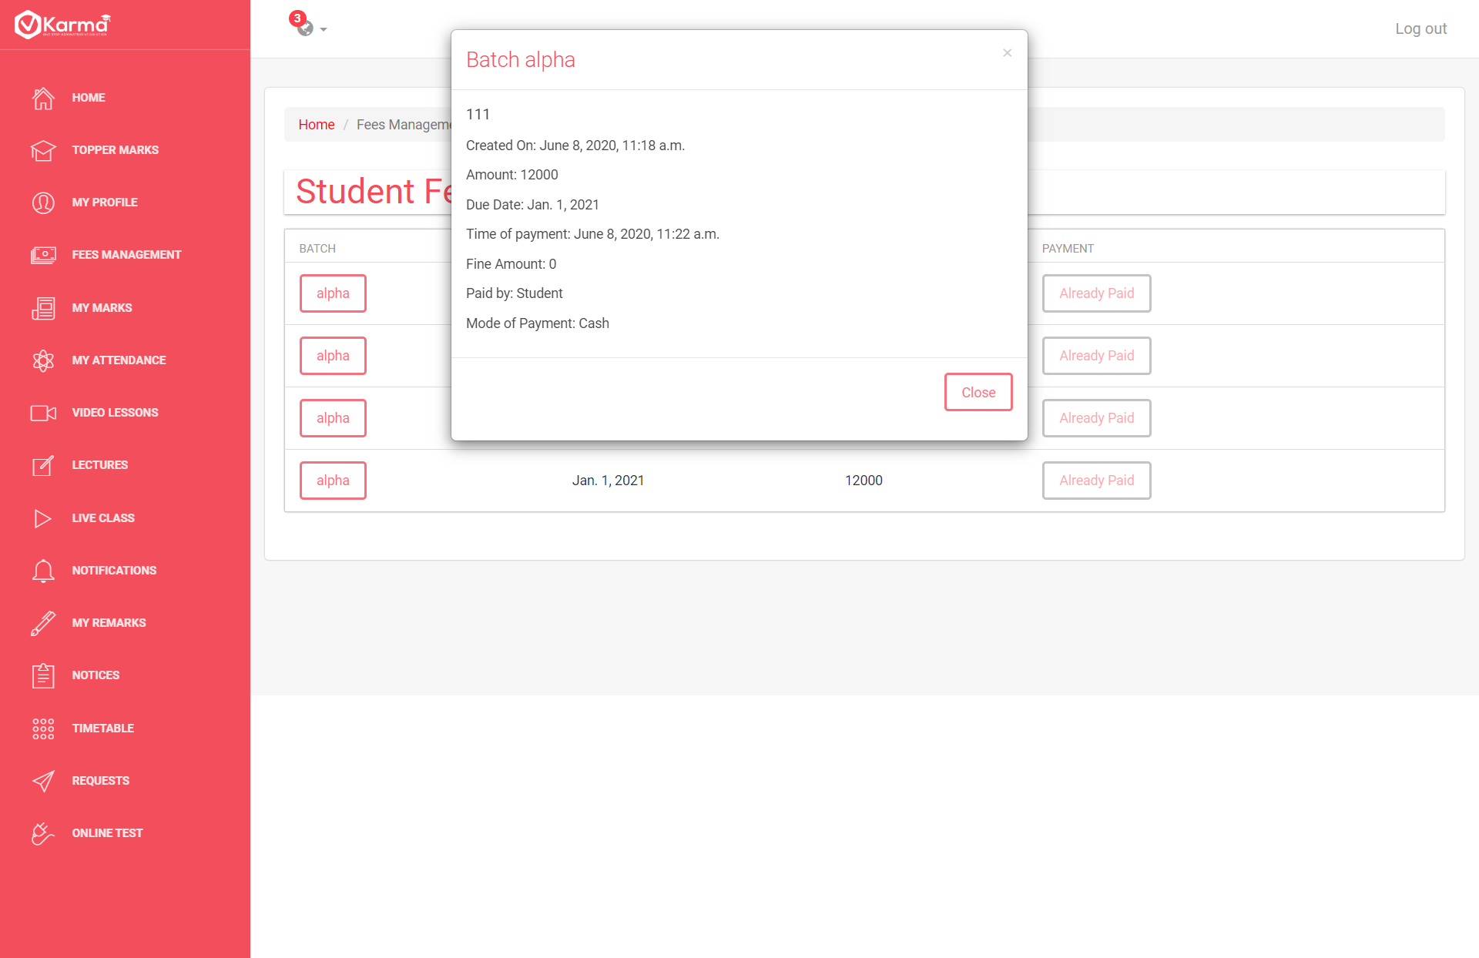

Student can view all the payments created by admin and check whether they are paid or not and can check details

If they are not paid he can pay them

1. **My Marks**

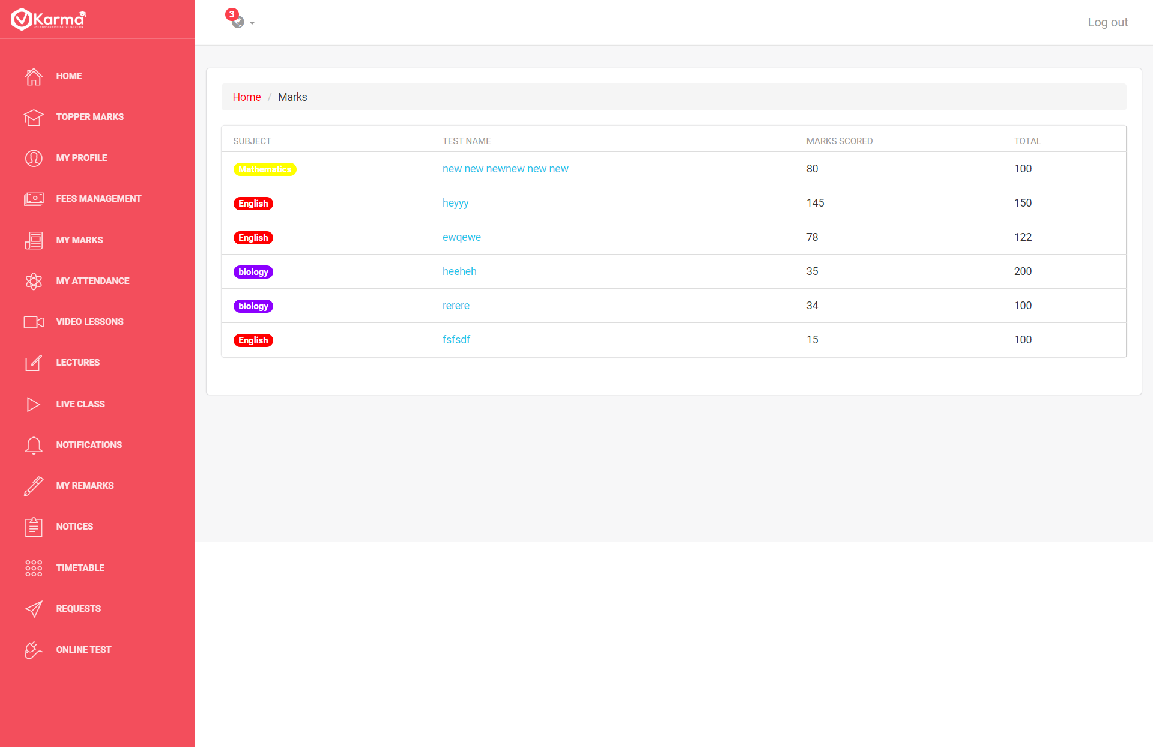

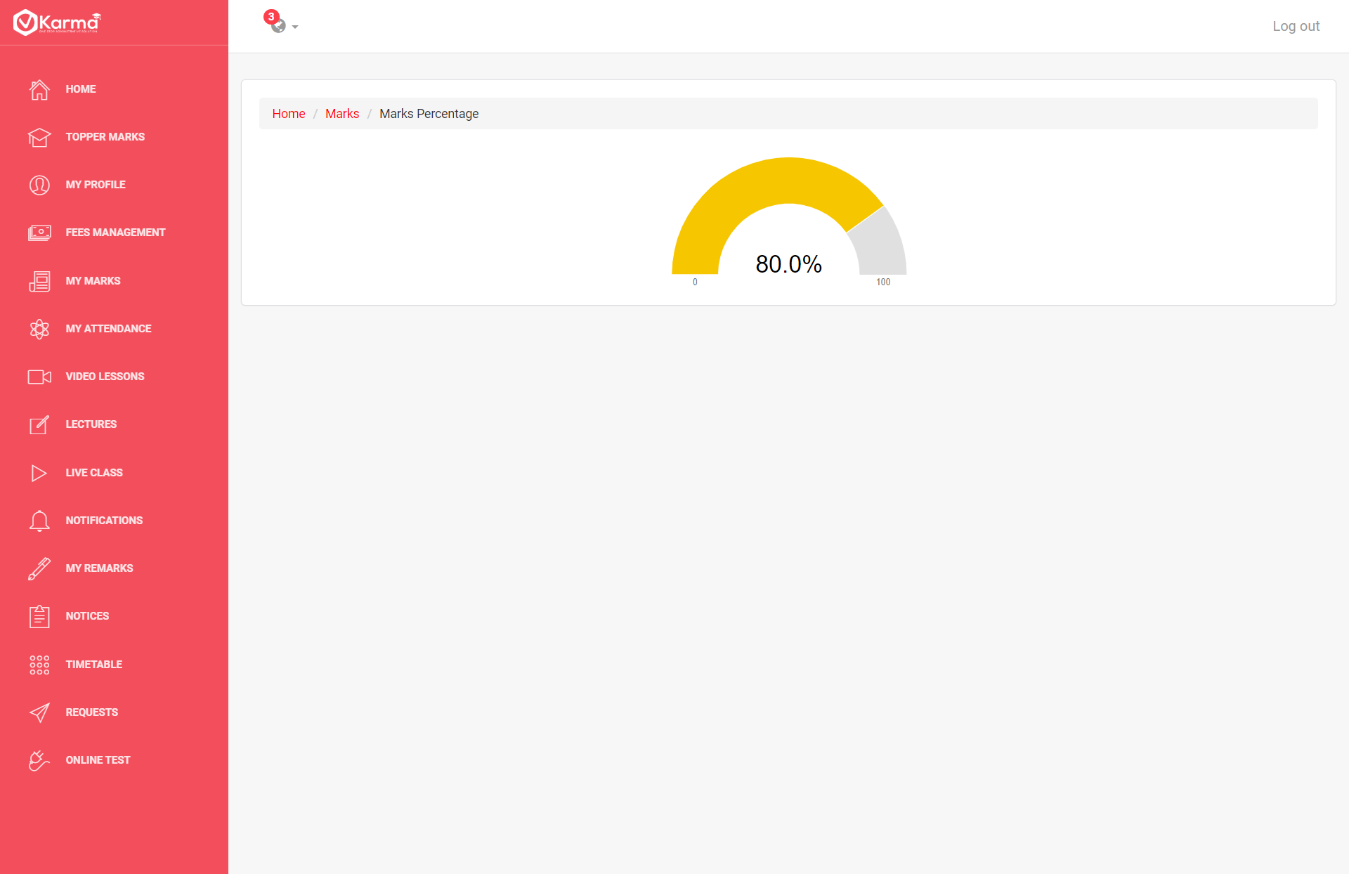

Student can view his marks in all tests and check his percentage by clicking on test name

1. **Attendance**

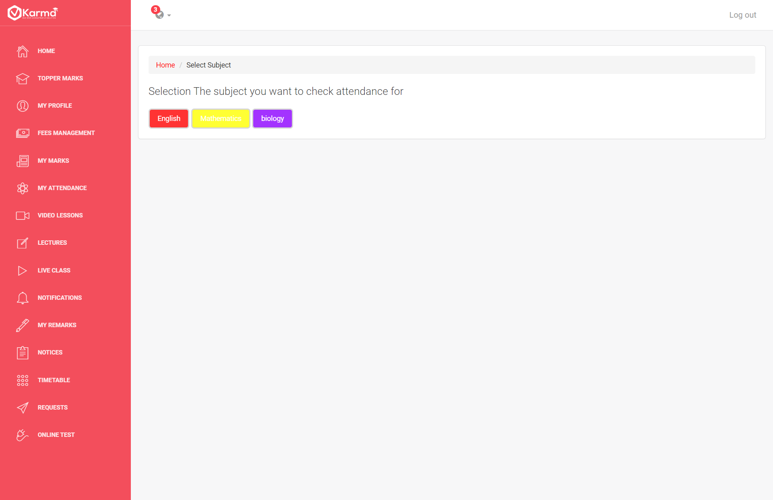

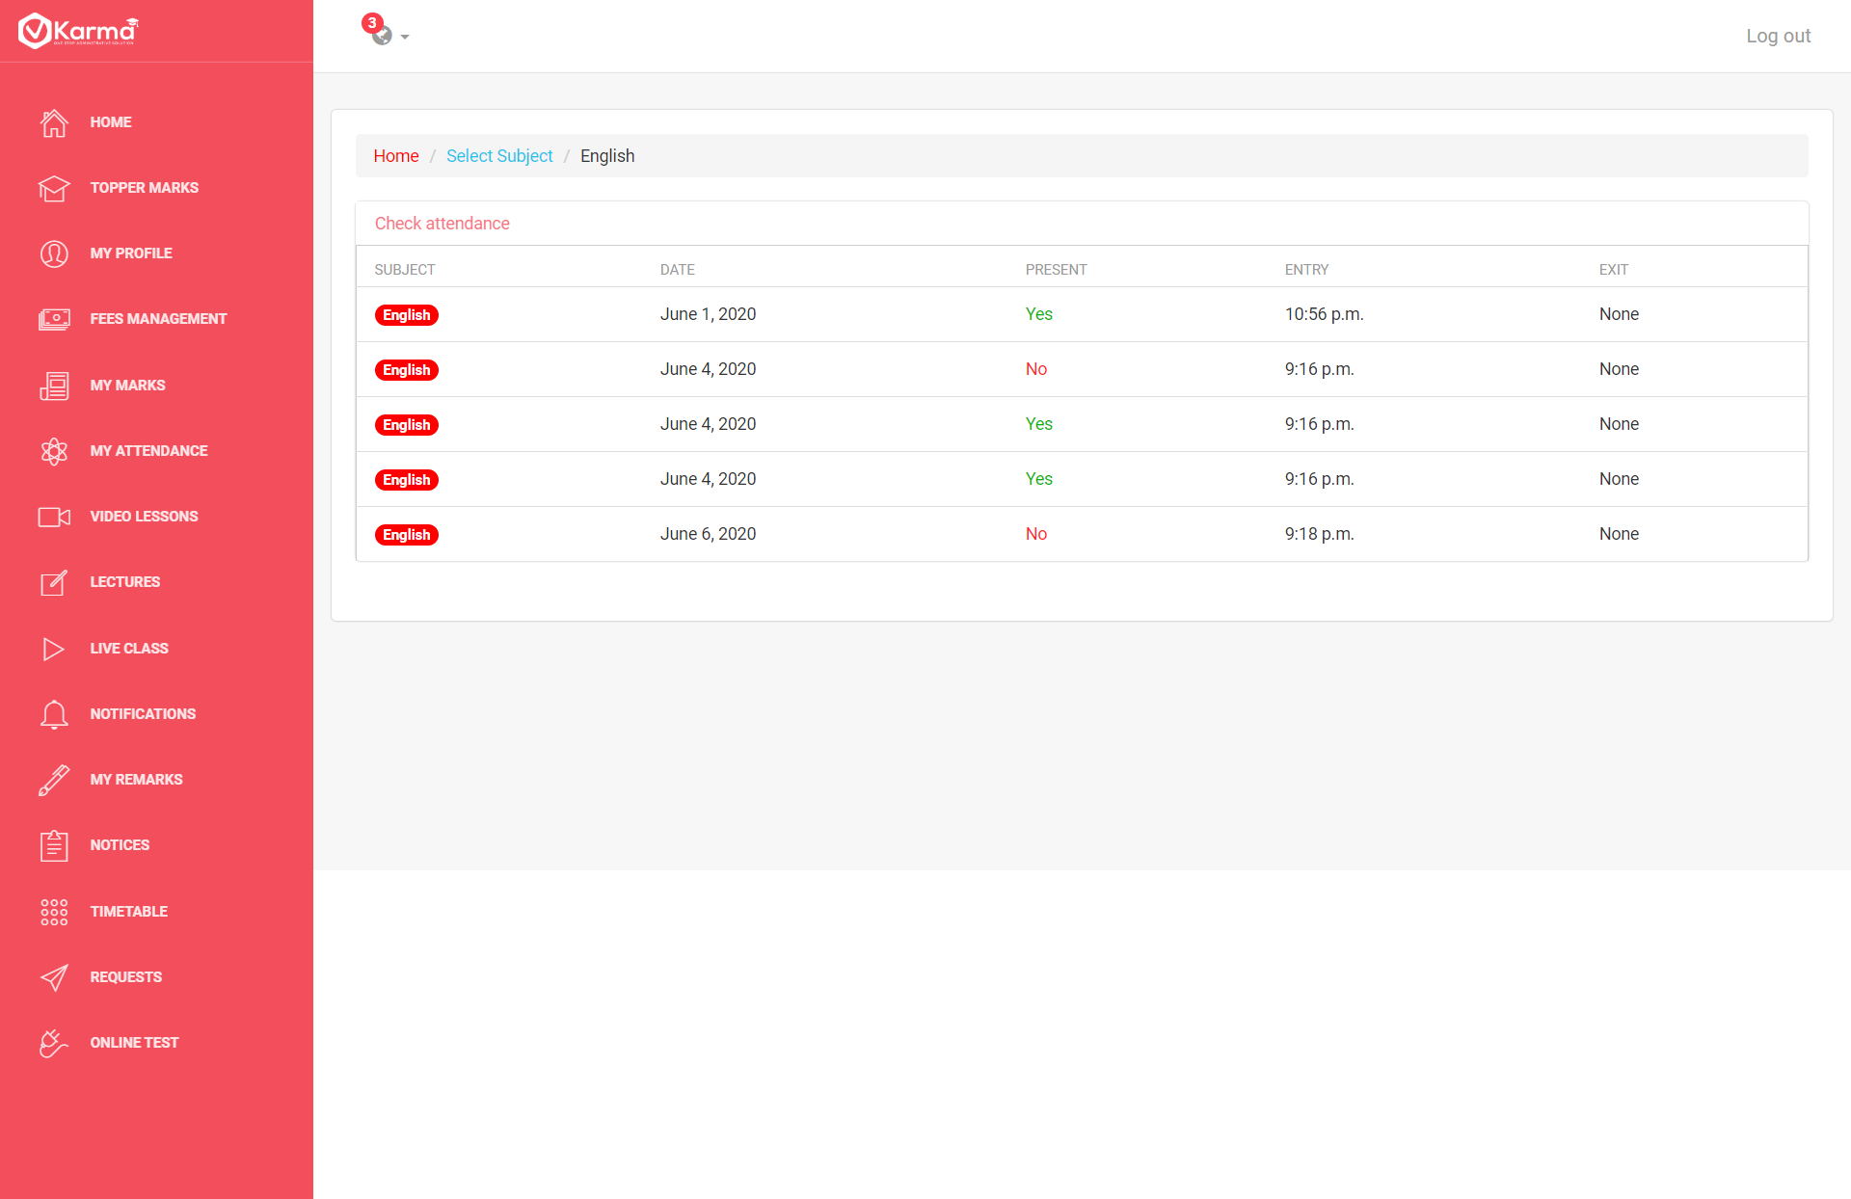

Students can view their attendance for each subject for each class held by respective teacher

1. **Video Lessons**

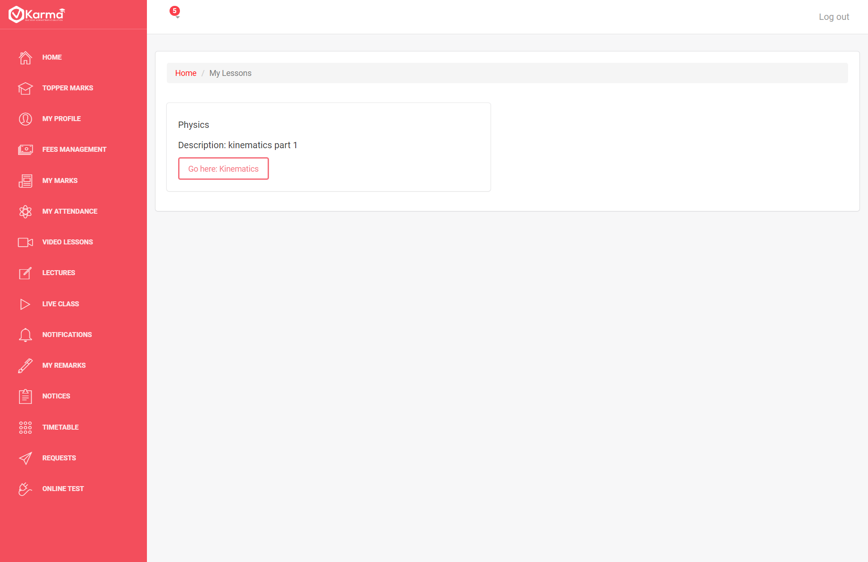

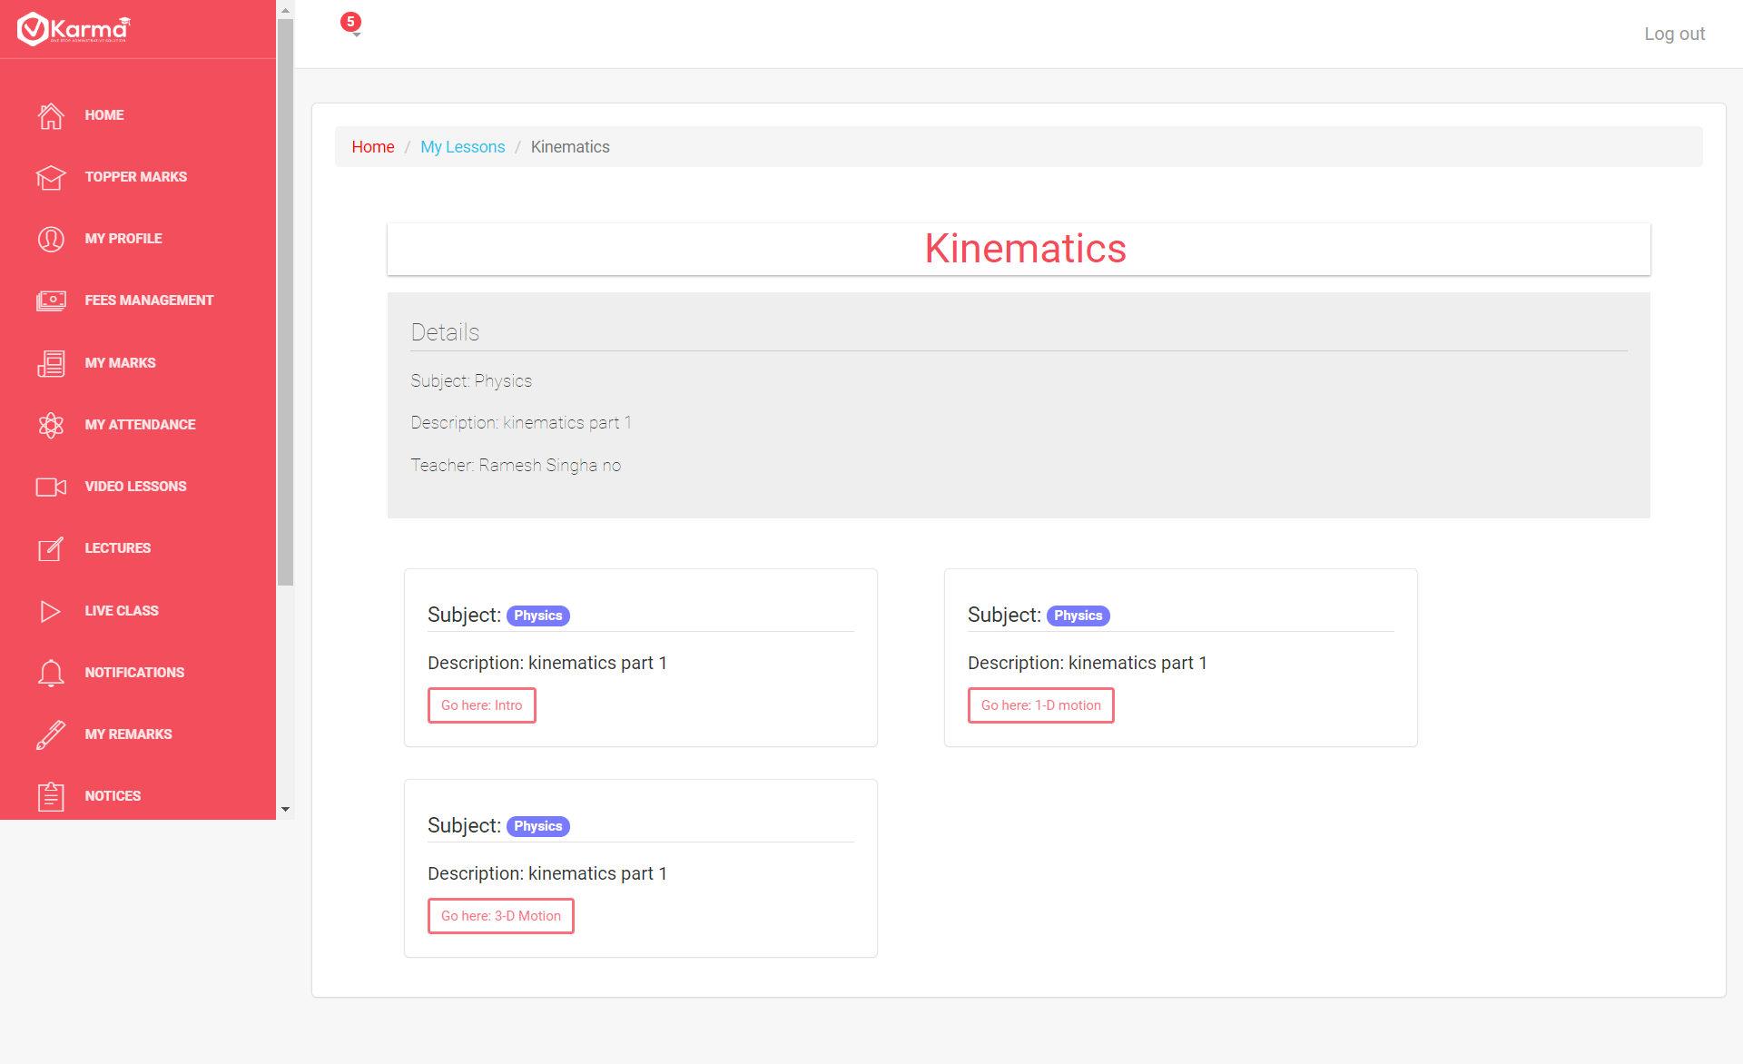

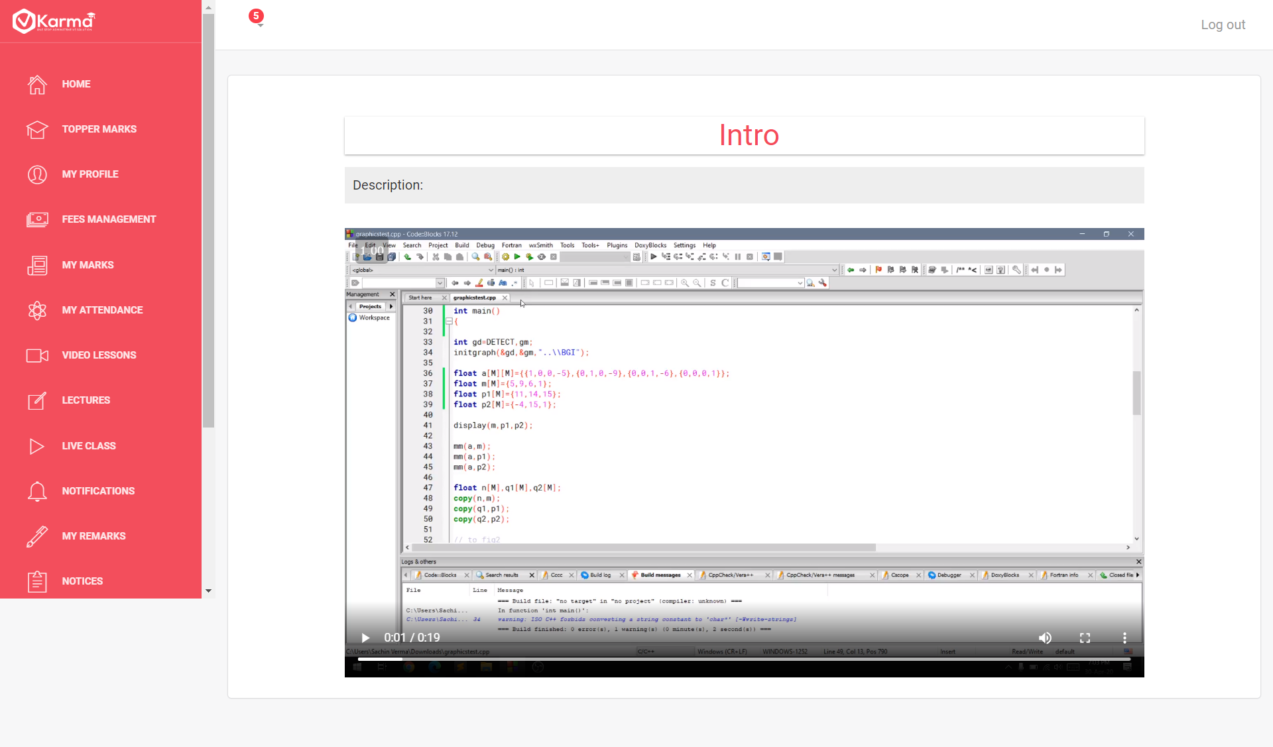

Students can view all the video lectures provided by their teachers

By selecting any video lectures title he can go to respective lecture and can watch the video

1. **Lectures**

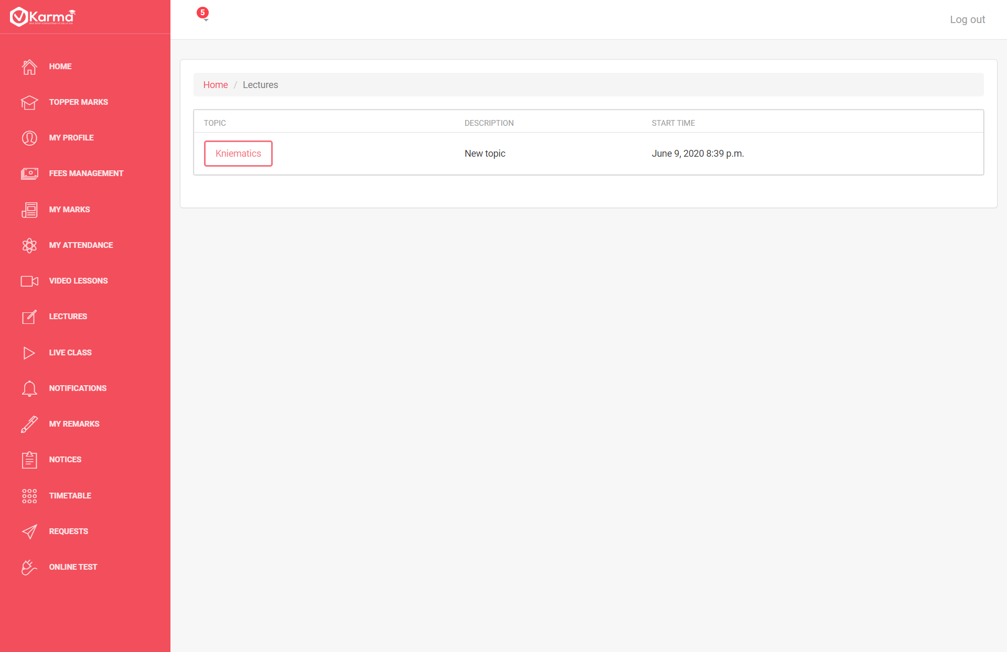

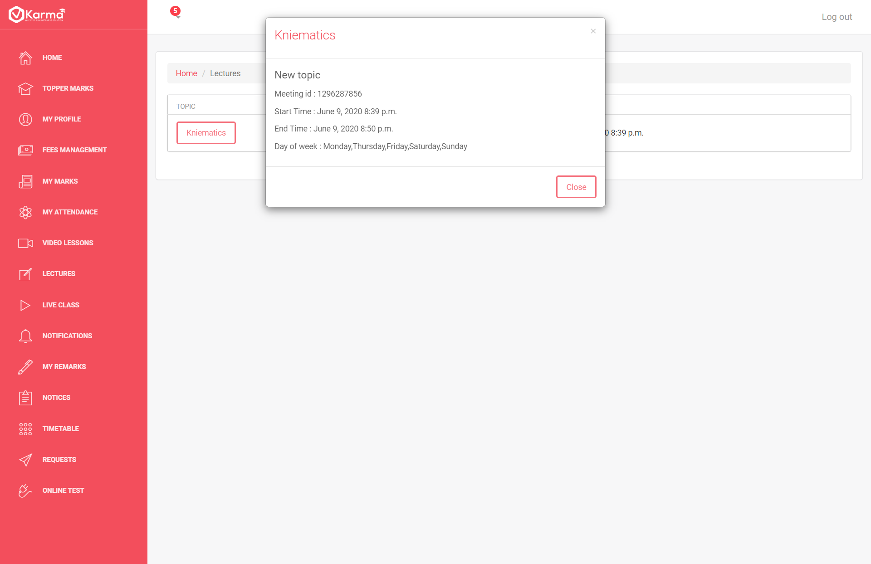

Students can view list of lectures scheduled by their teachers and check details by clicking on title

1. **Live Lectures**

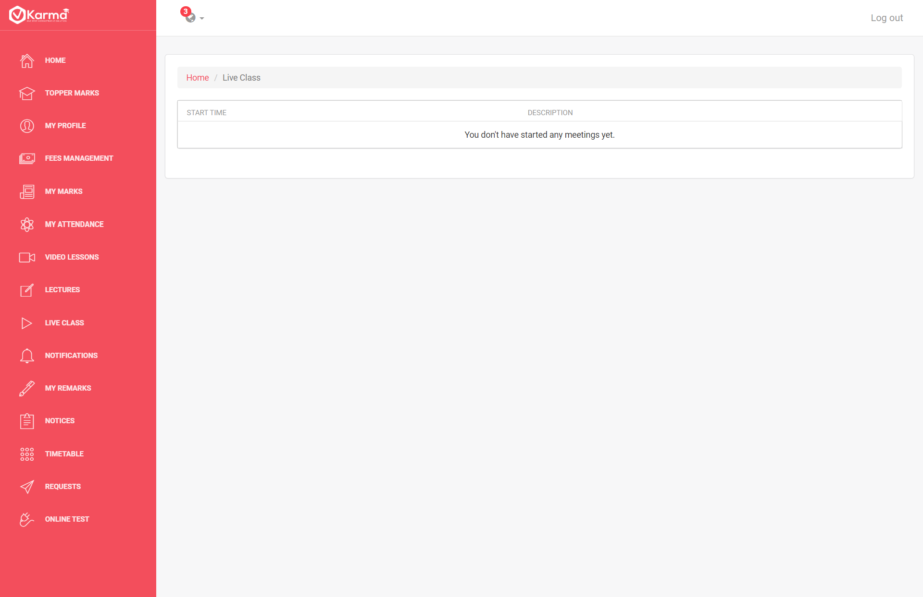

Students can view details of live lecture schedules by their teachers

**10. Notifications**

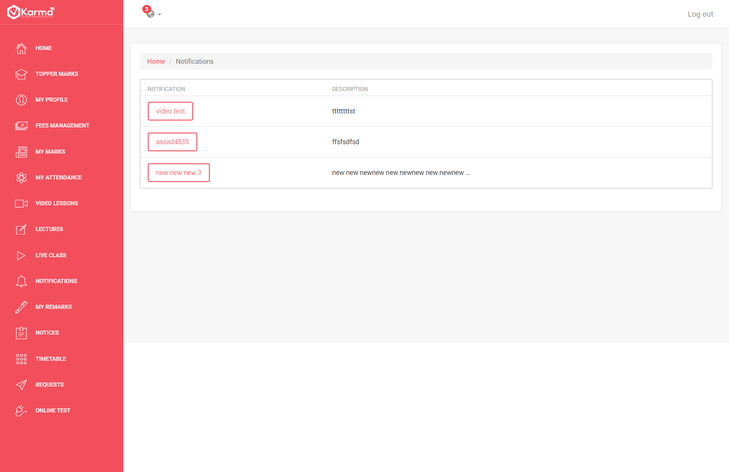

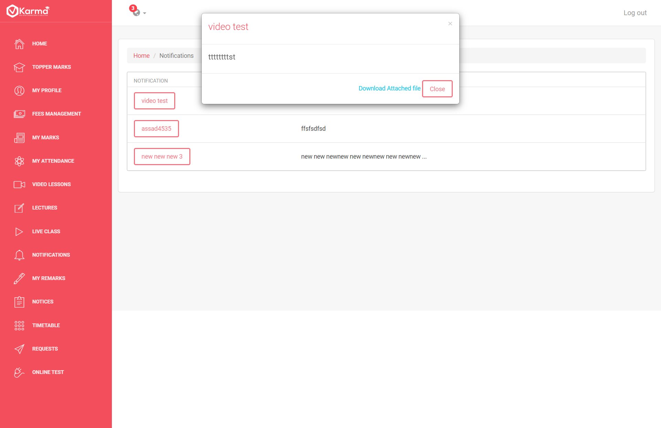

Students can view all their notifications and view all details by clicking on their title

**11.Remarks**

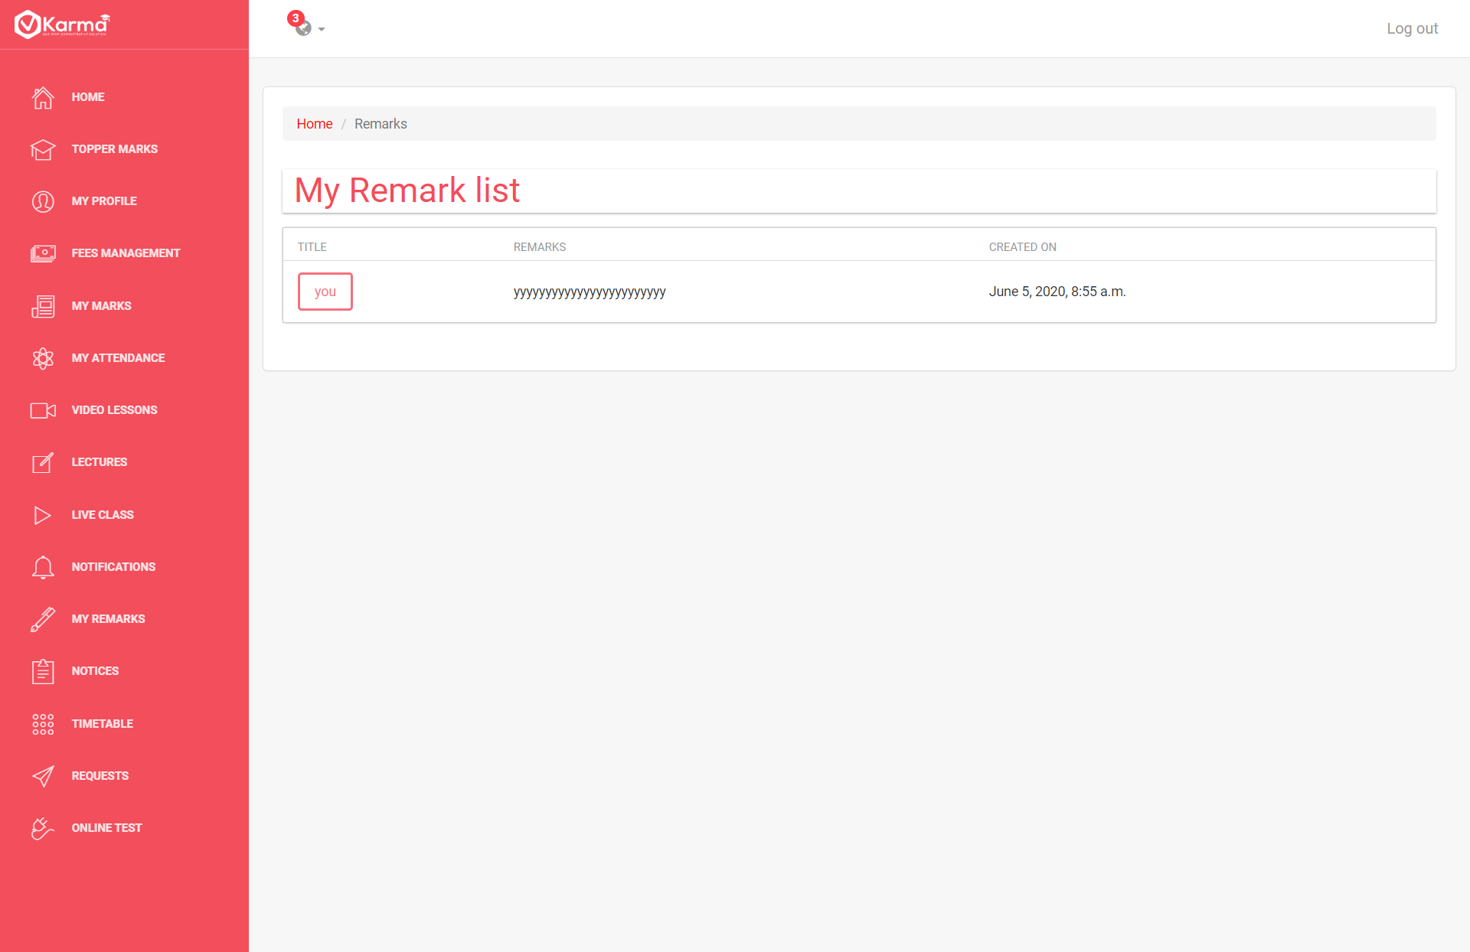

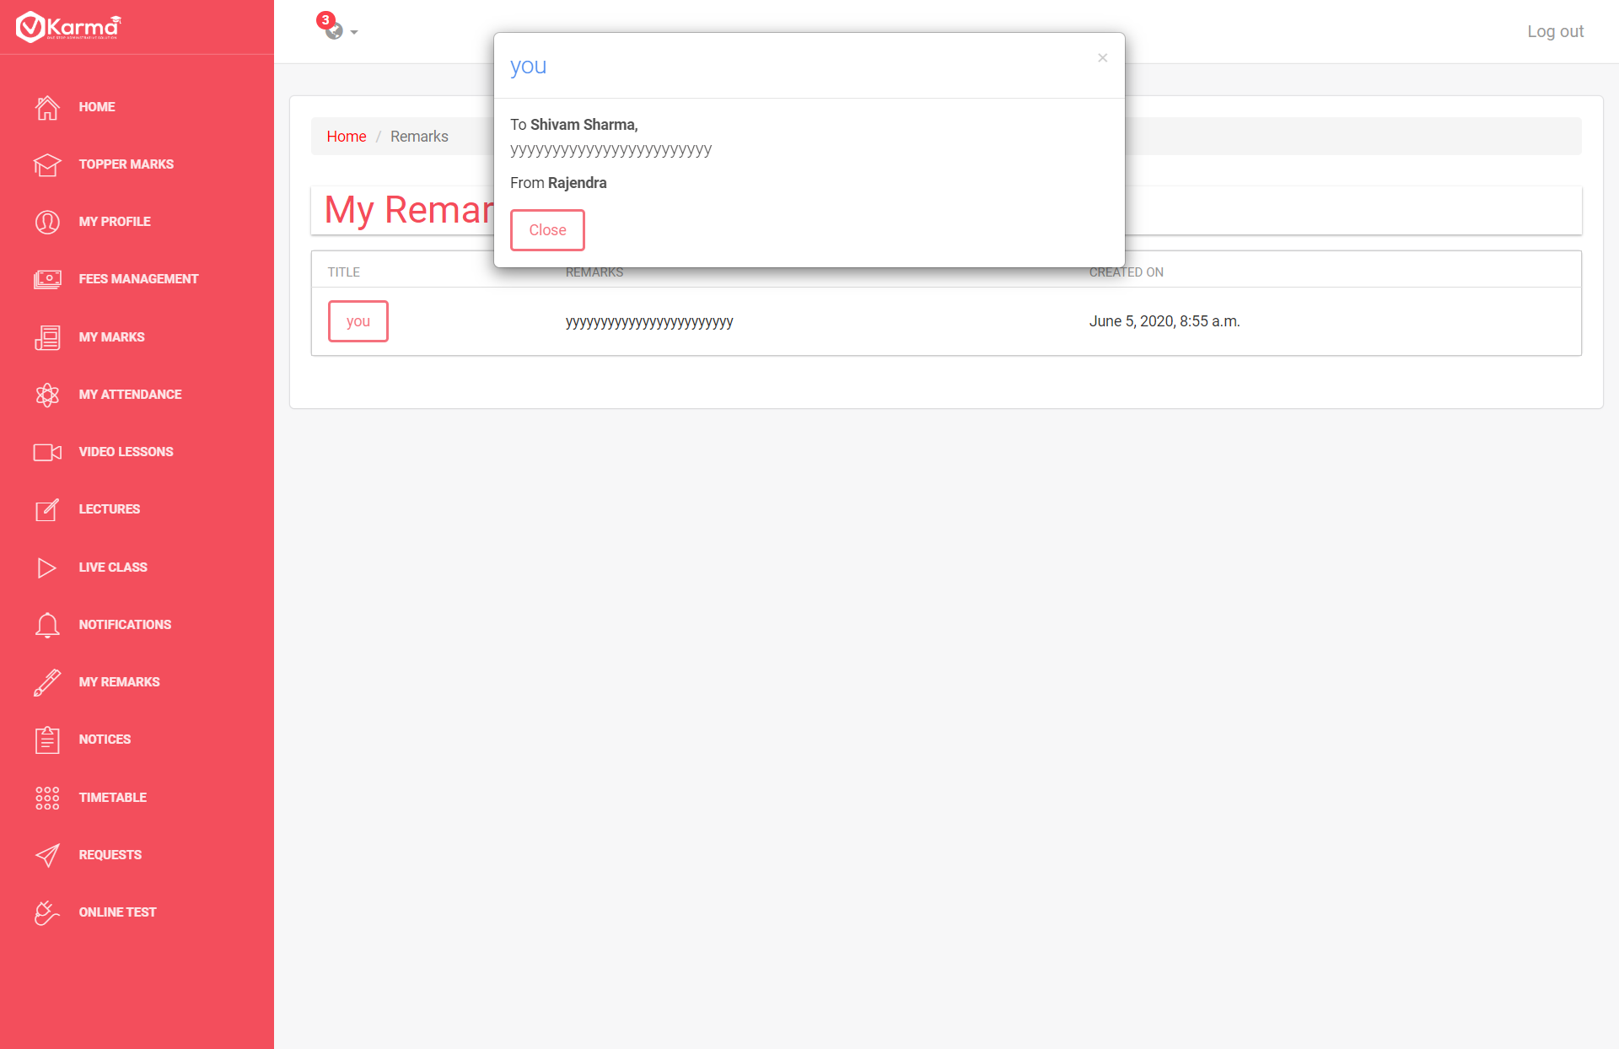

Students can view all the remarks given by his teachers

**12. Notice**

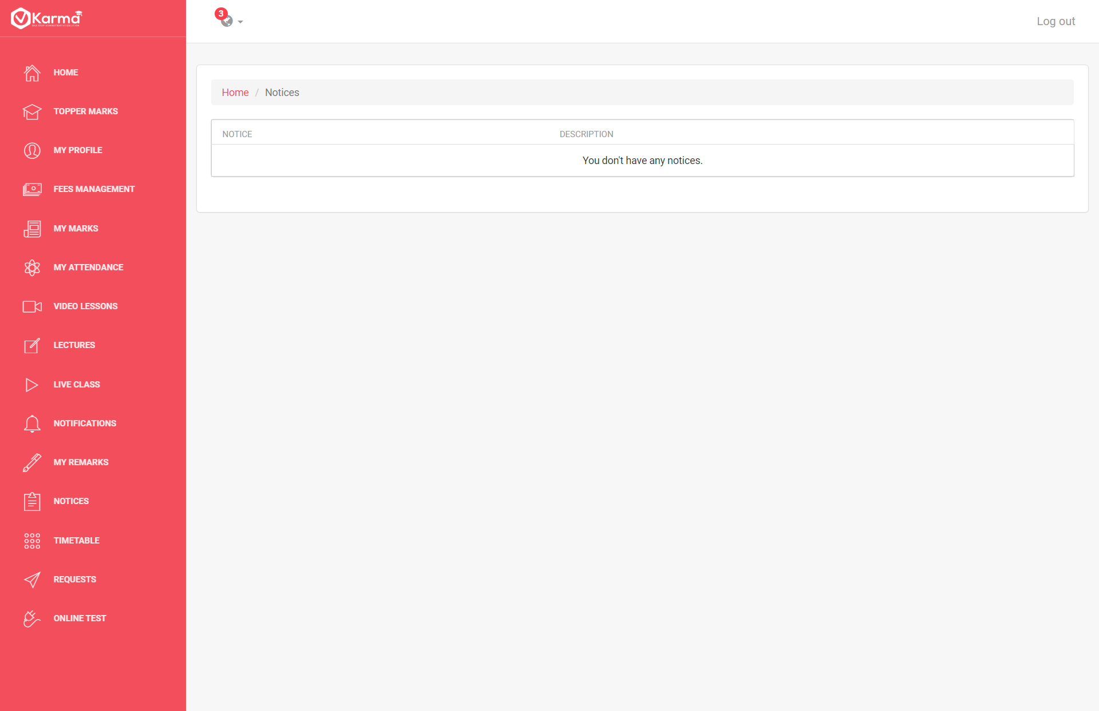

Students can view all the notices given to him

**13.Timetable**

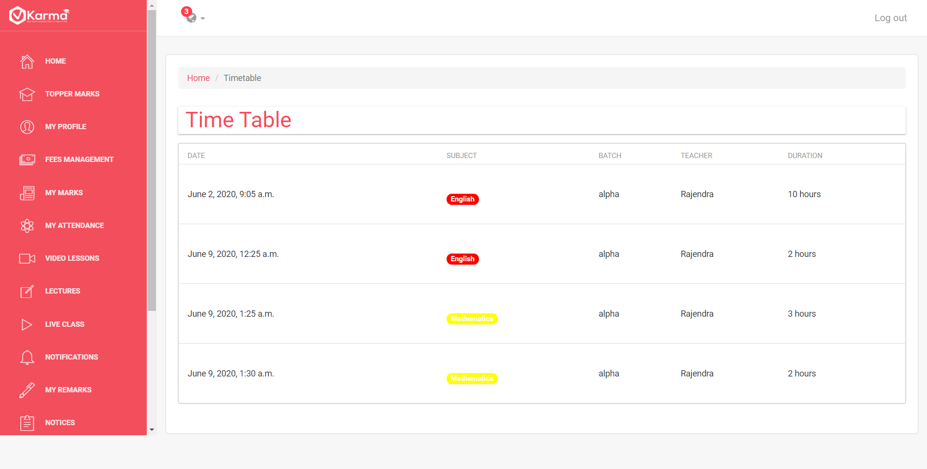

Student can view his timetable

**14.Requests**

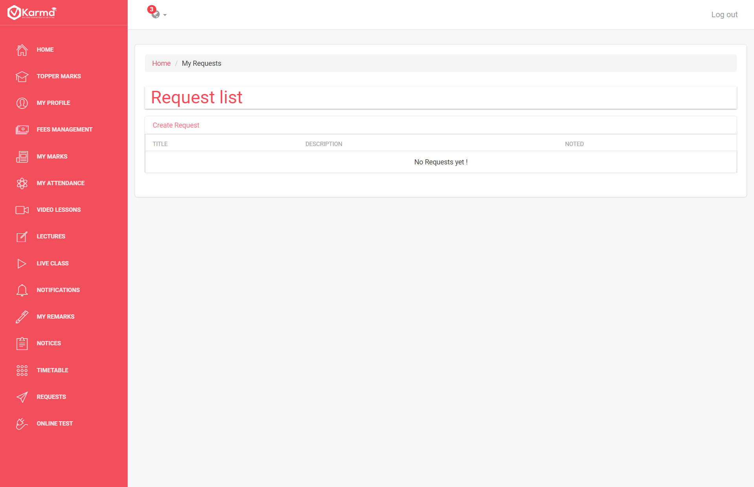

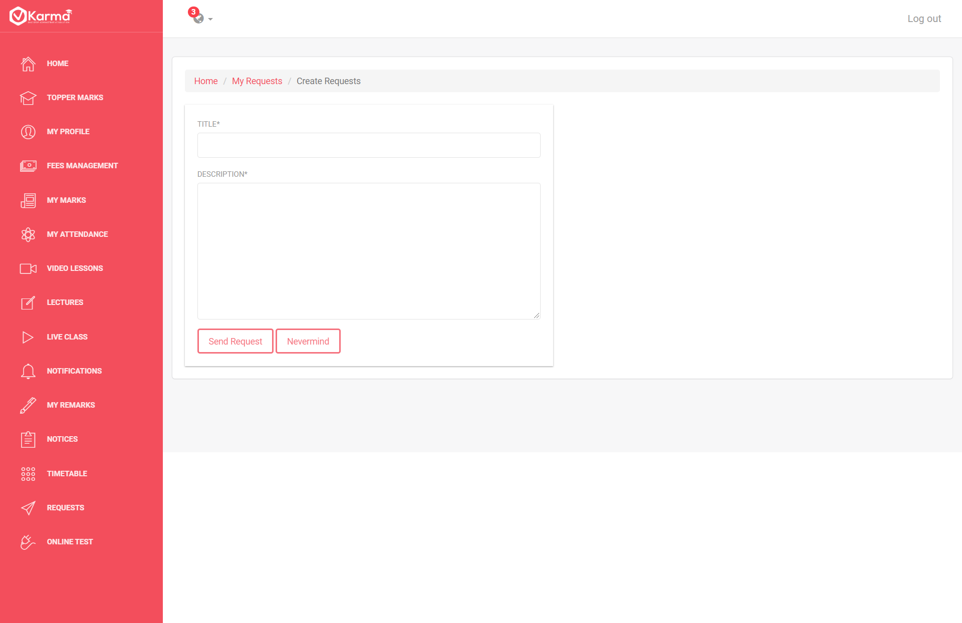

Students can view requests to them and can create a new request

**15. Online Test**

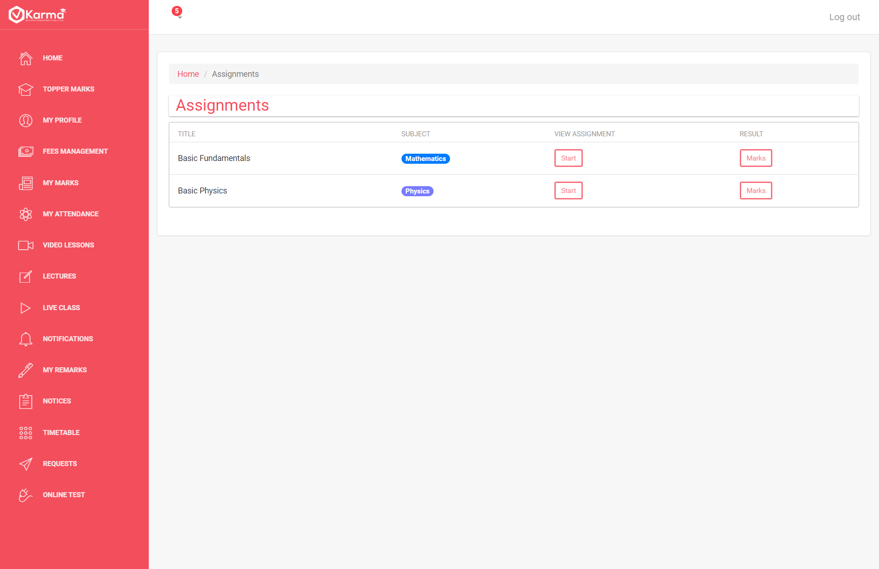

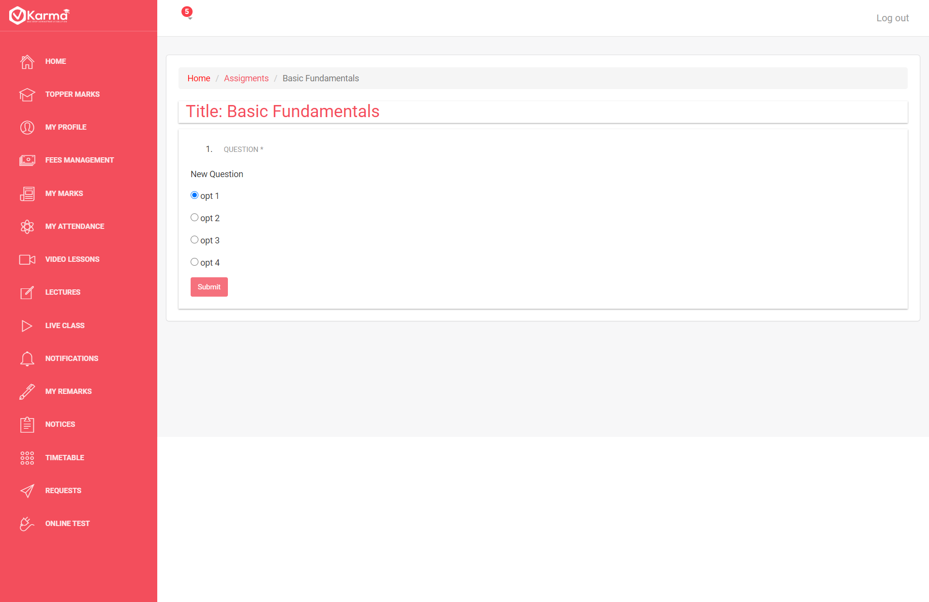

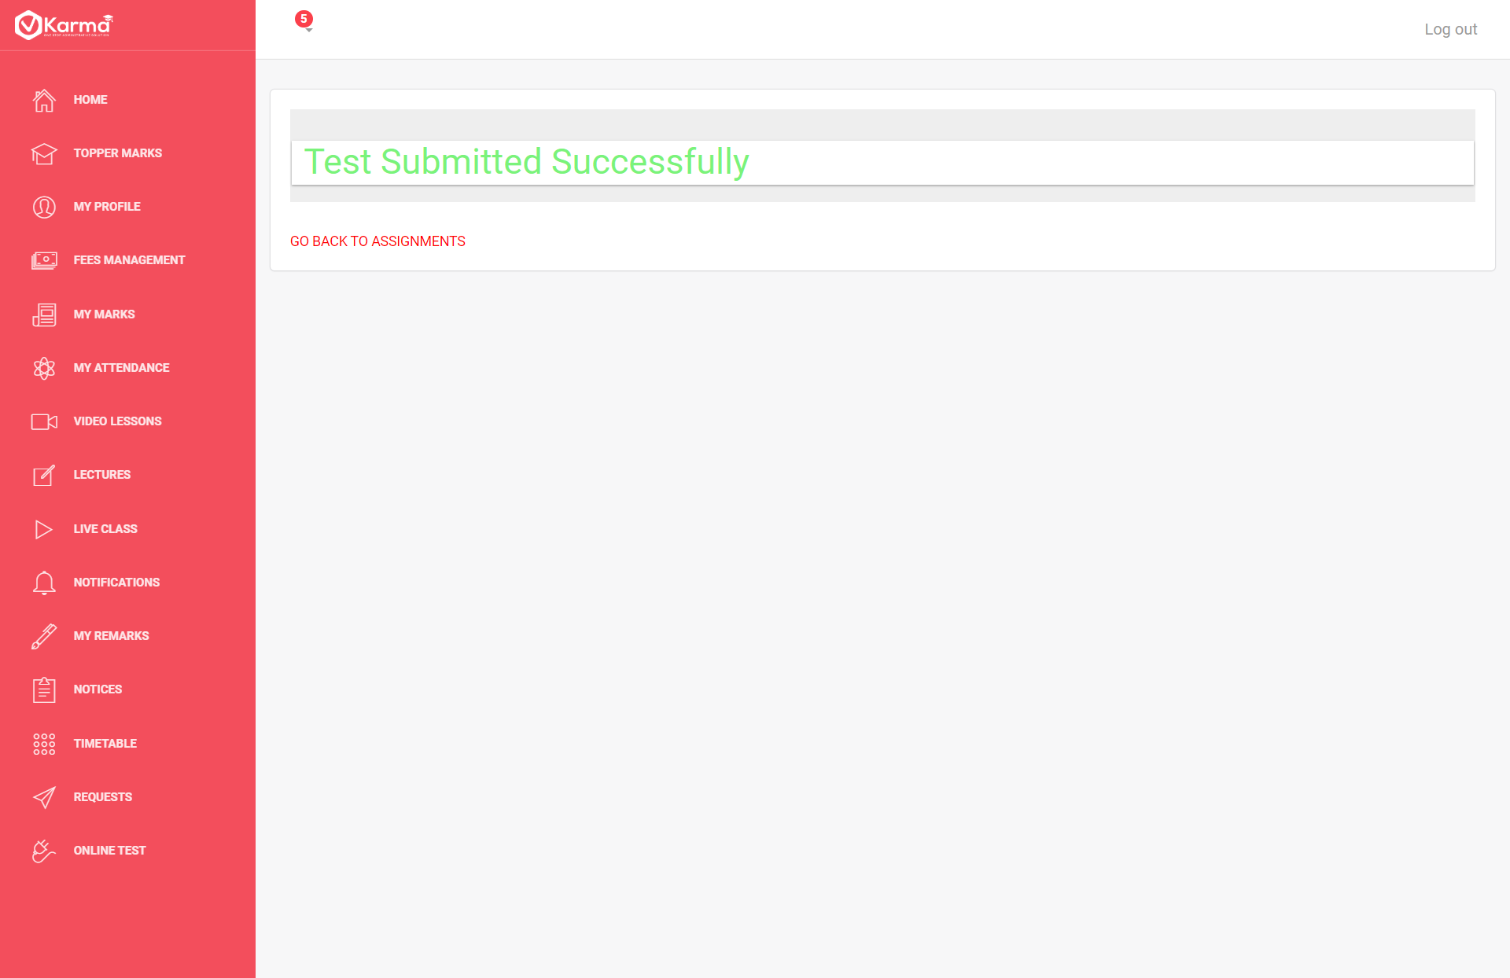

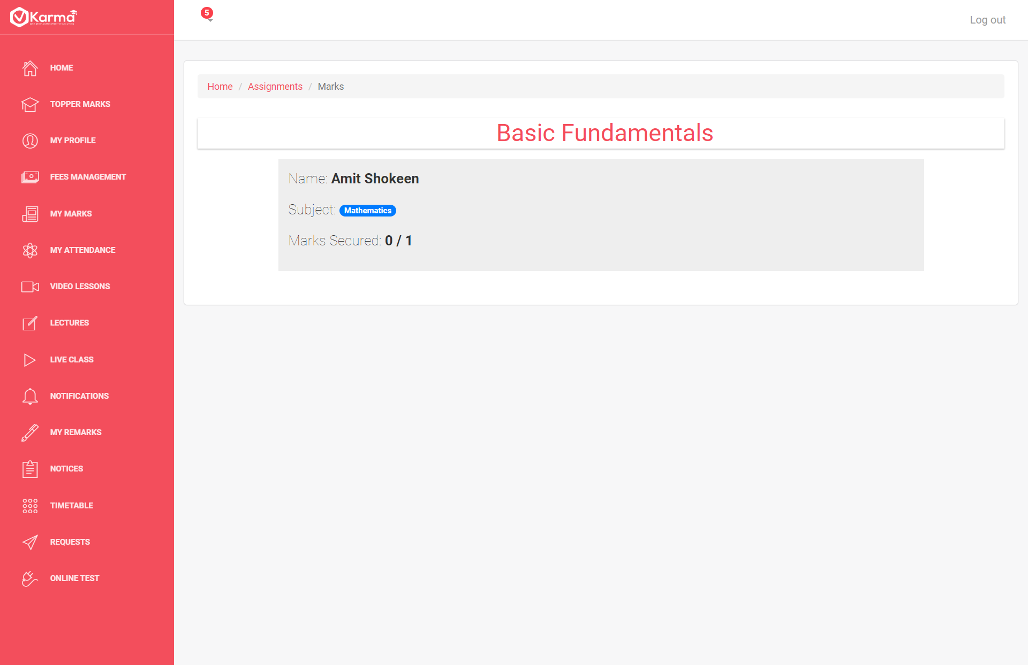

Student can view a list of all the Assignments given by the teacher online to him attempt them and view result

**Teachers:**

Teacher section allows the staff to provide assignments and homework and also stay connected with the parents.

1. **Teacher Home**

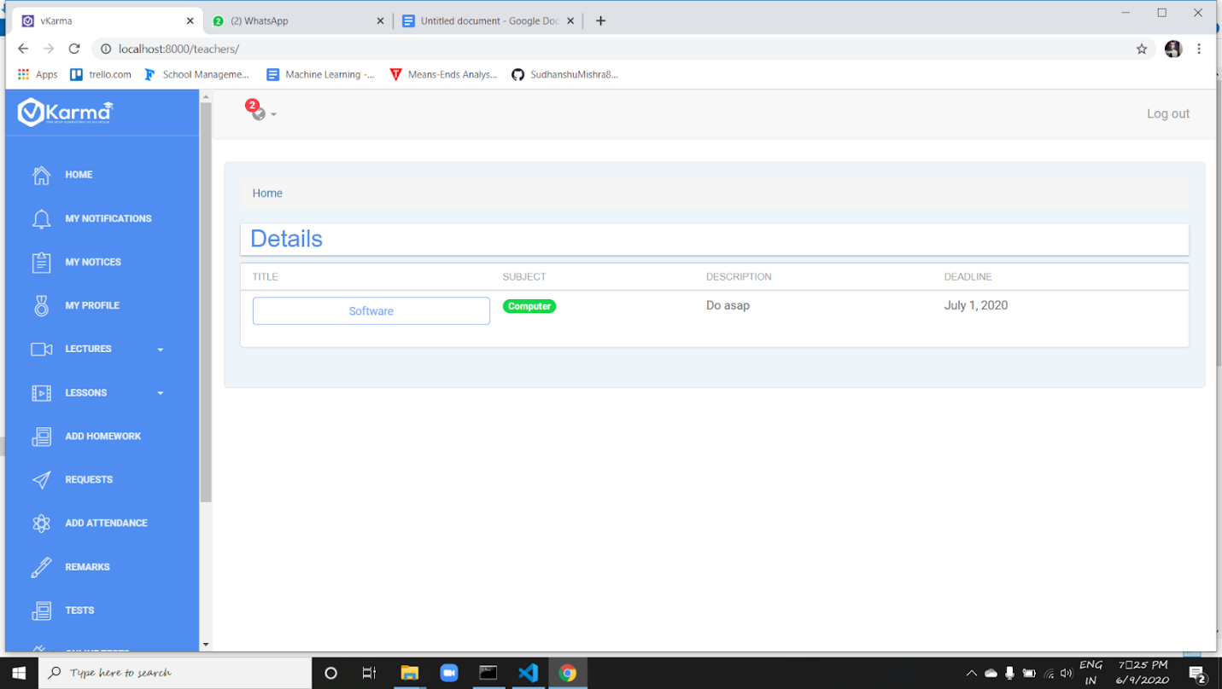

The home page of the teacher shows the list of the homeworks that has been given to the students of the particular batch along with the deadline.

The portfolio on the left provides many features that can help teachers and students to interact online,share assignments,homeworks etc.

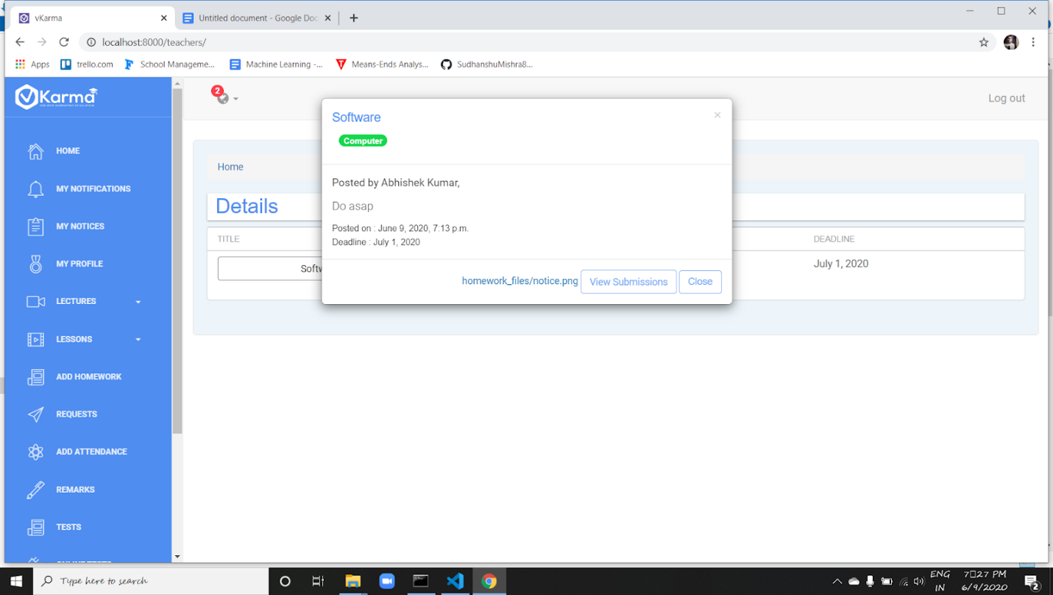

It also provides the feature to see the students who have submitted their homework by clicking on view submission button in the popup containing info about the homework

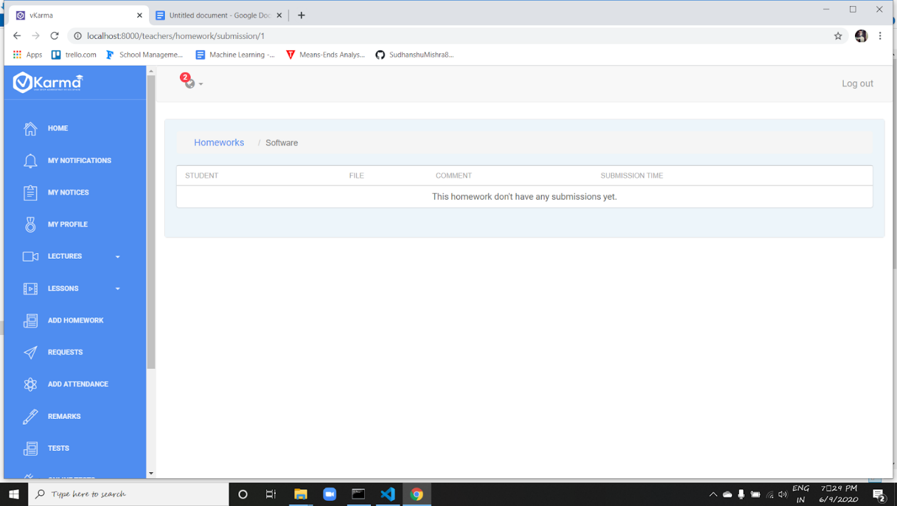

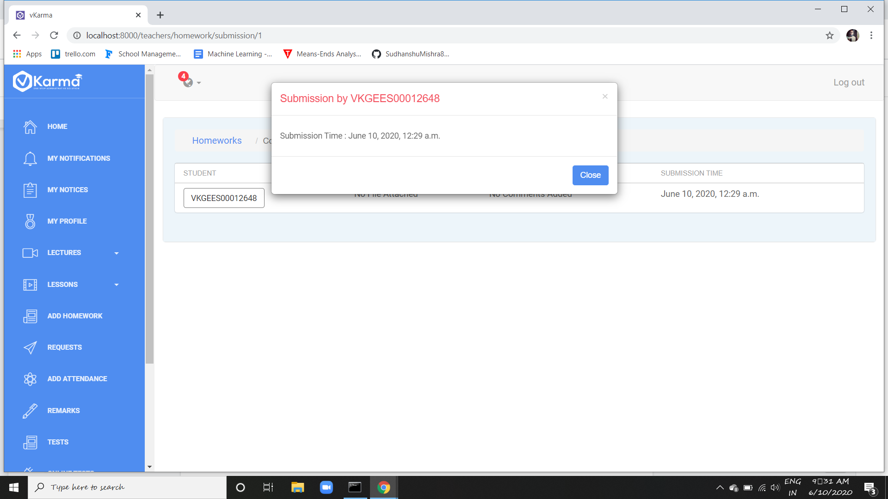

Teacher can view the submission of the homeworks done by the students.

1. **Notifications**

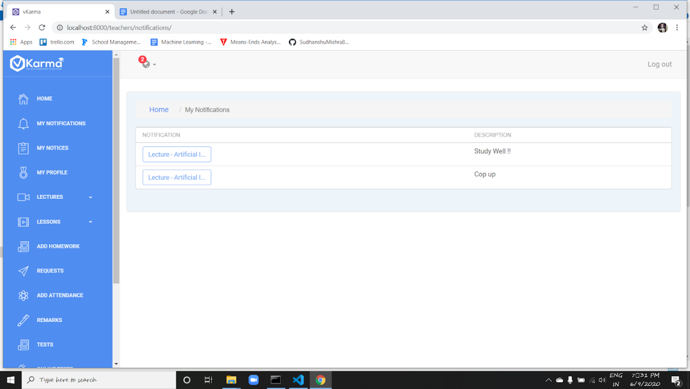

‘My notifications’ shows the list of lectures as notifications to the teachers that are to be held.

All detail about a given notification can be viewed in a popup by clicking on respective notification title.

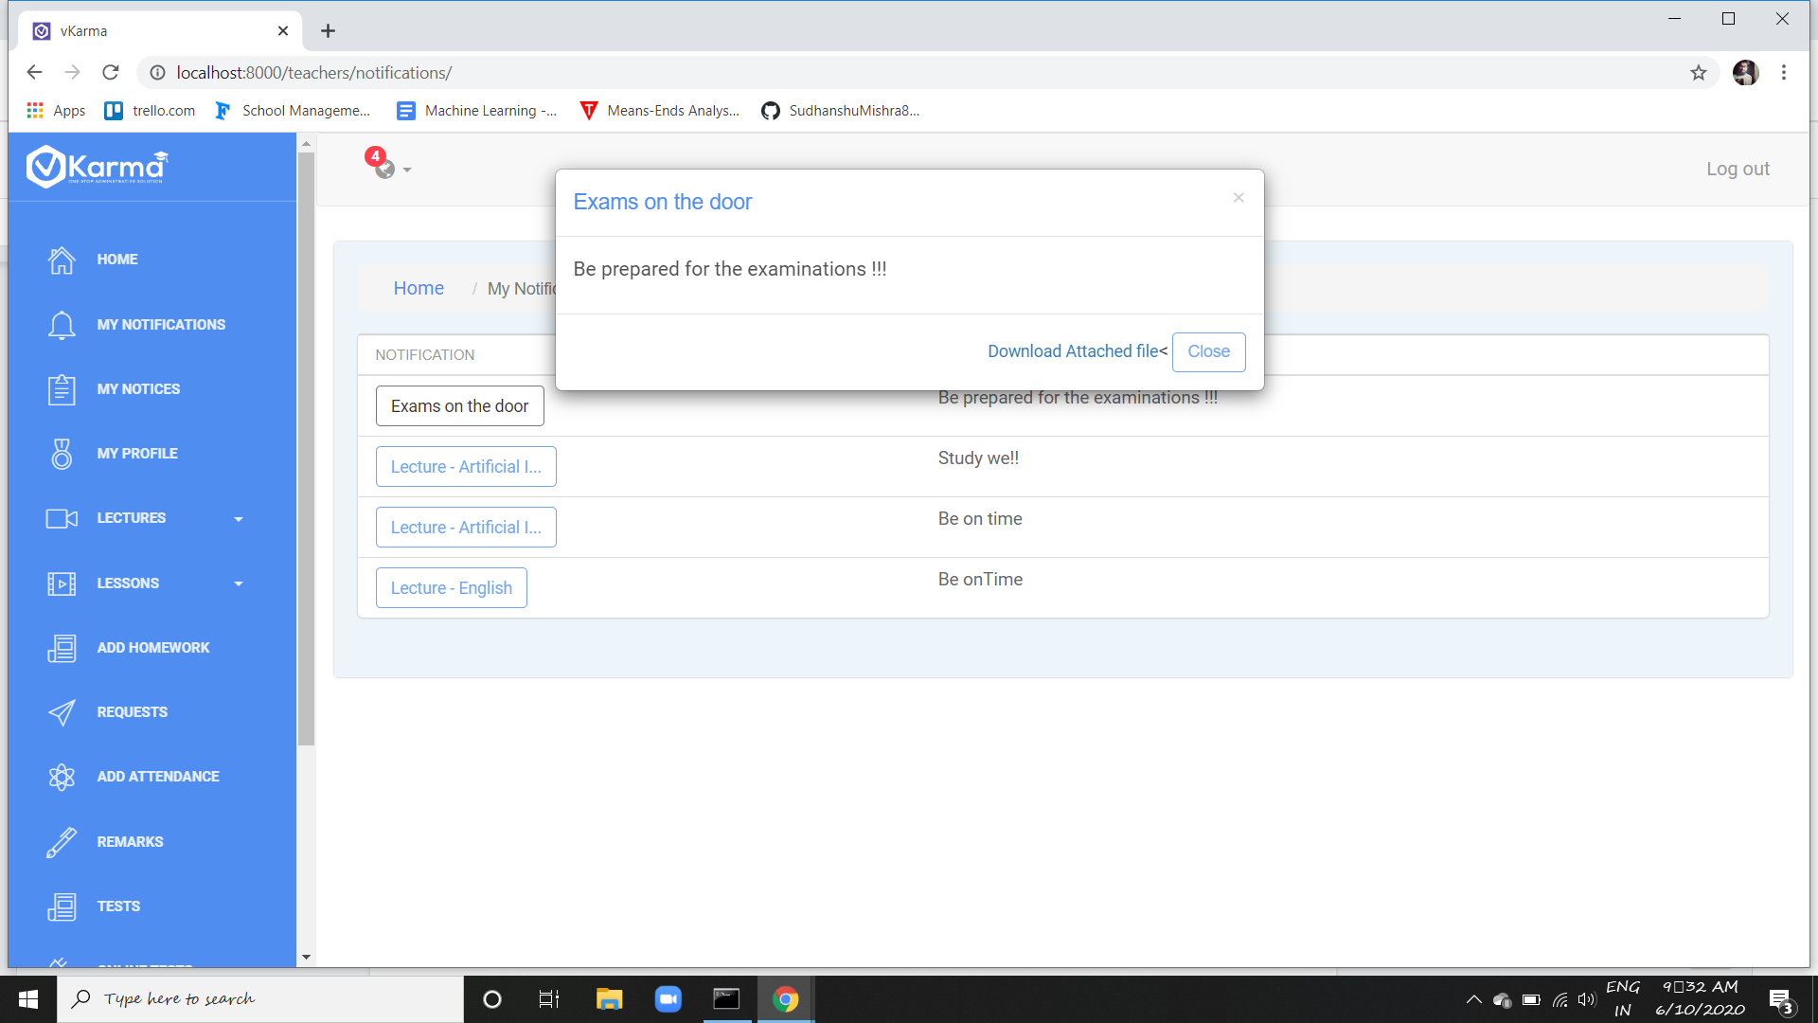

Notifications can be seen briefly by the teachers along with the option to download the attached file.

1. **My Profile**

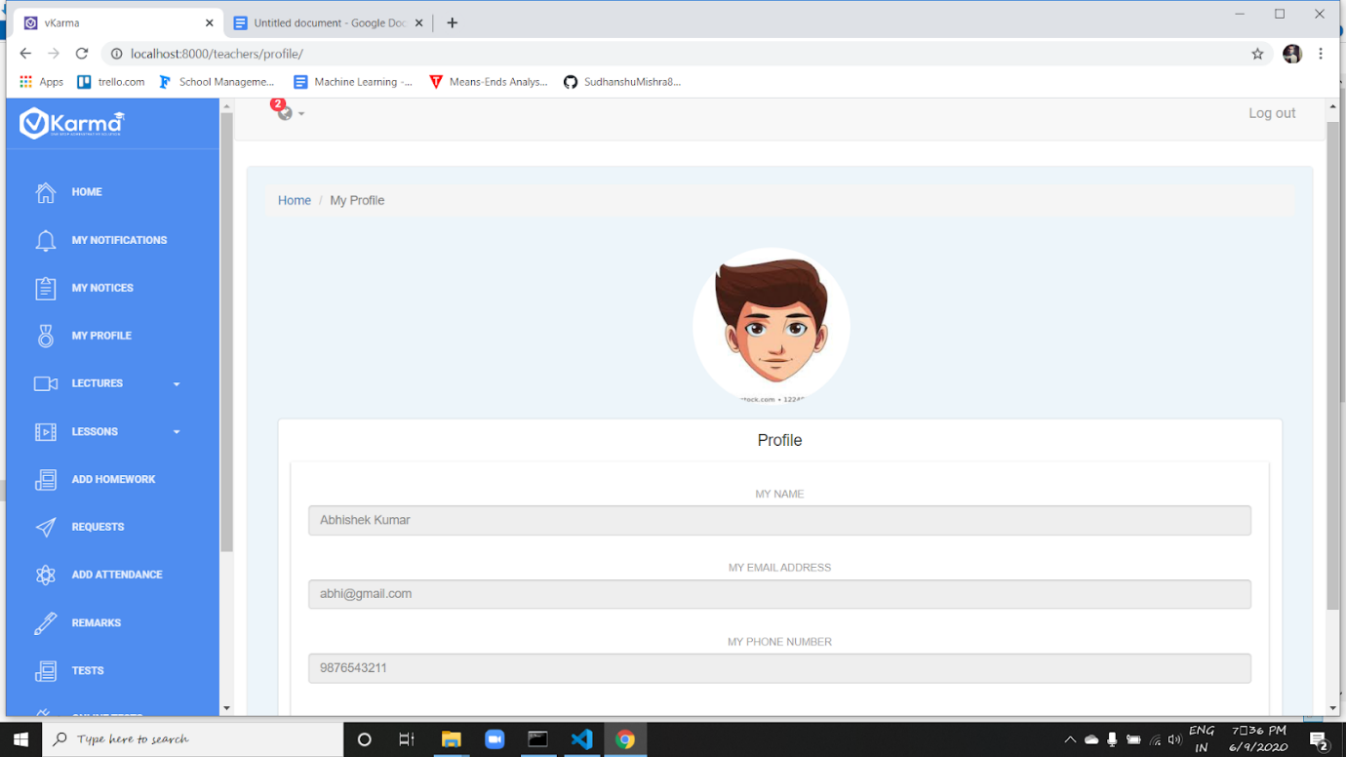

“My profile” button gives the appearance of the teacher’s details provided along with the profile picture.

1. **Lectures**

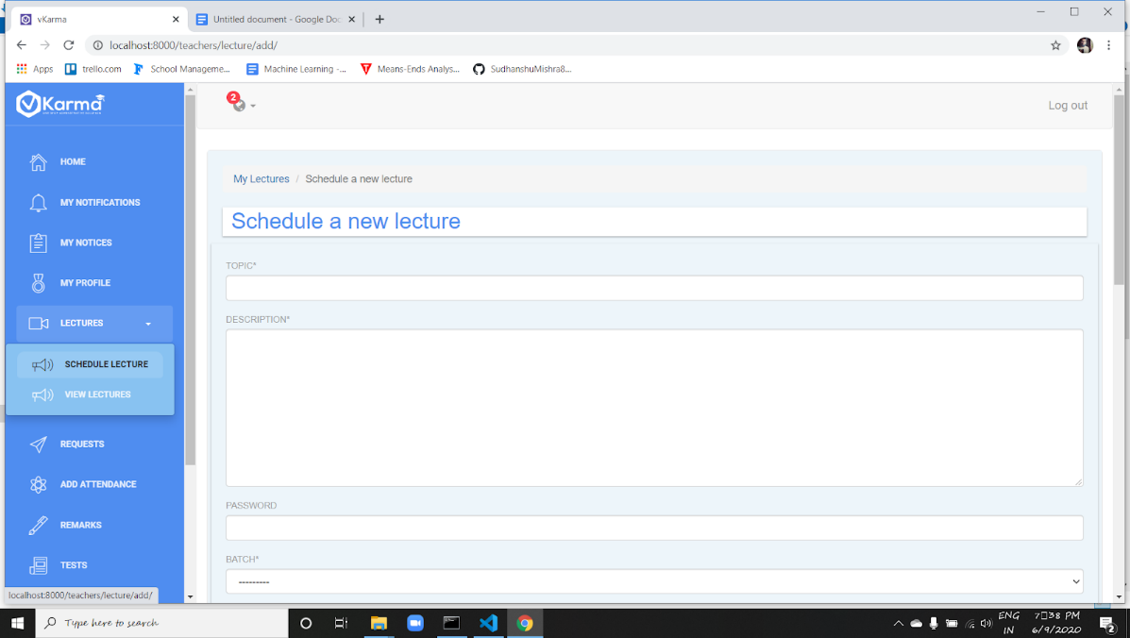

Teacher can schedule a lecture for the students and inform them about the same.

Whenever a lecture is created by the teacher for a batch the details will be visible to all students in the corresponding batch

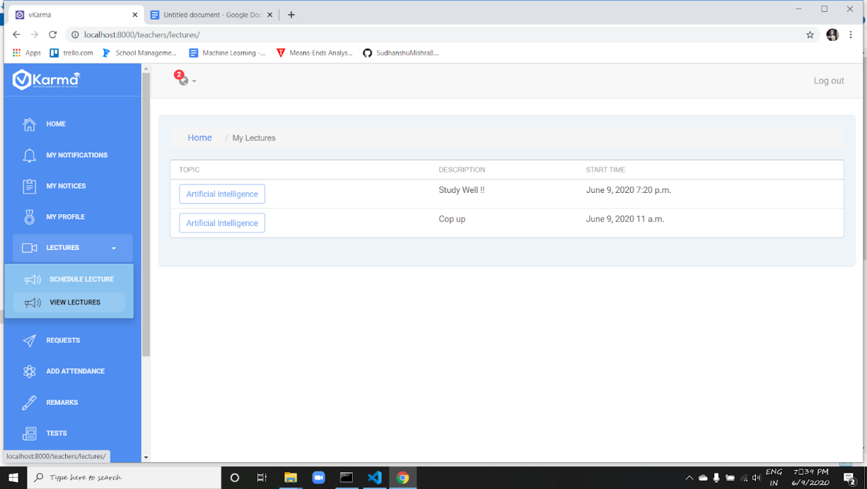

And the scheduled lectures can be also be seen later for the teachers ease. It makes the section more durable.

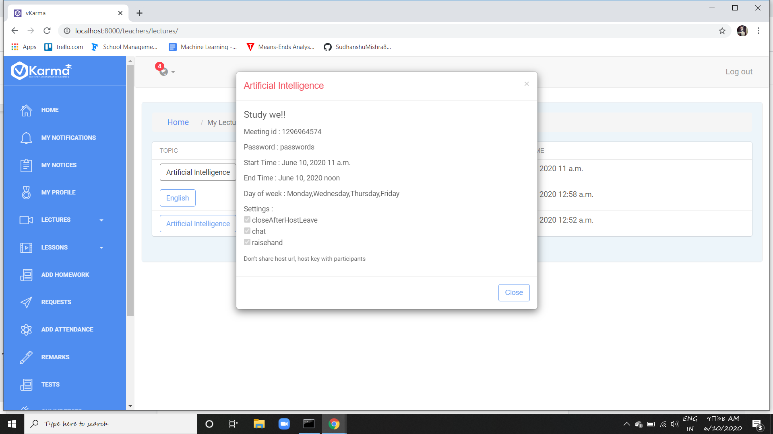

1. **Lessons**

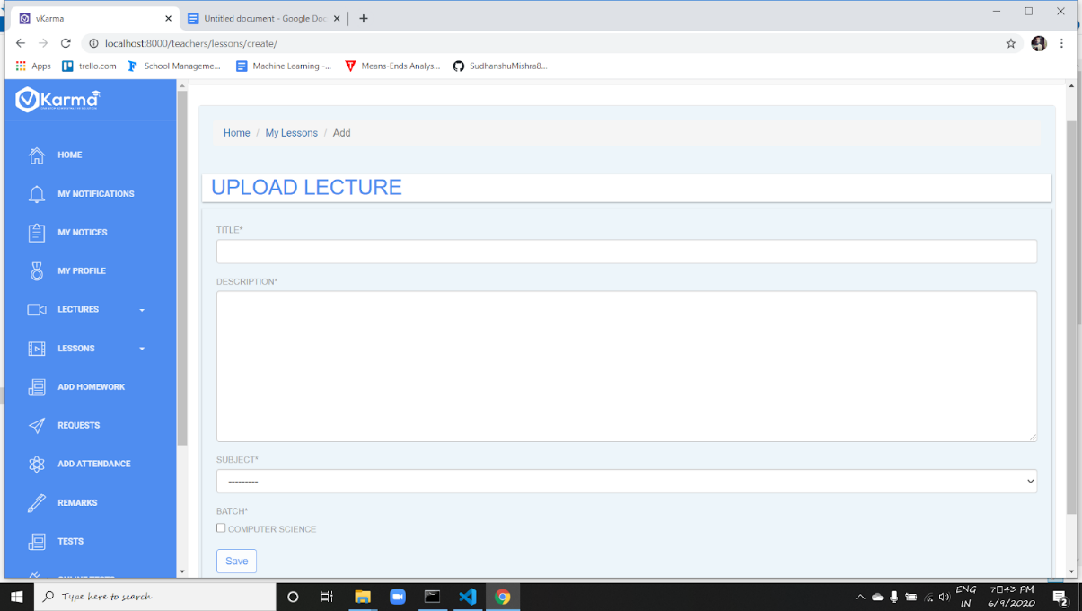

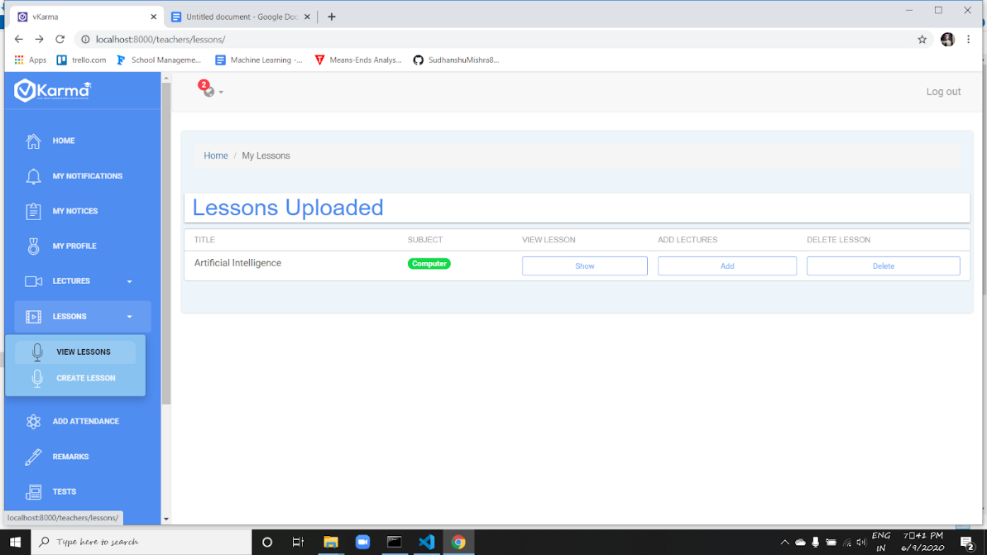

Teacher can upload lessons and a list of all uploaded lesson can be view in view lesson. Further teacher can add more videos to a given lesson using add button or delete lesson using delete button.

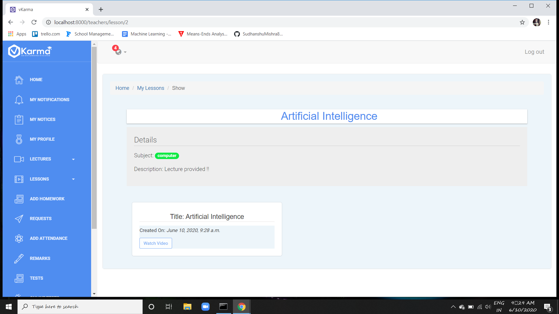

Show button shows the lectures uploaded by the teacher on a specific Topic.

1. **Homework**

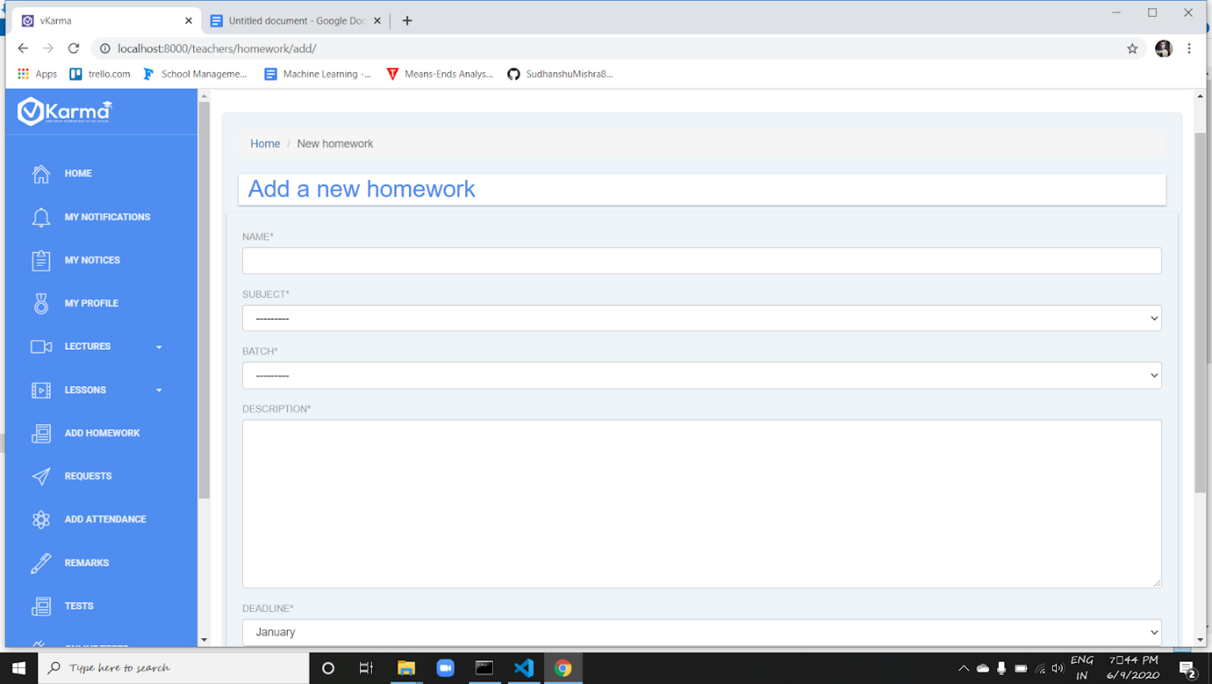

Homework section allows the teacher to circulate the homework among the students. Teacher can create homework for a batch and then all the students of that batch will view the assigned homework.

Teacher can check the homework and its submission through his home page

1. **Requests**

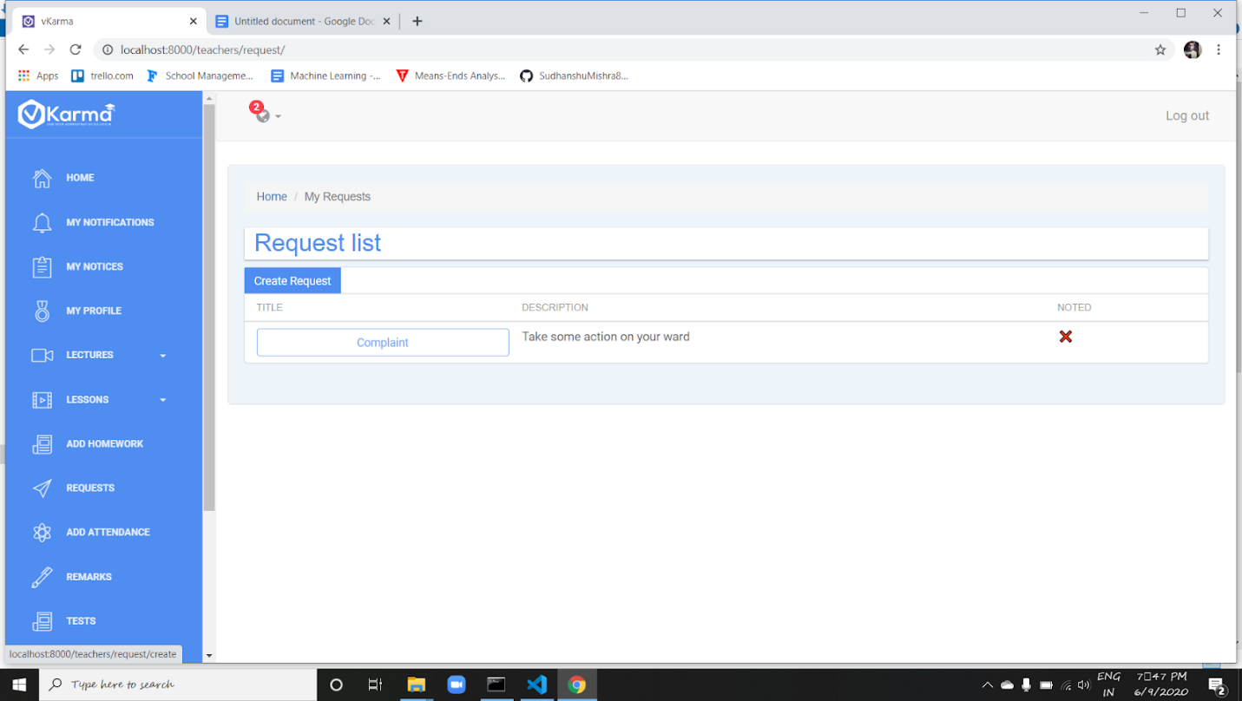

Teachers can create requests using create request button to the parents and staff which helps the parents to stay in touch with the staff and institute.

And all the requests created can be viewed in list form at request list page.

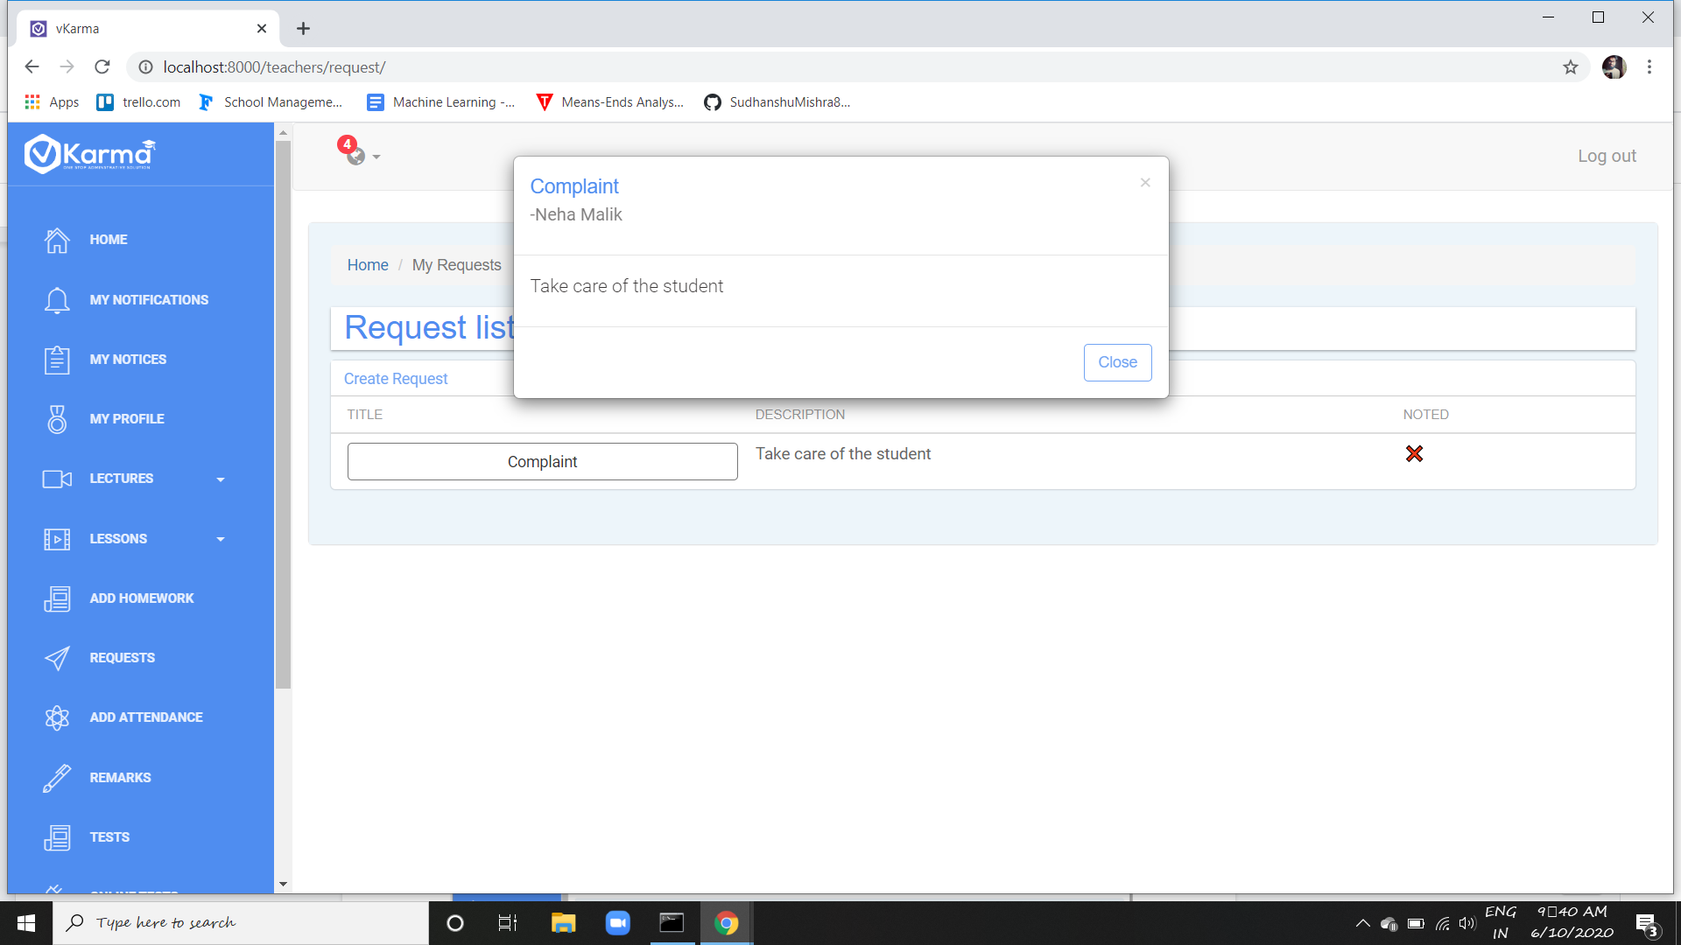

1. **Attendance**

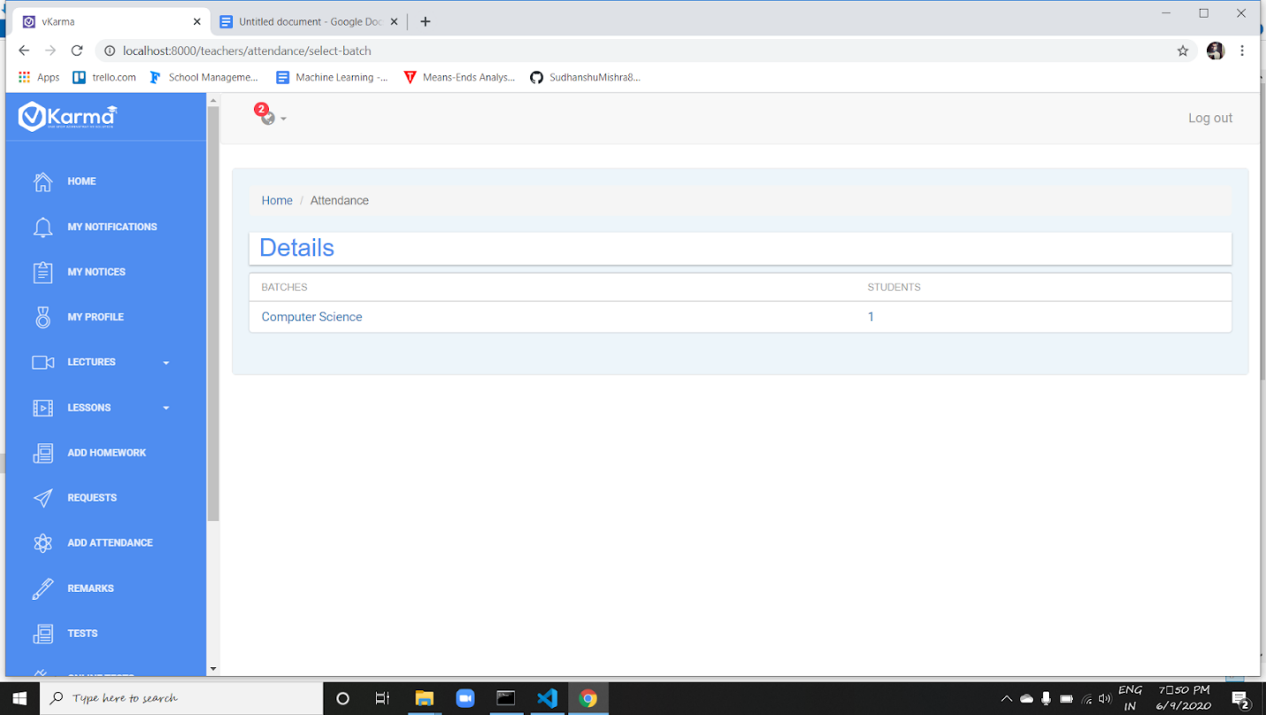

Attendance of the students  can be updated by the teachers regularly for each subject separately.

Teacher can navigate through batch then to the respective student and mark his attendance.

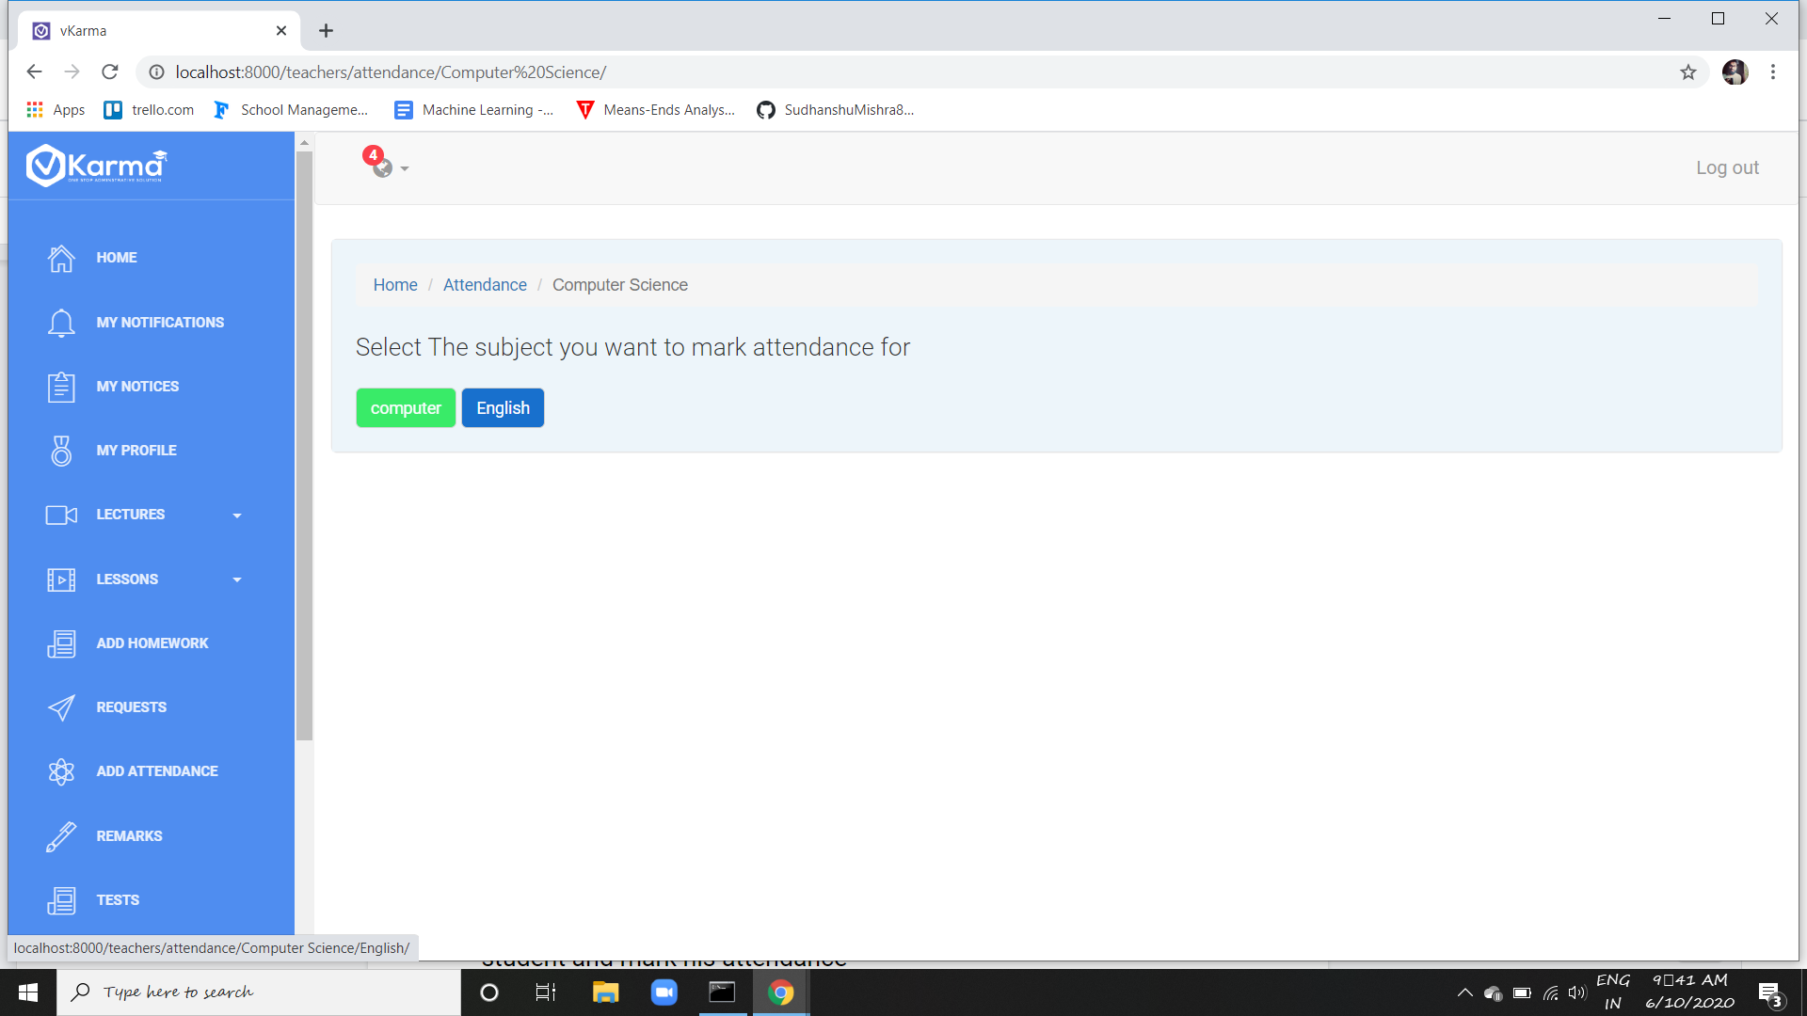

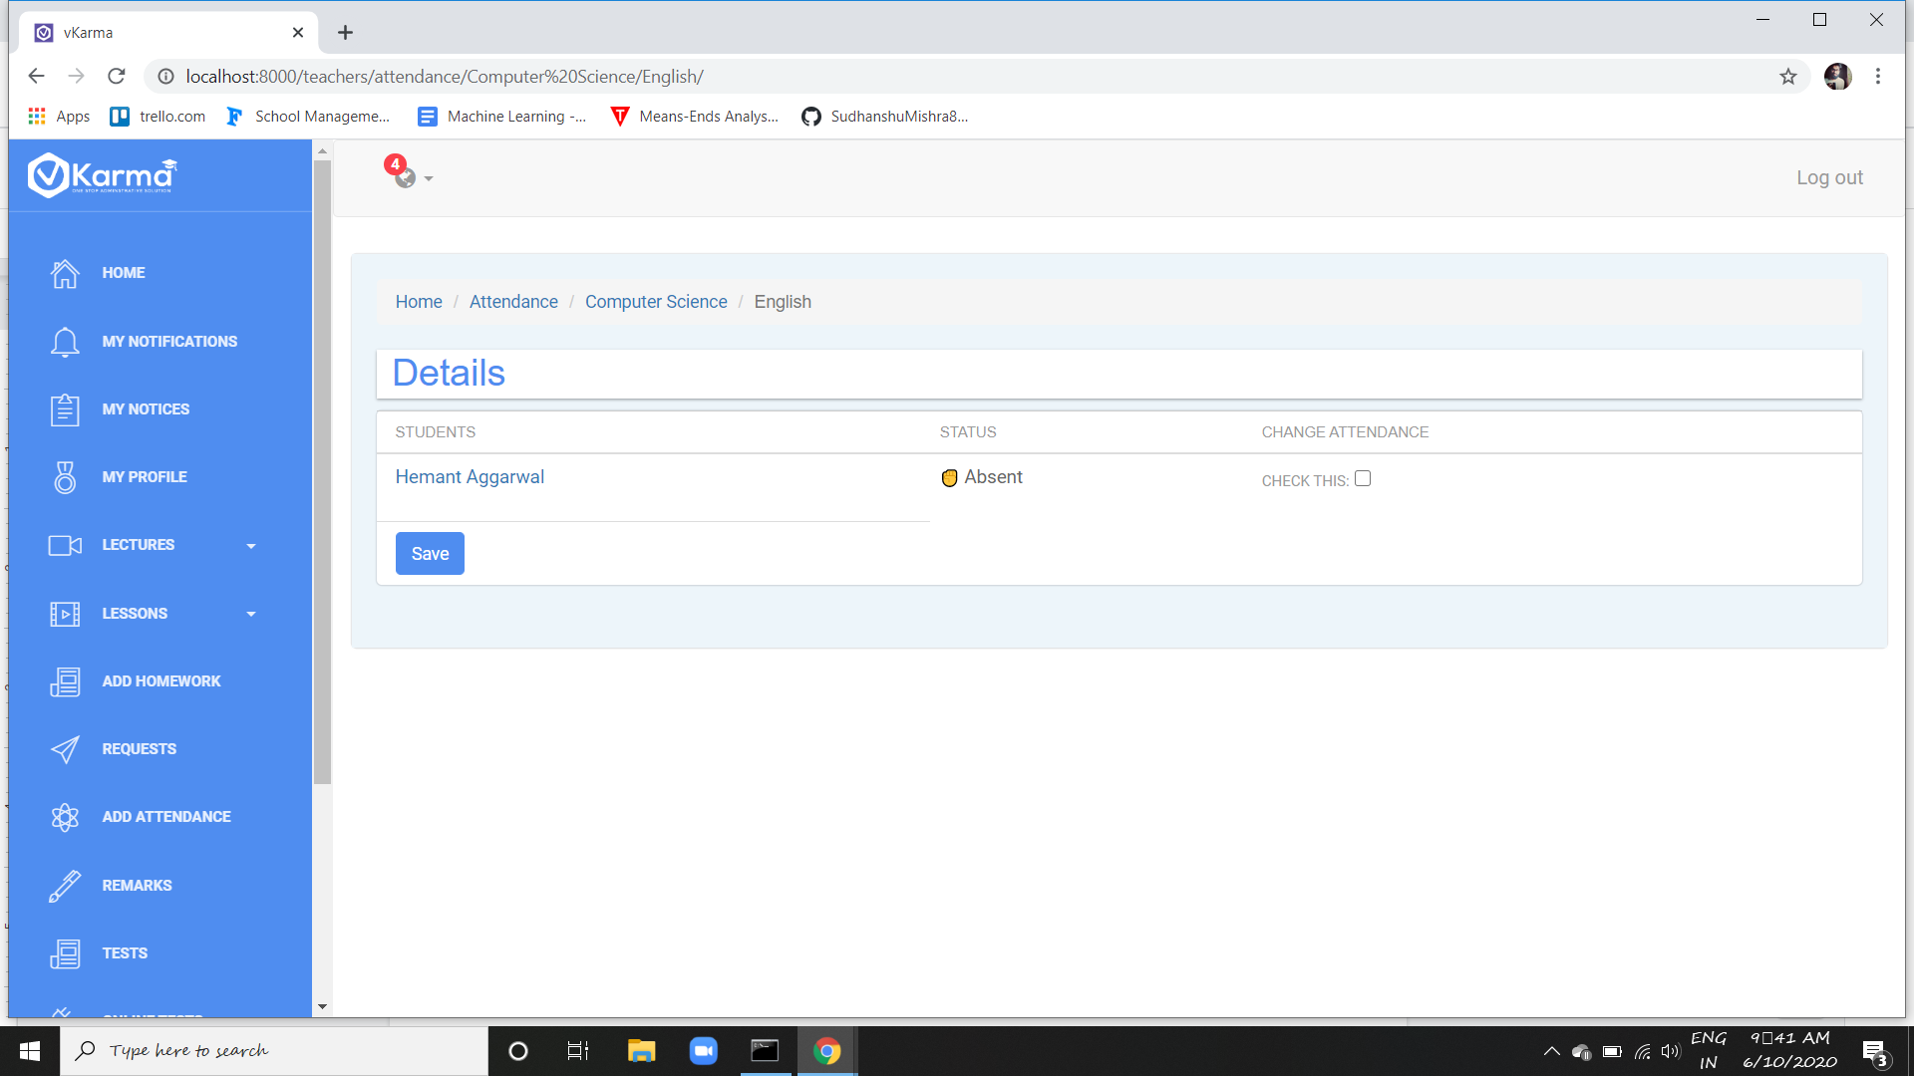

Attendance is further shown to the parents in their dashboard which help them keep tracking their ward regularity towards the institute .

1. **Remarks**

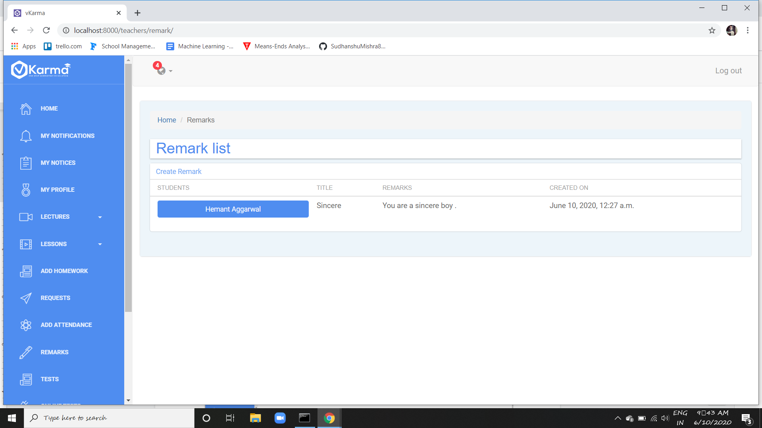

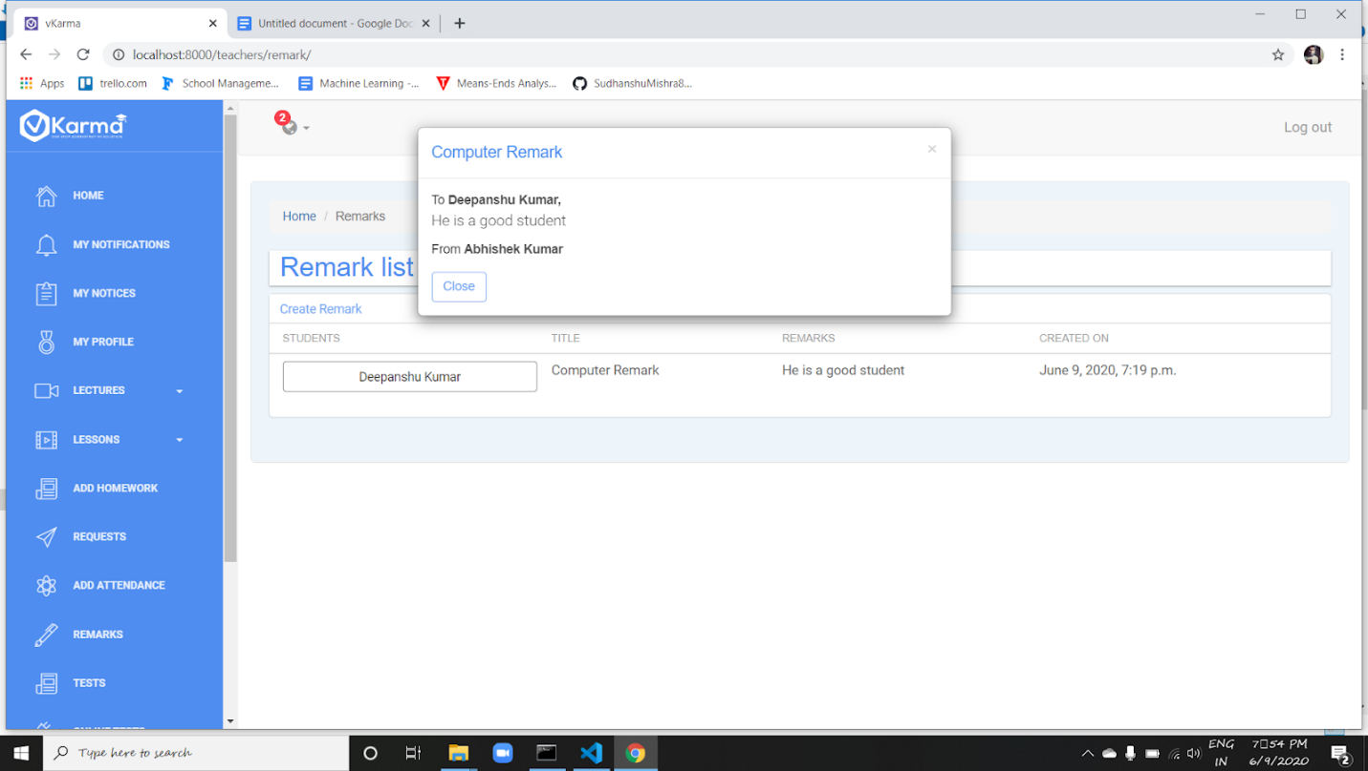

Remarks option helps teachers to provide remarks to the students.

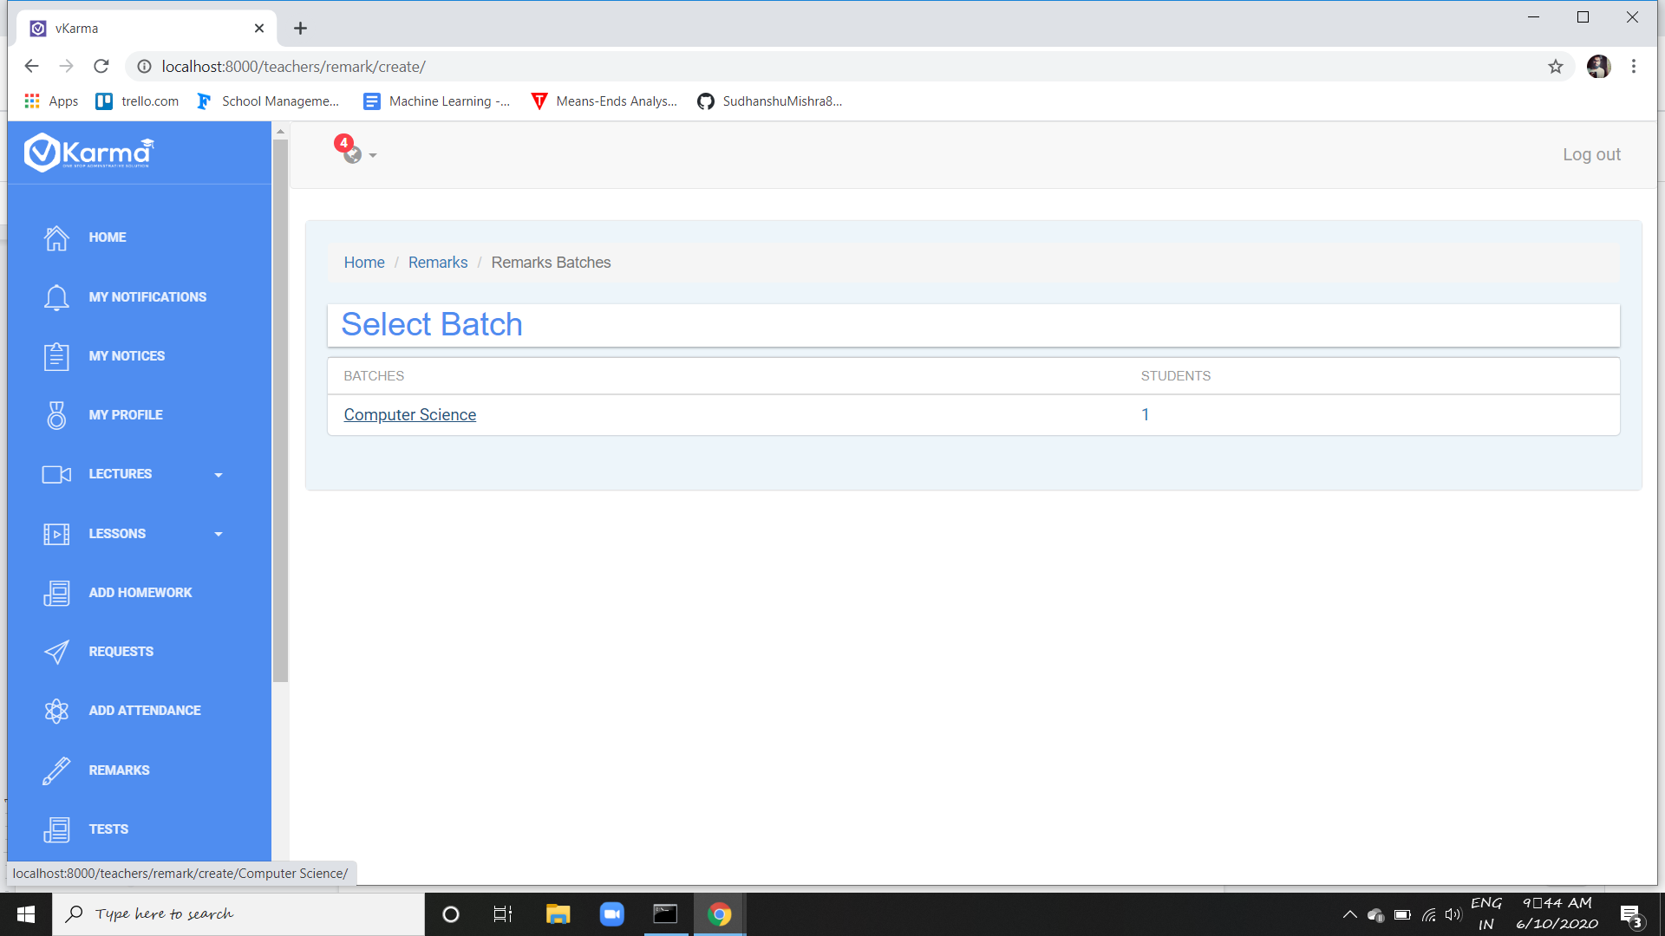

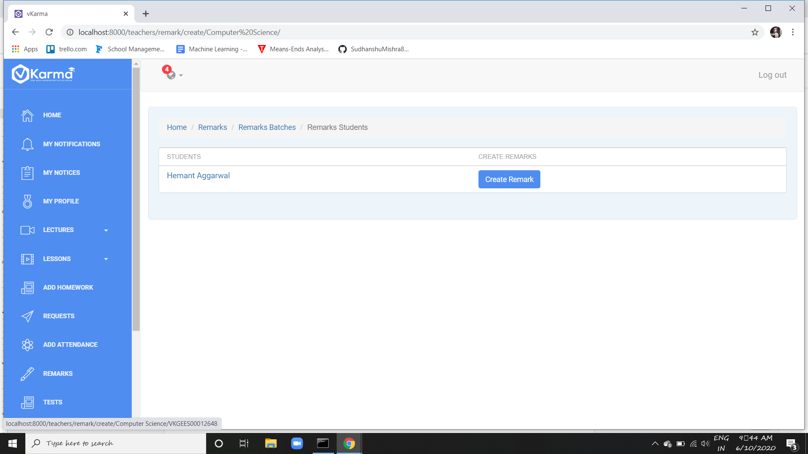

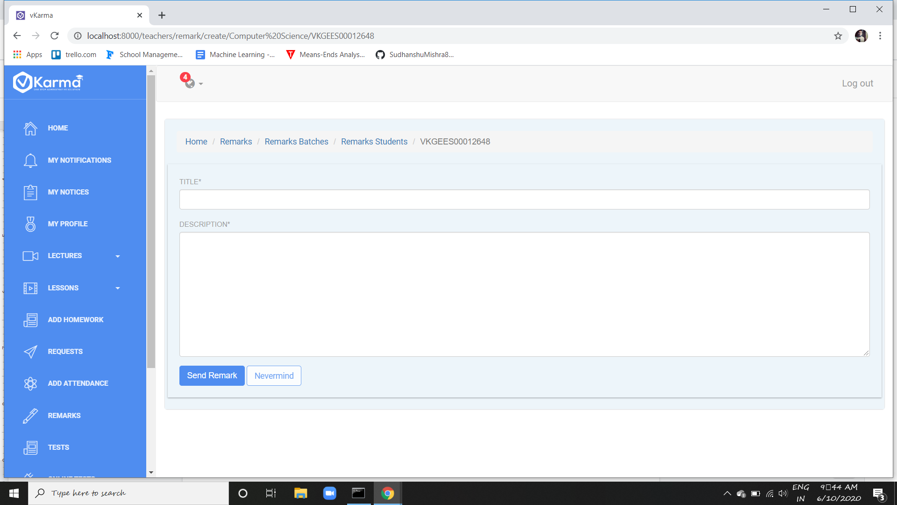

Teacher can create a remark for any student using create remark button and that corresponding remark will be shown in respective student profile page

Teacher can see all the remarks he had given in list form at remark list page

1. **Tests**

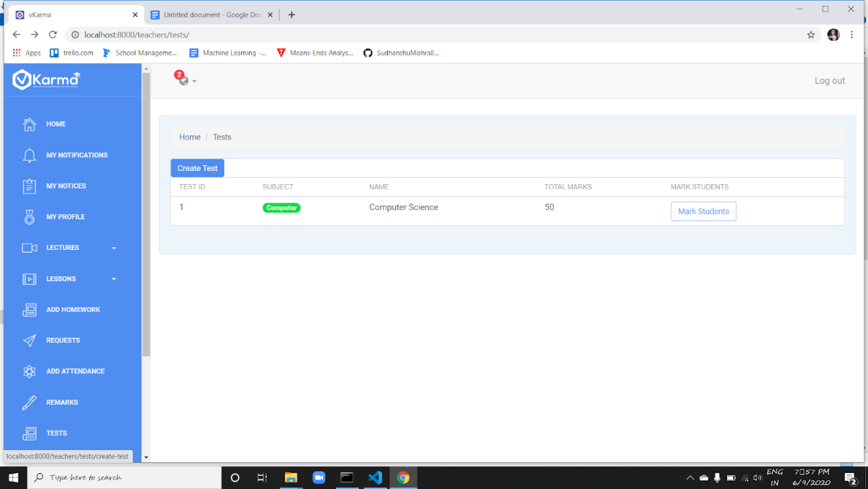

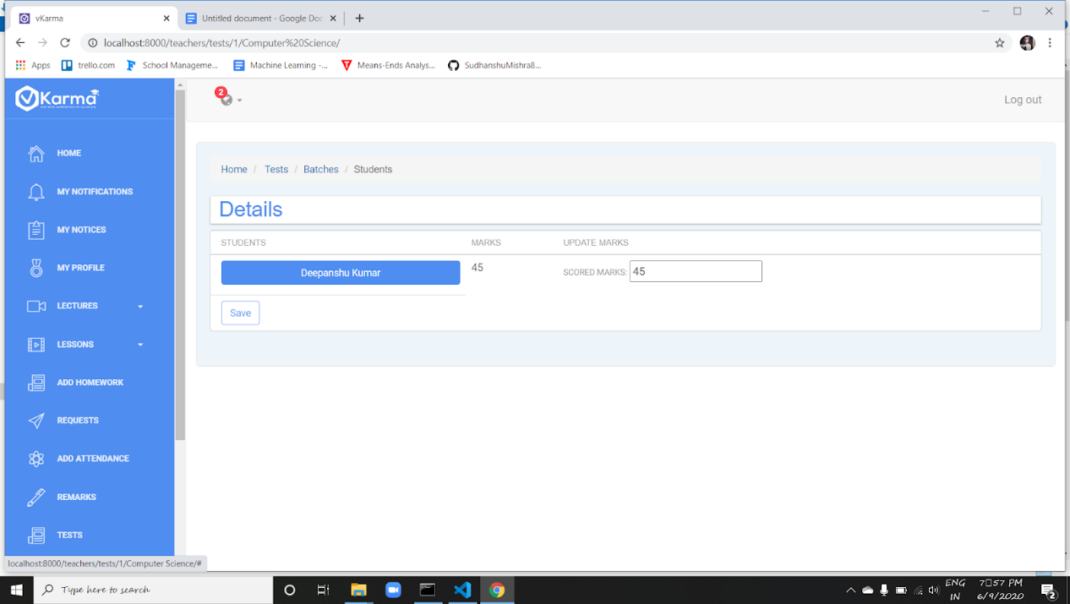

Teacher can create tests using create test button and all the test will be listed at Test page.

Further teacher can navigate through any test then to batch and then to any particular student and mark him for the respective test.

Teachers are able to assign marks to every student in his batch in the “Tests” section.

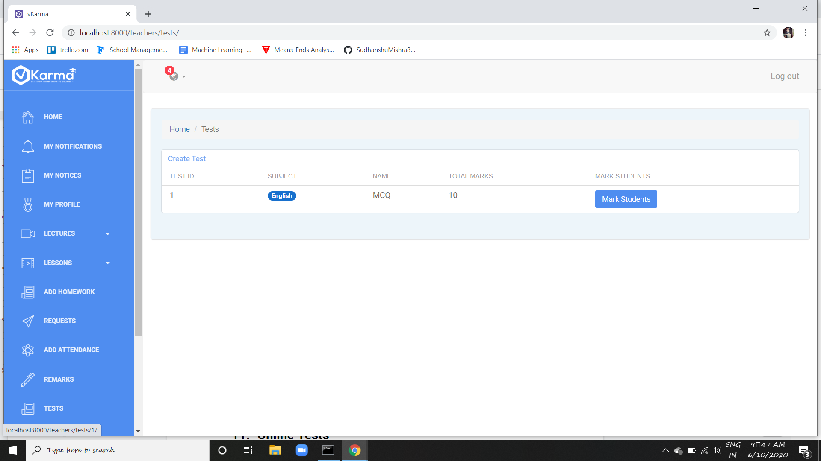

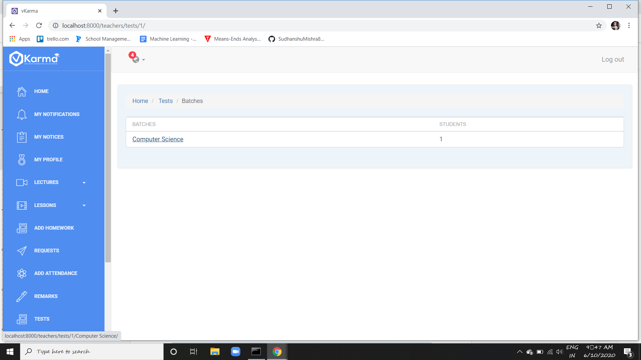

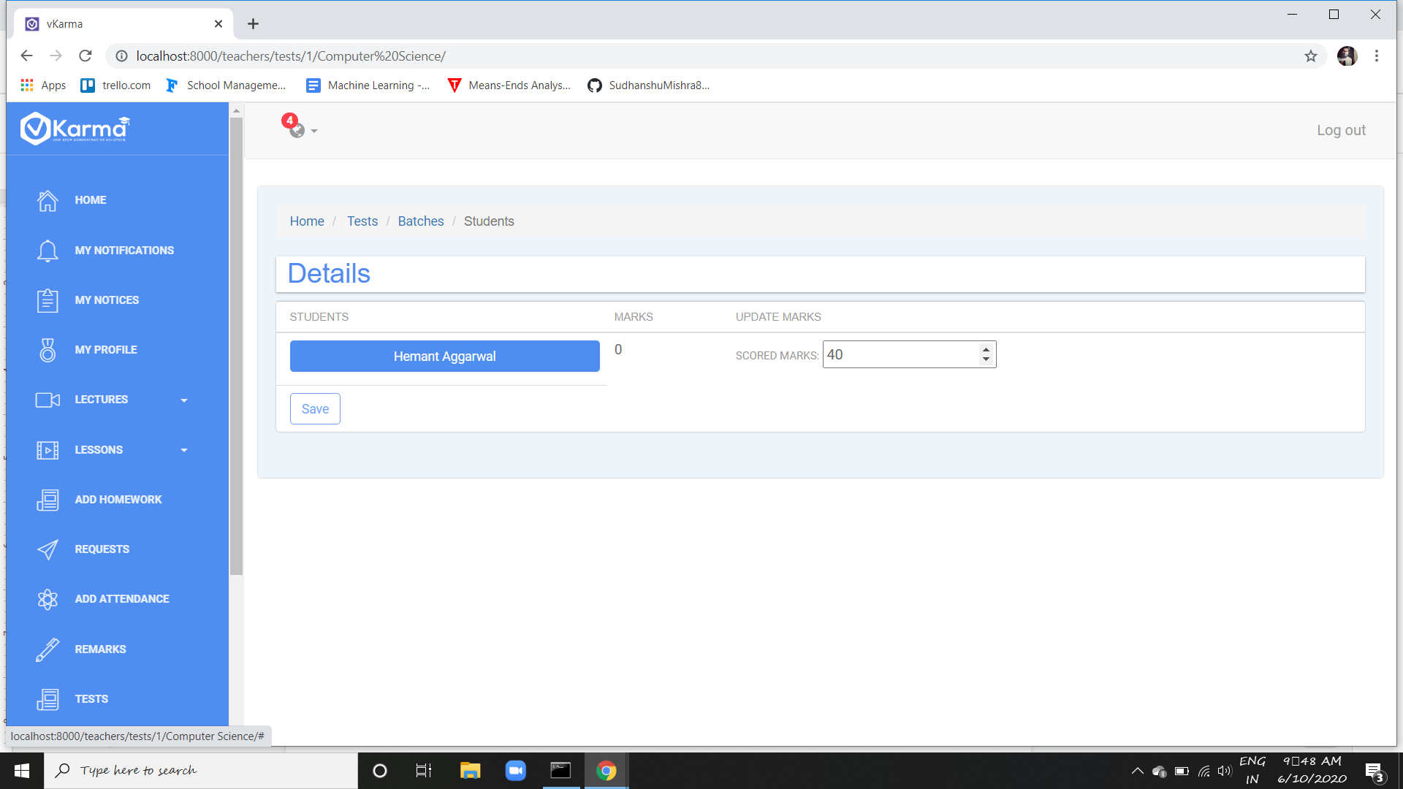

And students as well parents are allowed to see the assigned marks on their dashboards.

1. **Online Tests**

Online Tests contains the feature to create assignments for the students.

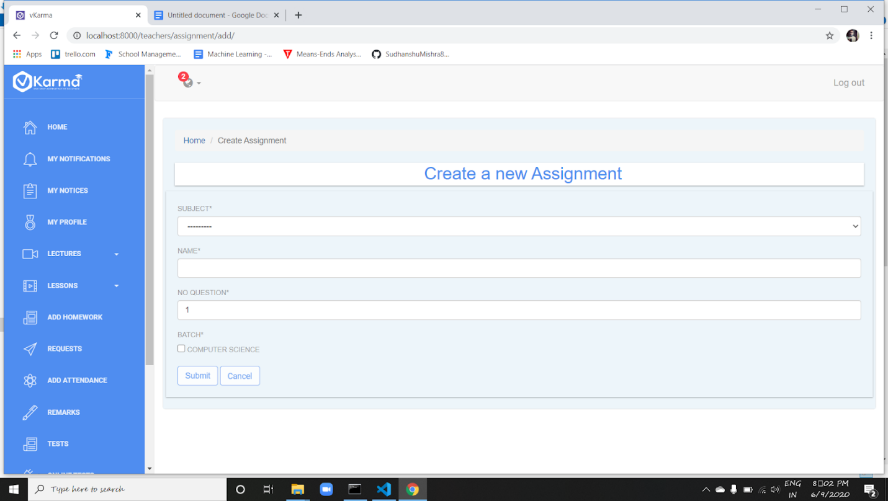

After adding an assignment, teacher can view the list of assignments added and can delete any added assignment whenever he wants.

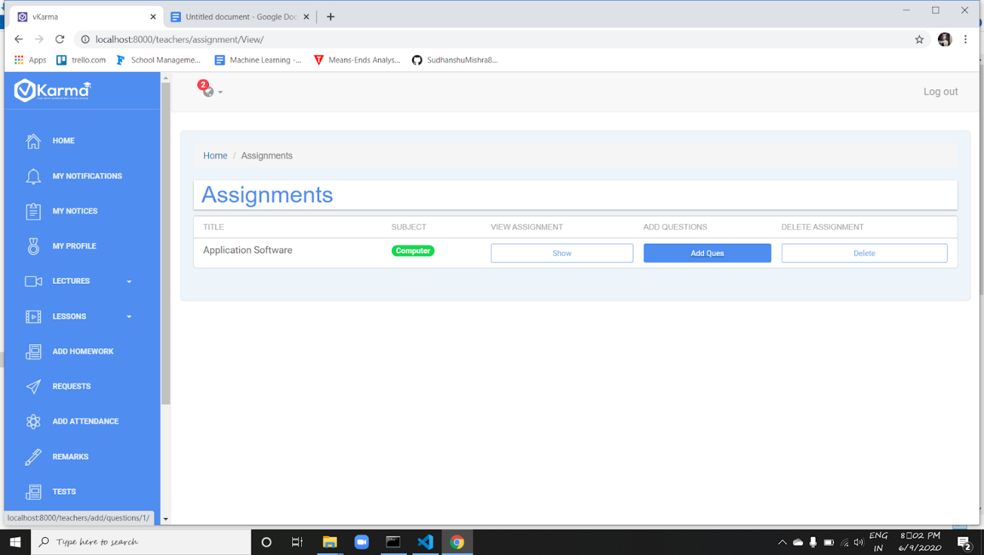

Teachers can add as many questions he wants to a single Online Assignment.

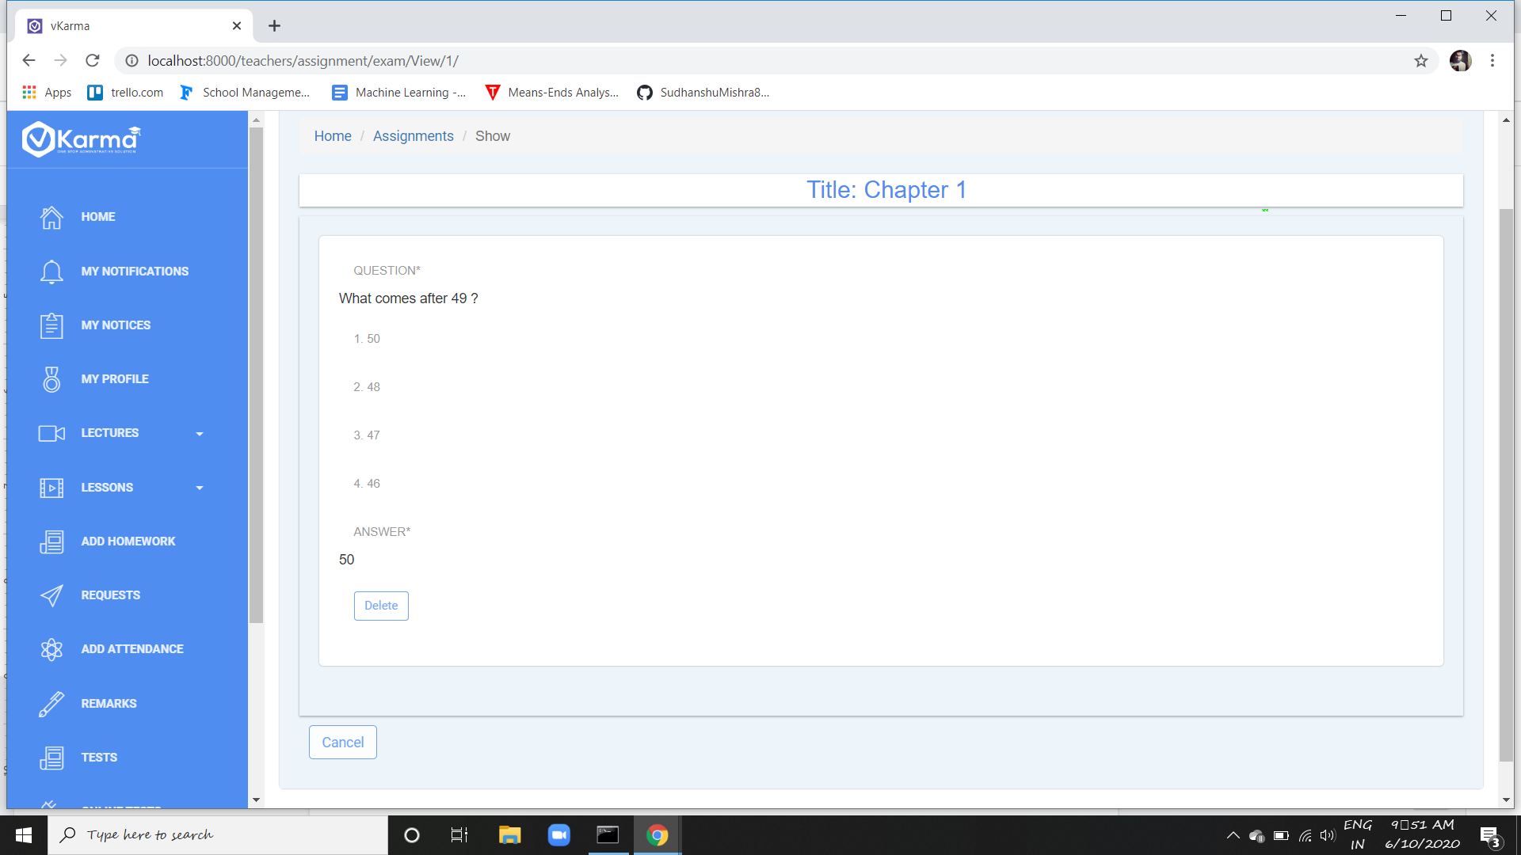

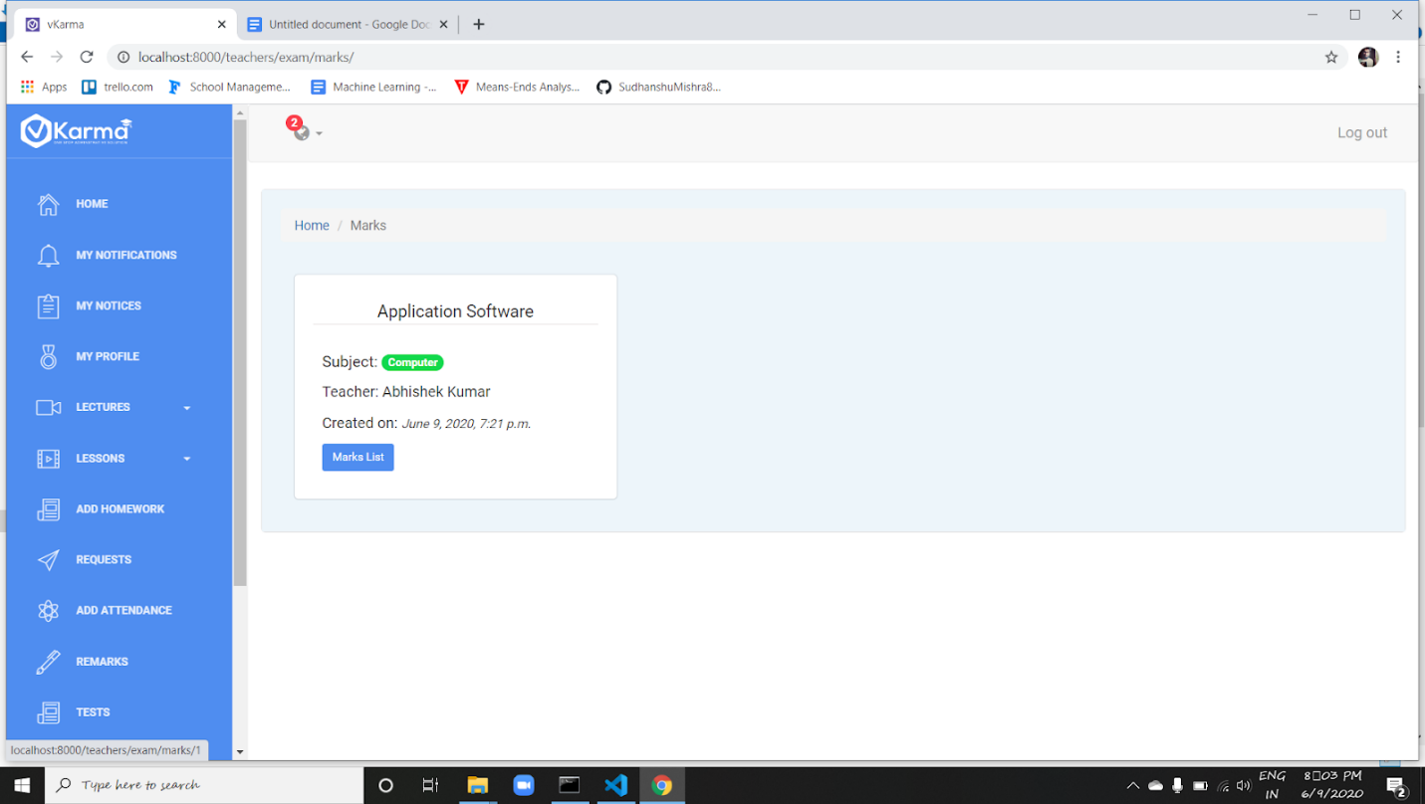

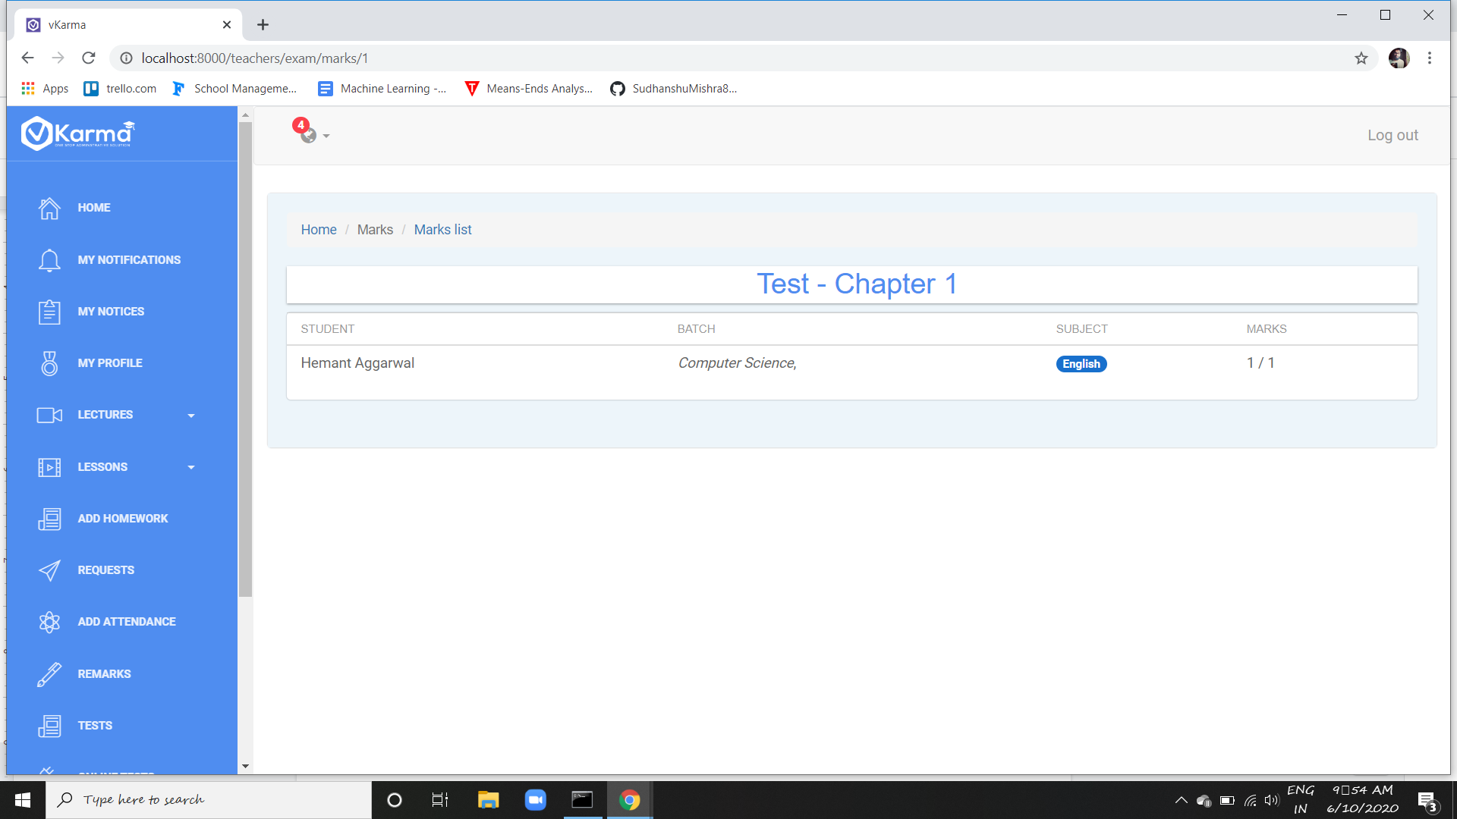

Teacher can add questions in test using add ques button and view all questions using show button

and can mark using Check Marks button

1. **Schedule**

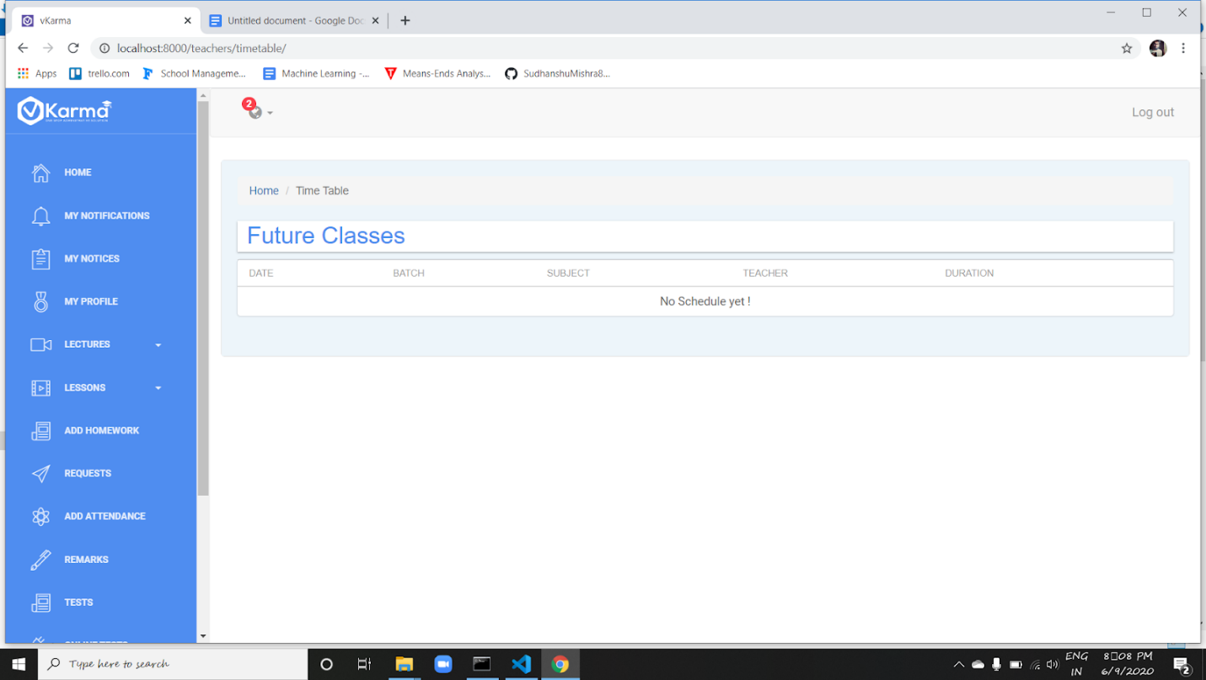

All the future classes scheduled for the teacher can be viewed on this page

1. **Changing Password**

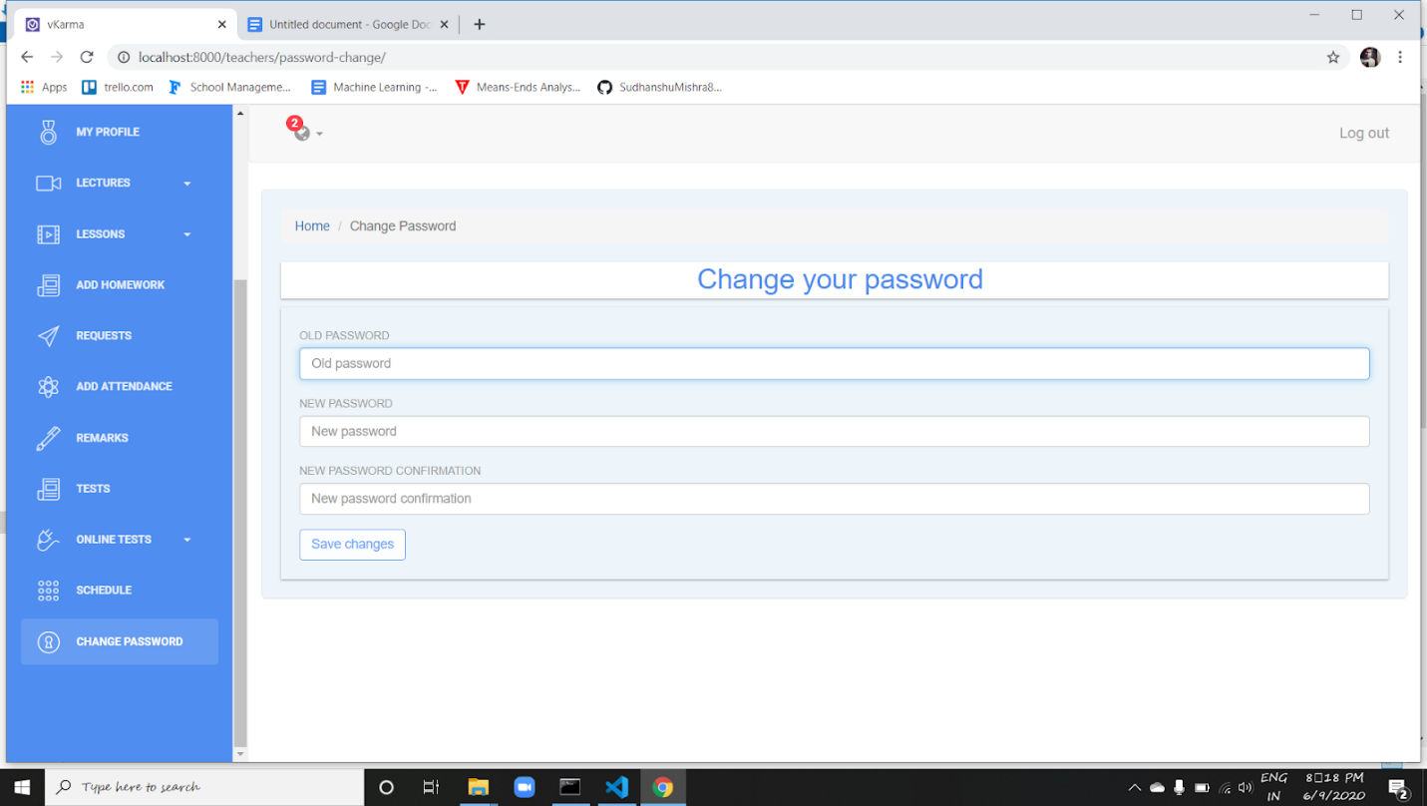

Teacher is also allowed to change their password whenever they want to make secure their accounts.

**Parents**

Parents  section is the parent’s login access.

to help tracking his child's activities.

1. **Parent Home**

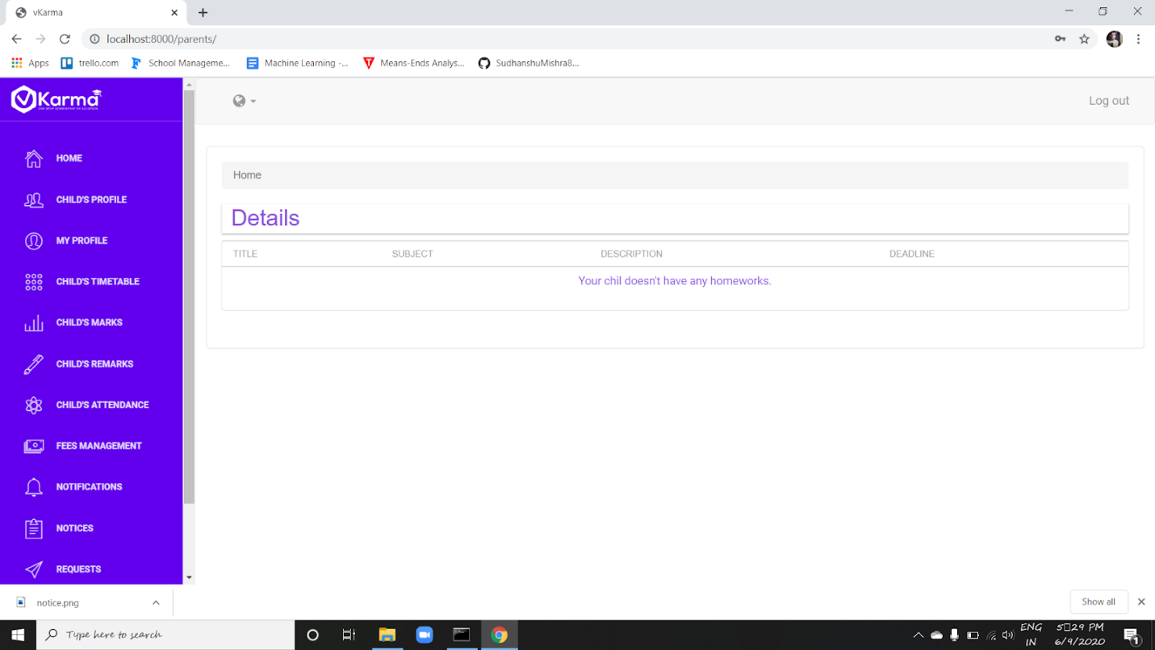

The portfolio present on the left provides the features of tracking the child's updated activity.

On the home page , the allotted homework to the student is listed along with the subject and the deadline.

1. **Profile**

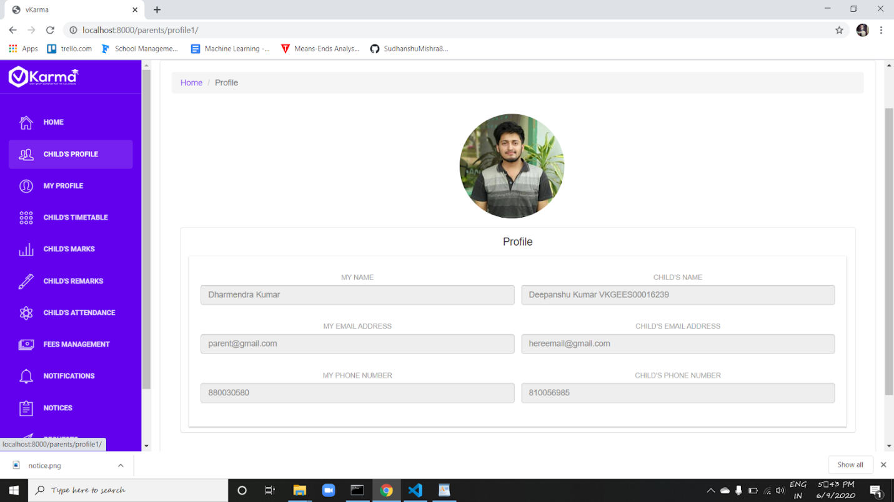

"My profile" and "child's profile" options provides the view to check the details.

It display parents and the children information side by side

1. **Time Table**

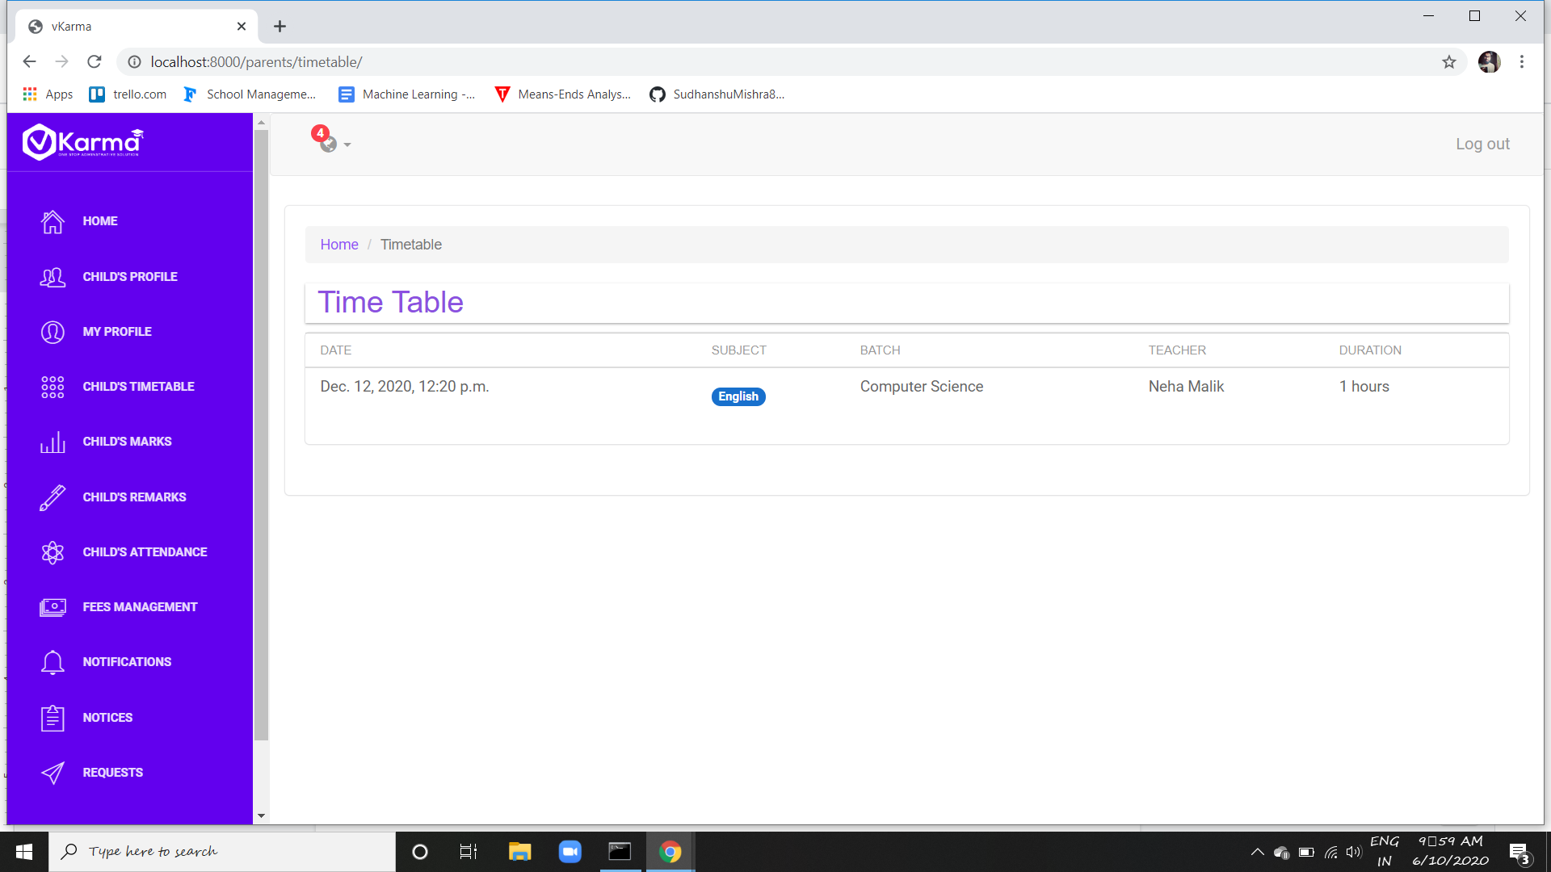

Parent can see their child's time table using this page

1. **Marks**

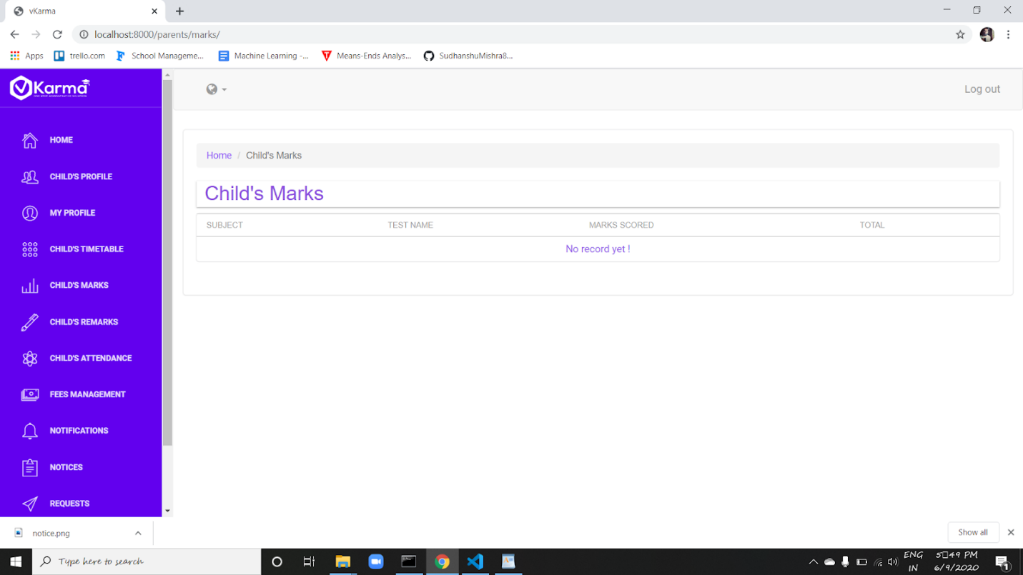

The marks scored in tests by the student can be seen by the parents along with total marks obtained.

1. **Remarks**

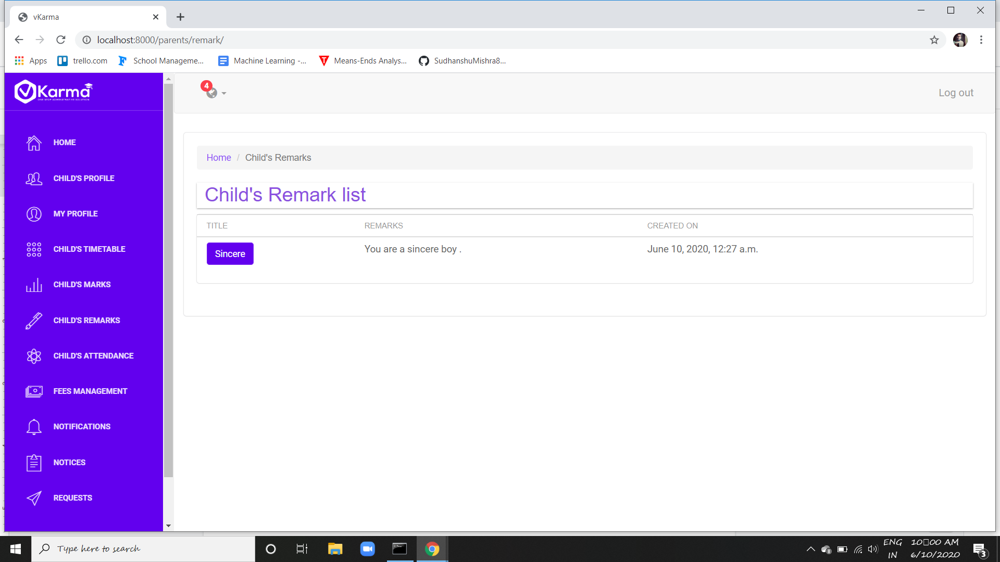

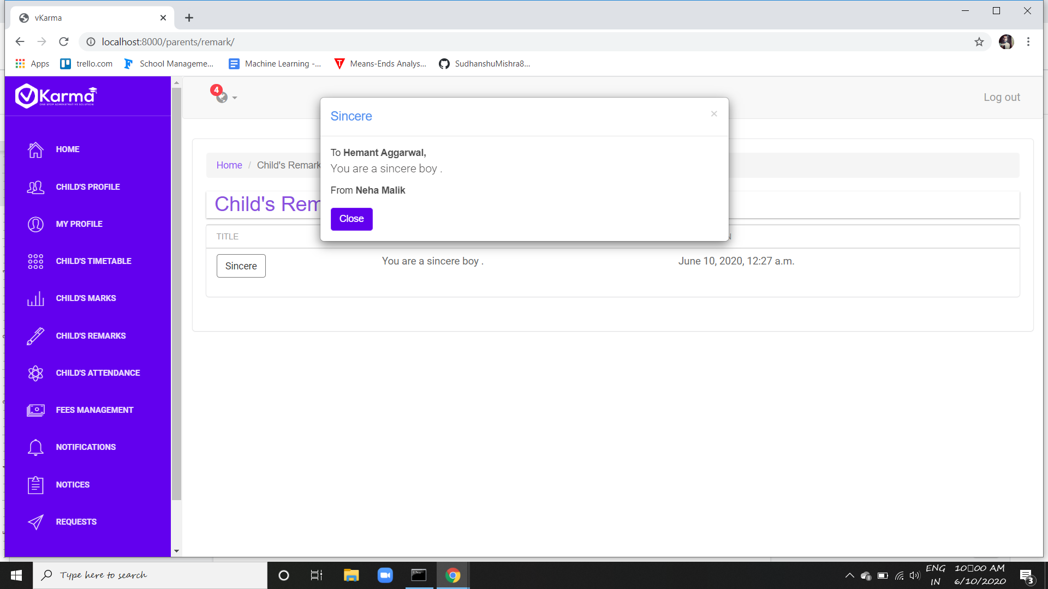

Parents can see all the remarks given to their child by the teachers

1. **Attendance**

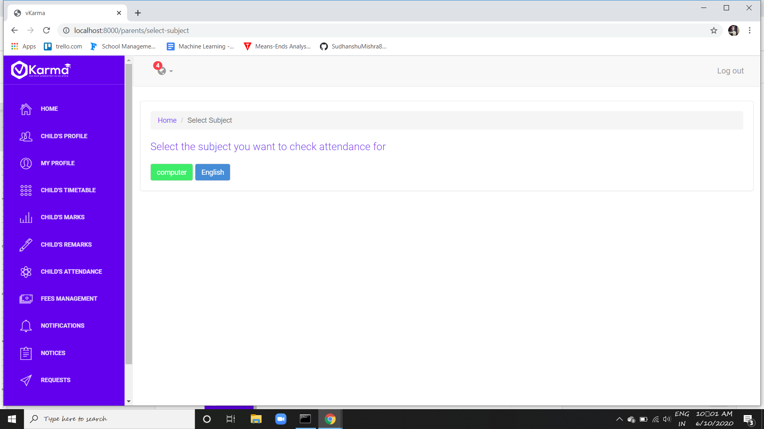

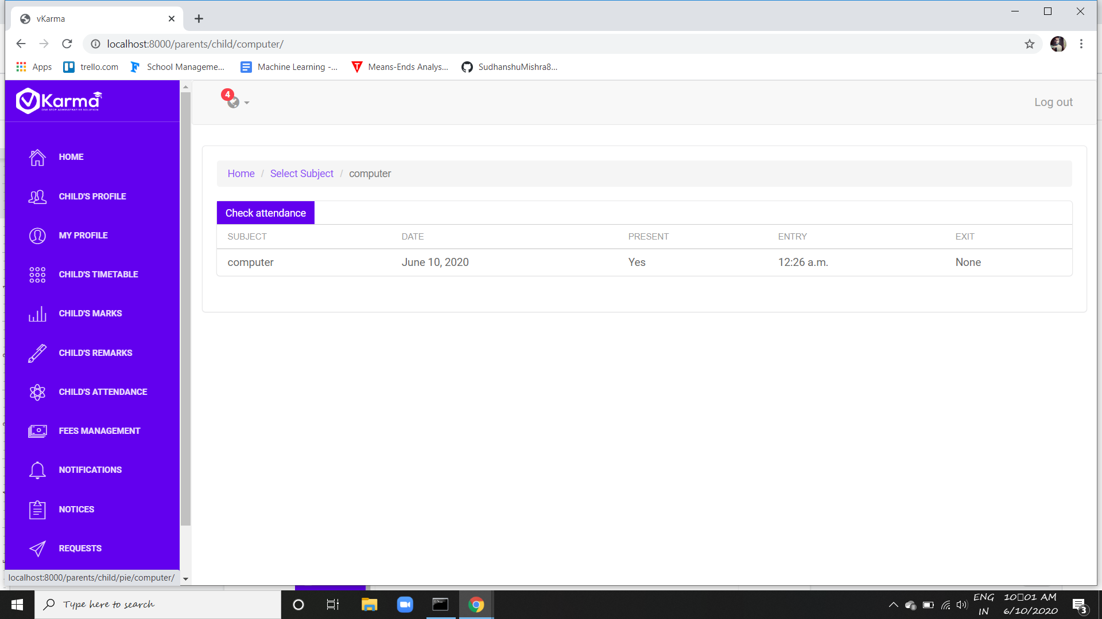

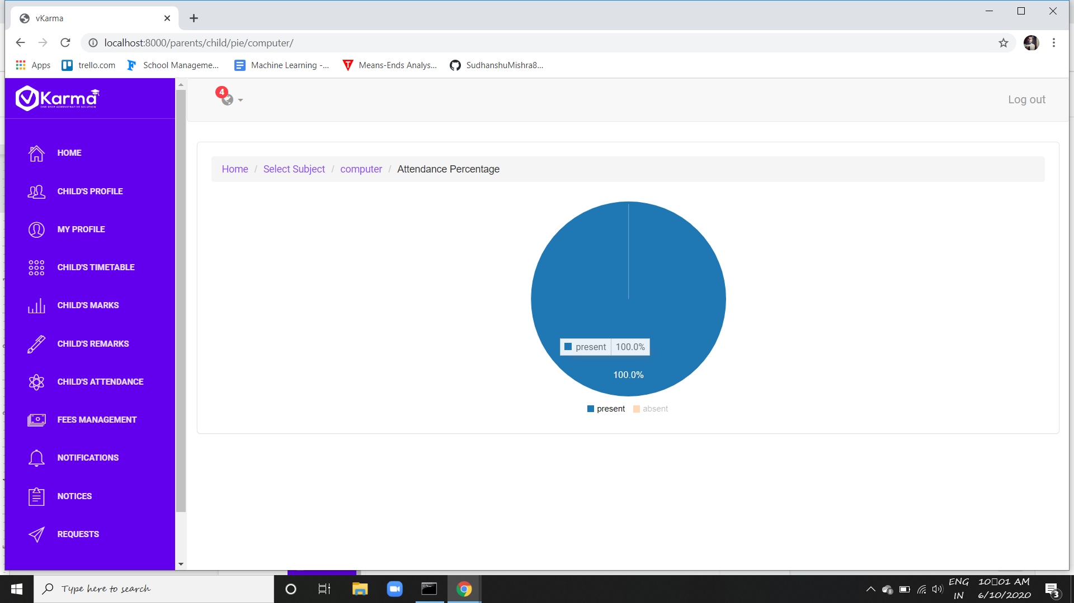

Parents can check the attendance of their child graphically.

1. **Fees Management**

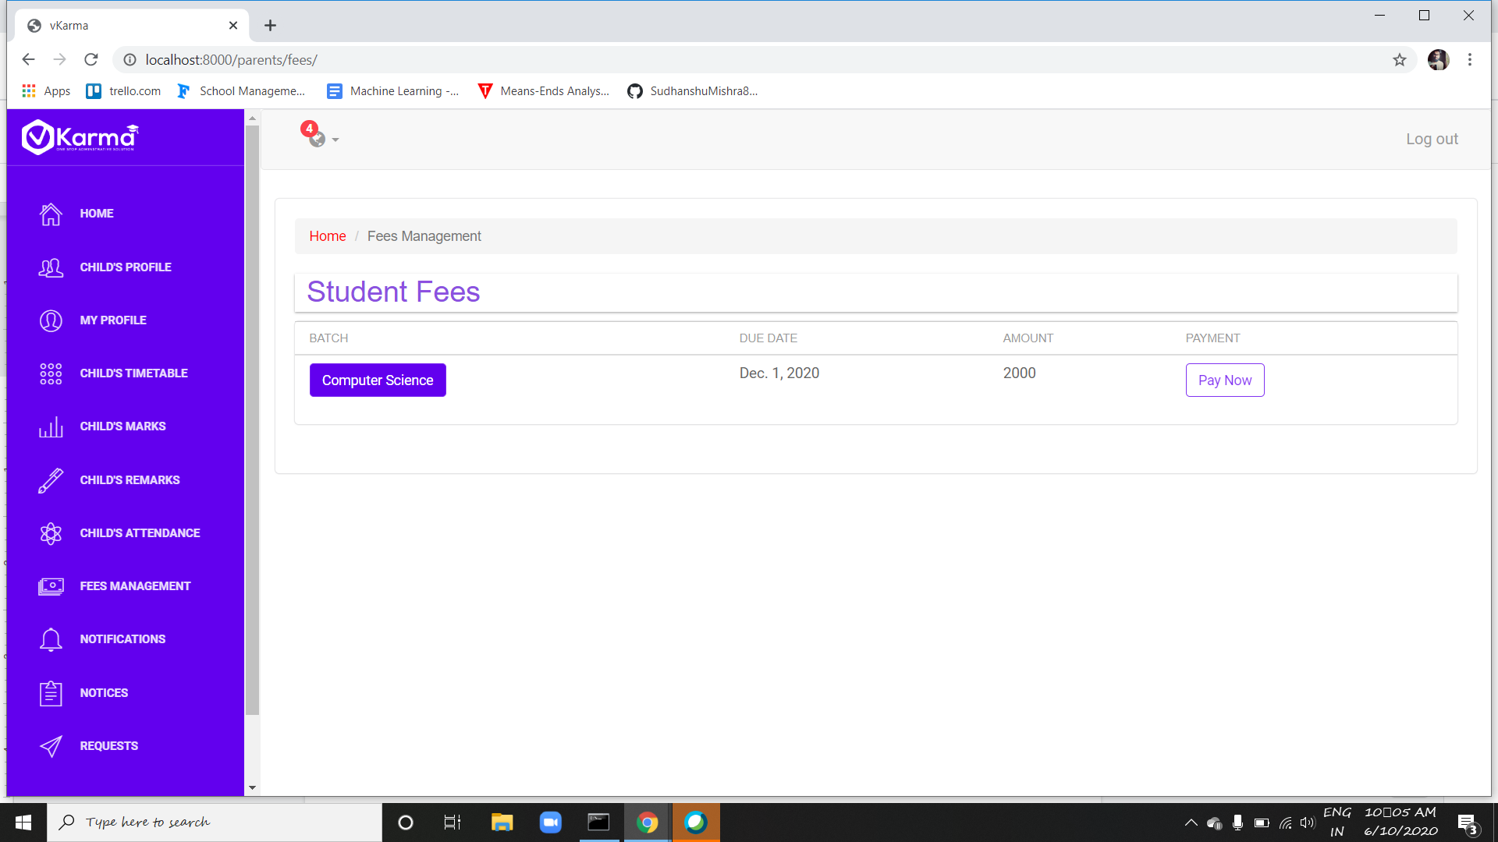

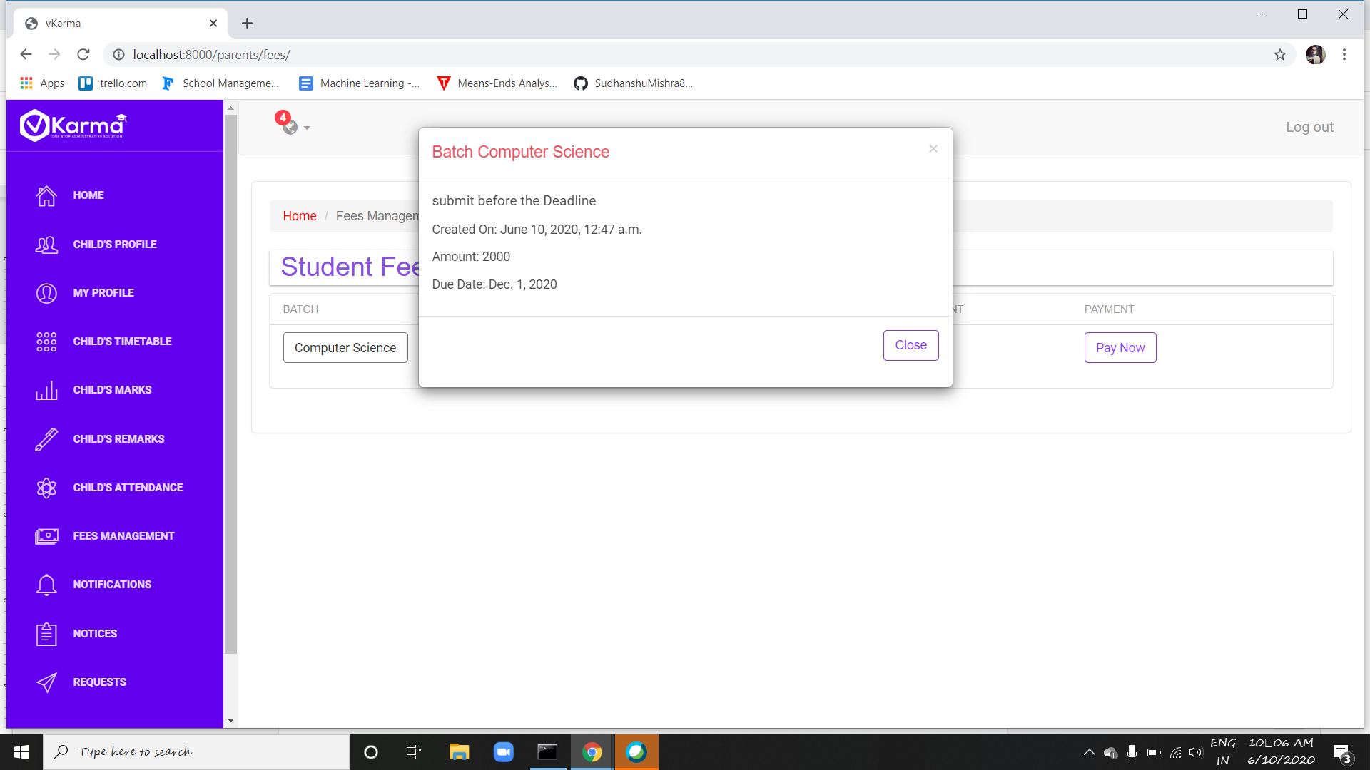

Parents can view all the fee installments done in past or to be done in future

They can view details on clicking the batch button and pay using the pay button

1. **Notifications**

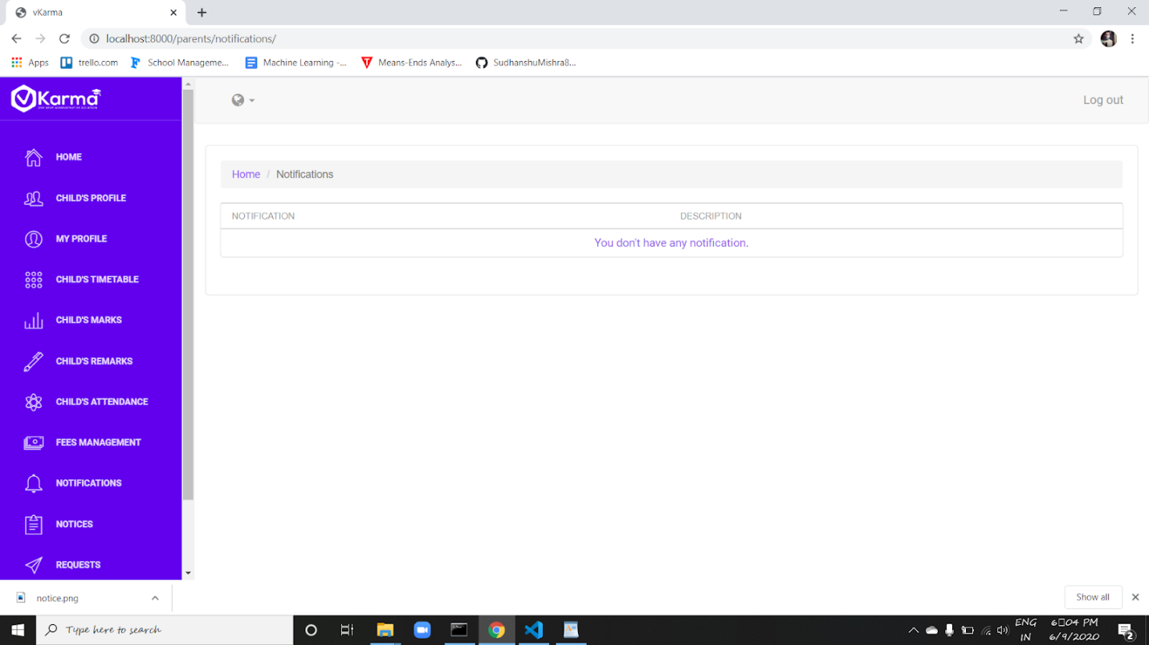

Parents can see all the notification in list form through this page

Further details can be seen by clicking on title of the notification

1. **Notices**

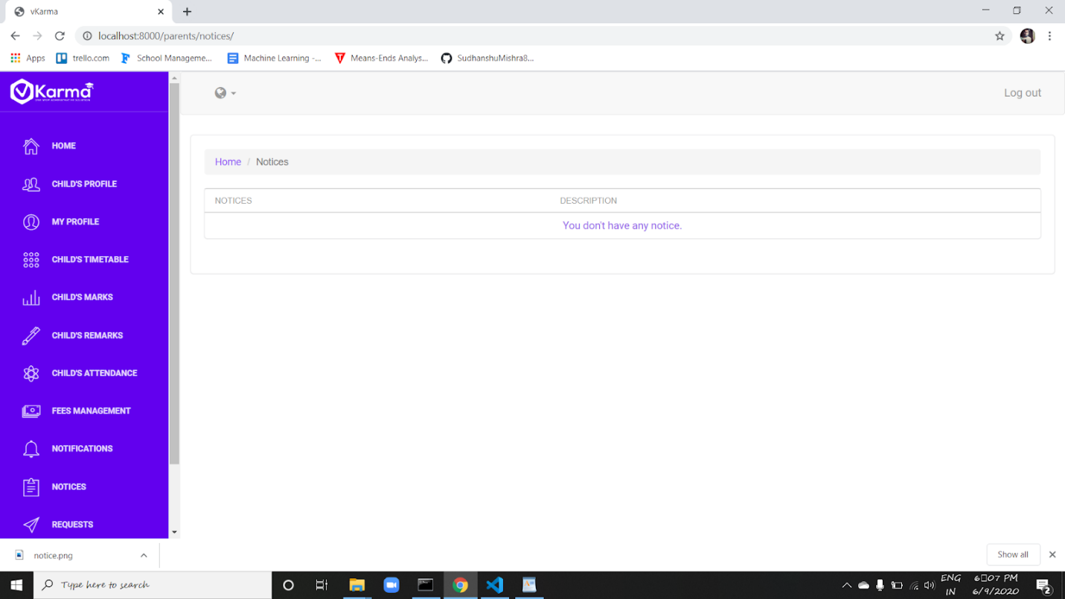

Parents can see all the notice given to him in list form through this page

Further details can be seen by clicking on title of the notice

**10.Requests**

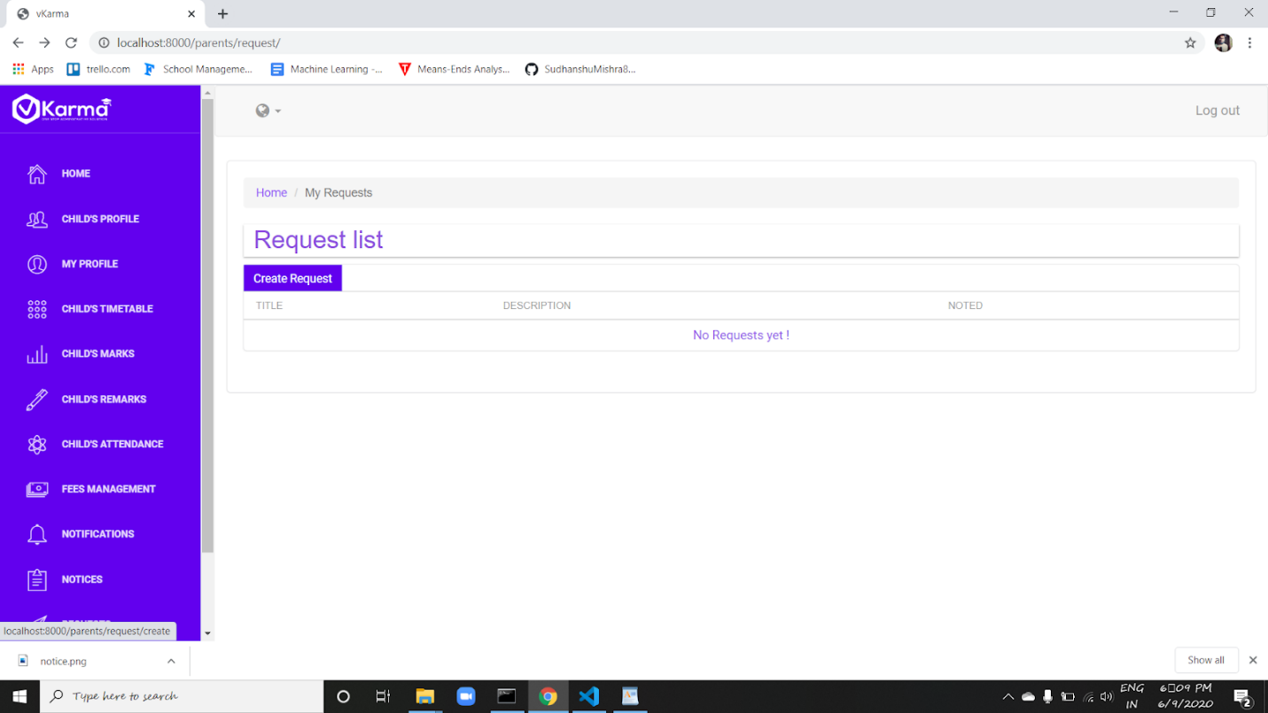

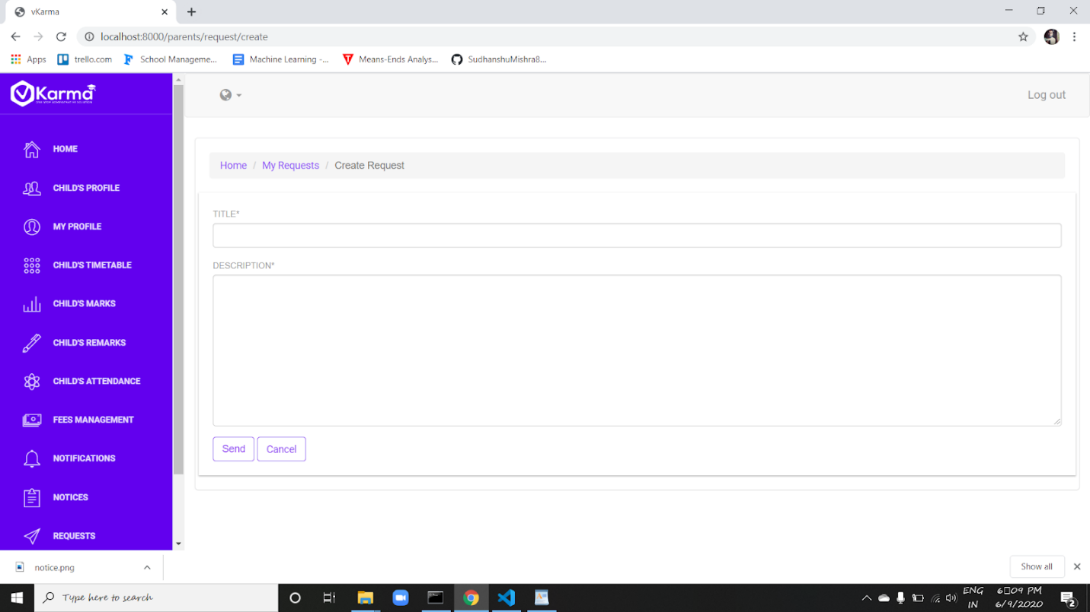

Request feature allows the parents to create a query or request to the institute department using create request button by which they stay connected to the concerns

Parent can view all the request he had made in list form on this page